#### 7.5.5 Amphoteric Impurities

If an impurity atom can act as a donor and acceptor it is called amphoteric. This can occur if the impurity has several levels in the band gap (such as Au in Ge or Si). In this case, the nature of the impurity depends on the position of the Fermi level. Another possibility is the incorporation on different lattice sites. For example, carbon in GaAs is a donor if incorporated on the Ga-site. On the As-site carbon acts as an acceptor.

Thus, e.g., crystal growth kinetics can determine the conductivity type. In Fig. [7.21](#u116076_4_En_7_Chapter-Fig21) the conductivity due to carbon background is shown for GaAs grown using MOVPE under various growth conditions. At high (low) arsine partial pressure incorporation of carbon on As-sites is less (more) probable, thus the conductivity is n-type (p-type). Also, growth on different surfaces can evoke different impurity incorporation, e.g., n-type on (001) GaAs and p-type on (311)A GaAs, since the latter is Ga-stabilized.

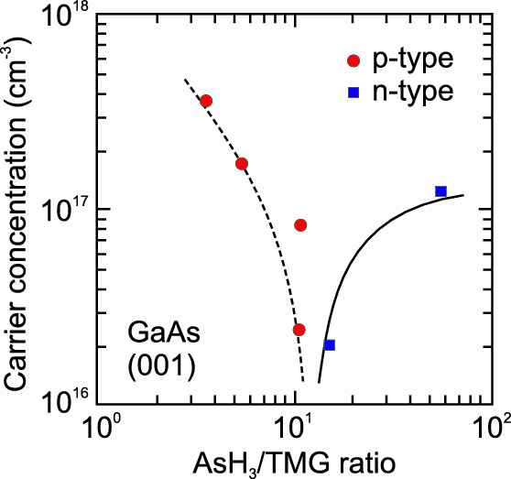

Fig. 7.21

Background doping of GaAs due to carbon in MOVPE for different ratios of the partial pressures of AsH

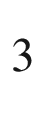

and TMG (trimethylgallium). The conductivity type (*blue squares*: n-type, *red circles*: p-type) depends on the incorporation of C from CH

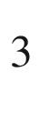

radicals on Ga- or As-site. *Lines* are guides to the eye.

Experimental data from [613]

The charge density at an impurity nucleus can be investigated via the isomer shift as determined by Mössbauer spectroscopy [614, 615]. The incorporation of the isotope

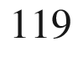

Sn can be controlled in III-V compounds to be on cation or anion site as donor or acceptor, respectively. This is accomplished by introducing

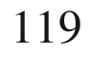

In or

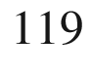

Sb on group-III and group-V site, respectively, both decaying into



Sn without leaving their lattice site. The isomer shifts of

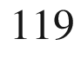

Sn in various III-V compounds are shown in Fig. [7.22](#u116076_4_En_7_Chapter-Fig22). In [615] it is concluded from these data that the tin donor is formed by a positive tin ion and the electron charge transfer to its neighboring (group-V) atoms is rather small. For tin as an acceptor, for the present conditions an ionized, i.e. negatively charged acceptor, the isomer shift follows closely the trend from substitution in group-IV semiconductors. Therefore four electrons form the tetrahedral bond, while the extra electron is located rather at the (positively charged) group-III next neighbors and not in the impurity cell. The difference to the point charge Coulomb distribution is called central-cell correction.

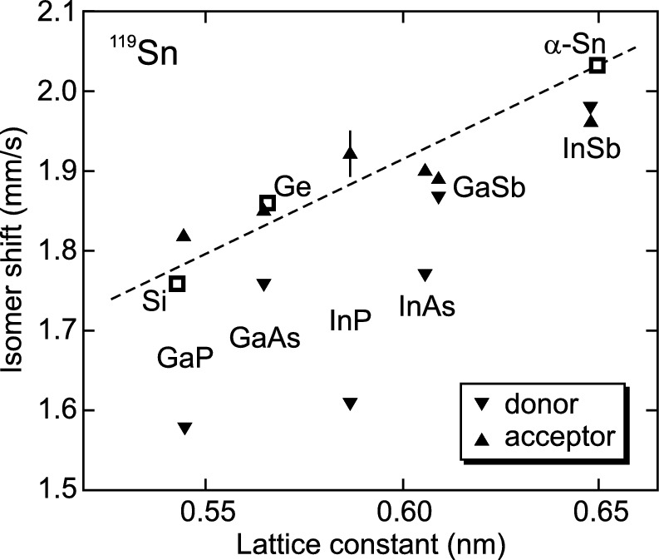

Fig. 7.22

Isomer shift (relative to CaSnO

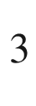

) of



Sn in various group-IV and III-V compound semiconductors as labeled. *Dashed line* is trend from isoelectronic substitution.

Experimental data from [615]

Deviation from the ideal stoichiometry introduces point defects that can be electrically active and change conductivity type and carrier concentration. In the case of CuInSe

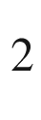

, excess Cu could go on interstitial positions or promote selenium vacancies, both leading to n-type behavior. This material is particularly sensitive to deviations from ideal stoichiometry for both Cu/In ratio (Fig. [7.23](#u116076_4_En_7_Chapter-Fig23)) and Se deficiency [616].

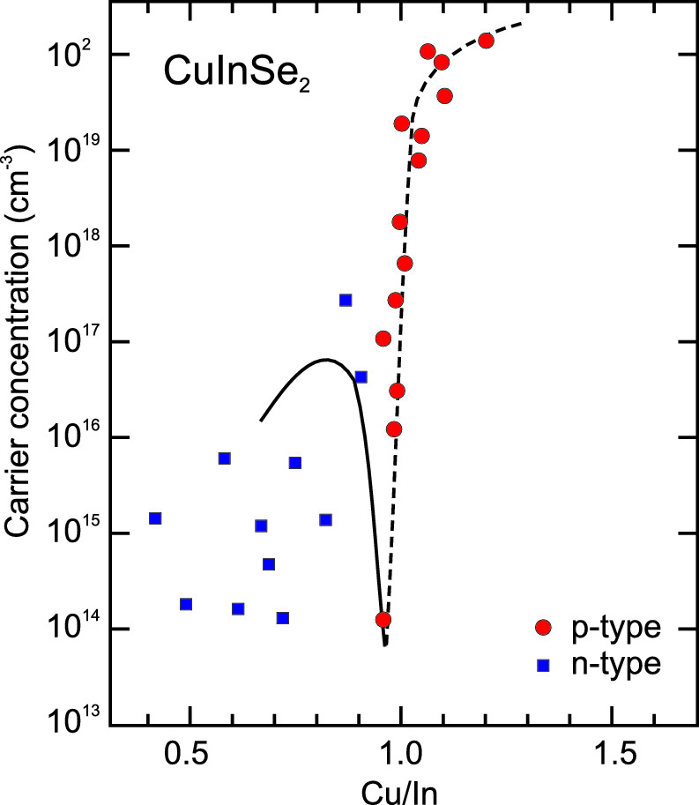

Fig. 7.23

Carrier concentration and conductivity type (*blue squares*: n-type, *red circles*: p-type) as a function of stoichiometry for CuInSe

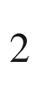

thin films. *Lines* are guides to the eye.

Experimental data from [616]

#### 7.5.6 Autodoping

If intrinsic defects such as vacancies or interstitials, possibly as a result of non-stoichiometry, or anti-site defects cause electronic levels relevant for conductivity one speaks of autodoping. An example is the role of A-B antisites in AB

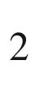

O

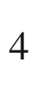

spinels (Sect. [3.​4.​7](The_Physics_of_Semiconductors00001.docx#u116076_4_En_3_Chapter)). In the perfect crystal the A (B) atoms occupy tetraeder (octaeder) places. Typical charges are A

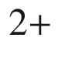

and B

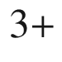

. Thus (without charge transfer) the A atom on octaeder site (A

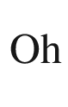

) acts like a donor and the B atom on a tetraeder site (B

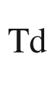

) as an acceptor. Such defects have been classified in [617] as being able to create compensated, semi-insulating, n-type or p-type material depending on the defect formation energies and the position of the electronic levels of the A

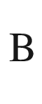

and B

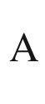

defects in the band gap (Fig. [7.24](#u116076_4_En_7_Chapter-Fig24)). An example for a p-type spinel oxide is ZnCo

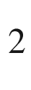

O

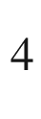

 [618].

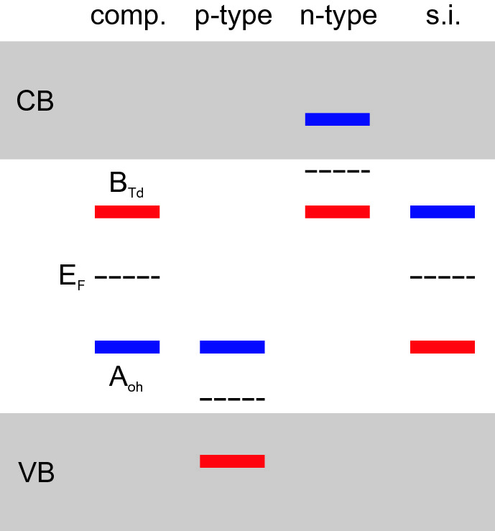

Fig. 7.24

Schematic position of electronic levels of A

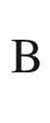

(*blue*, 0/− transition level) and B

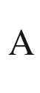

(*red*,

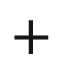

/0 transition level) defects in AB

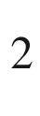

O

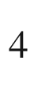

spinels and resulting material properties (compensated, n- or p-type or semi-insulating). After [617]

#### 7.5.7 High Doping

For low doping concentrations, the impurity atoms can be considered to be decoupled. At low temperature, only hopping from one impurity to the next is possible due to thermal emission or tunneling and the semiconductor becomes an insulator.

With increasing concentration, the distance between impurities decreases and their wavefunctions can overlap. Then, an impurity band develops (Fig. [7.25](#u116076_4_En_7_Chapter-Fig25)). A periodic arrangement of impurity atoms would result in well-defined band edges as found in the Kronig-Penney model. Since the impurity atoms are randomly distributed, the band edges exhibit tails. For high doping, the impurity band overlaps with the conduction band. In the case of compensation, the impurity band is not completely filled and contains (a new type of) holes. In this case, conduction can take place within the impurity band even at low temperature, making the semiconductor a metal. This metal–insulator transition has been discussed by Mott [619]. Examples for highly doped semiconductors are transparent conductive oxides (Sect. [20](The_Physics_of_Semiconductors00007.docx#u116076_4_En_20_Chapter)), the contact layer for an ohmic contact (Sect. [21.​2.​6](The_Physics_of_Semiconductors00007.docx#u116076_4_En_21_Chapter)) or the active layers in a tunneling diode (Sect. [21.​5.​9](The_Physics_of_Semiconductors00007.docx#u116076_4_En_21_Chapter)). The physics, properties and preparation of highly doped semiconductors are treated in detail in [620].

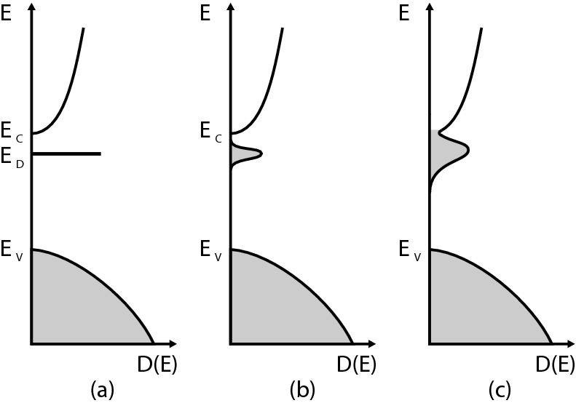

Fig. 7.25

Principle of the formation of a (donor) impurity band. **a** Small doping concentration and sharply defined impurity state at

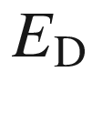

, **b** increasing doping and development of an impurity band that **c** widens further and eventually overlaps with the conduction band for high impurity concentration. The *shaded areas* indicate populated states at

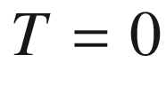

 K

The formation of the impurity band leads to a reduction of the impurity ionization energy as known from ([7.21](The_Physics_of_Semiconductors00003.docx#u116076_4_En_7_Chapter-Equ21)). Typical results are shown in Fig. [7.26](#u116076_4_En_7_Chapter-Fig26)a for n-type Ge [594] and Fig. [7.26](#u116076_4_En_7_Chapter-Fig26)b for p-type ZnTe [621]. At the critical doping concentration of

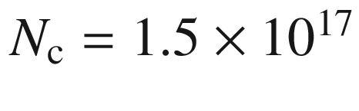

, the activation energy for the carrier concentration disappears. Similar effects have been observed for Si [622] and GaAs [623]. The freeze-out of the carrier concentration (see Fig. [7.9](The_Physics_of_Semiconductors00003.docx#u116076_4_En_7_Chapter-Fig9)) disappears as shown in Fig. [7.27](#u116076_4_En_7_Chapter-Fig27). Critical doping concentrations are listed in Table [7.6](#u116076_4_En_7_Chapter-Tab6). The decrease of the ionization energy

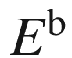

(donor or acceptor) follows the dependence [594, 622]

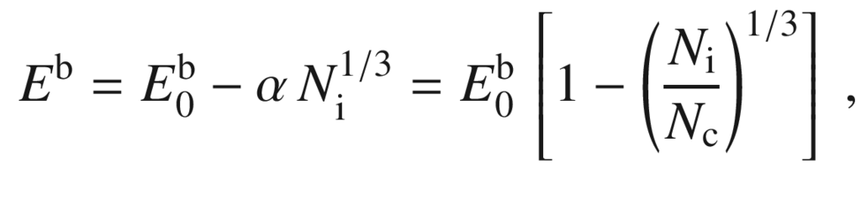

(7.52)

where

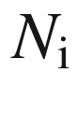

is the concentration of ionized dopants. A refined theory, considering screening, shift and tails of the conduction band and most importantly broadening of the donor level has been presented in [624].

The critical density can be estimated from the Mott criterion when the distance of the impurities becomes comparable to their Bohr radius ([7.22](The_Physics_of_Semiconductors00003.docx#u116076_4_En_7_Chapter-Equ22))

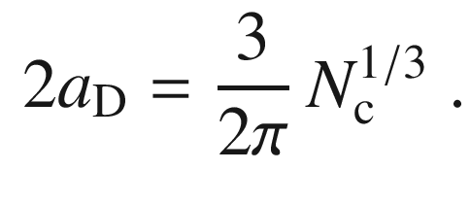

(7.53)

The pre-factor

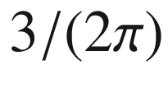

stems from the random distribution of impurities and disappears for a periodic arrangement. The Mott criterion is (rewriting ([7.53](#u116076_4_En_7_Chapter-Equ56)))

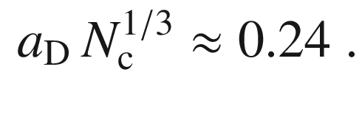

(7.54)

For GaAs with

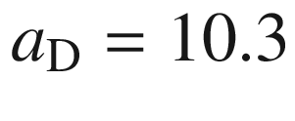

 nm, the criterion yields

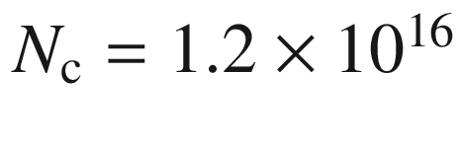

 cm

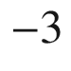

, in agreement with experiment.

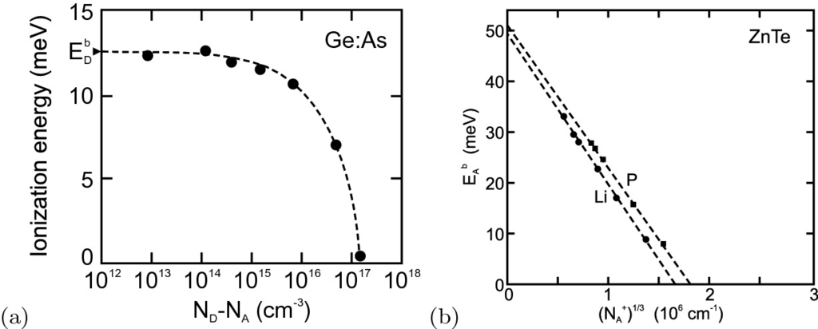

Fig. 7.26

**a** Donor ionization energy in n-type Ge for various doping concentrations. *Dashed line* is a guide to the eye. The arrow labeled

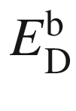

denotes the low-concentration limit (cf. Table [7.2](The_Physics_of_Semiconductors00003.docx#u116076_4_En_7_Chapter-Tab2)). Experimental data from [594]. **b** Acceptor ionization energy for ZnTe:Li and ZnTe:P as a function of the third root of the ionized acceptor concentration.

Data from [621]

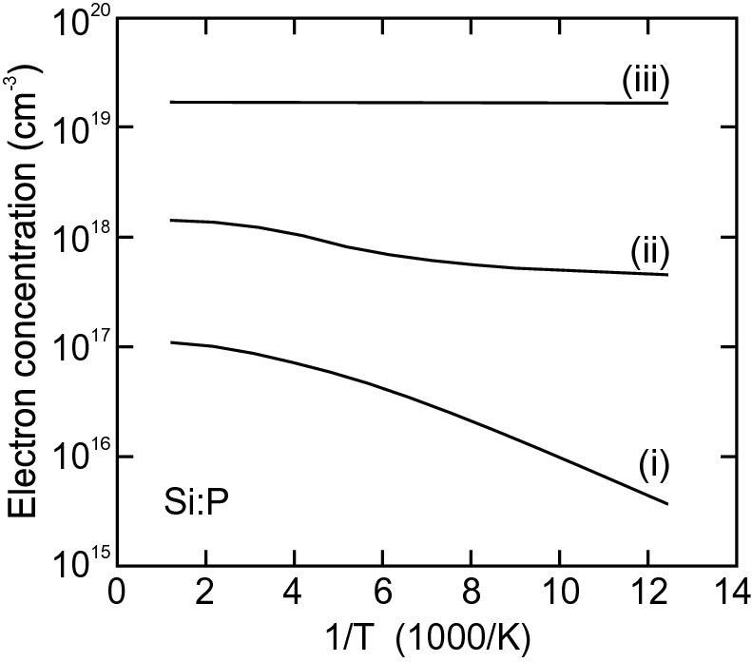

Fig. 7.27

Electron concentration versus inverse temperature for Si:P for three different doping concentrations ((i):

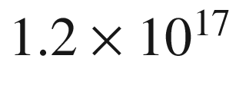

 cm

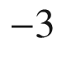

, (ii):

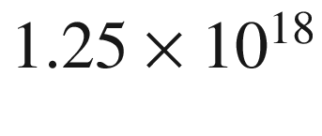

 cm

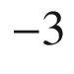

, (iii):

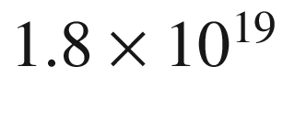

 cm

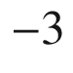

).

Experimental data from [622]

Table 7.6

Critical doping concentration for various semiconductors (at room temperature)

| Material | Type | $$N_{\mathrm {c}}$$   (cm  $$^{-3}$$  ) | References |
| --- | --- | --- | --- |
| C:B | p | $$2 \times 10^{20} $$ | [597] |
| Ge:As | n | $$1.5 \times 10^{17}$$ | [594] |
| Si:P | n | $$1.3 \times 10^{18}$$ | [622] |
| Si:B | p | $$6.2 \times 10^{18}$$ | [622] |
| GaAs | n | $$1.0 \times 10^{16} $$ | [623] |
| GaP:Si | n | $$6 \times 10^{19} $$ | [625] |
| GaP:Zn | p | $$2 \times 10^{19} $$ | [626] |
| GaN:Si | n | $$2 \times 10^{18} $$ | [627] |
| GaN:Mg | p | $$4 \times 10^{20} $$ | [598] |
| Al  $$_{0.23}$$  Ga  $$_{0.77}$$  N:Si | n | $$3.5 \times 10^{18}$$ | [628] |
| ZnTe:Li | p | $$4 \times 10^{18} $$ | [621] |
| ZnTe:P | p | $$6 \times 10^{18} $$ | [621] |
| ZnO:Al | n | $$8 \times 10^{18} $$ | [629] |

The achievable maximum concentration of electrically active dopants is limited by the concentration dependence of the diffusion coefficient, Coulomb repulsion, autocompensation and the solubility limit [575]. In Table [7.7](#u116076_4_En_7_Chapter-Tab7) the maximum carrier concentrations for GaAs with various dopants are listed.

As an example we show the Ga-doping of epitaxial ZnO layers on sapphire in Fig. [7.28](#u116076_4_En_7_Chapter-Fig28). Under slightly Zn-rich (O-polar) conditions the growth mode is two-dimensional and the carrier concentration increases linearly with the Ga concentration,

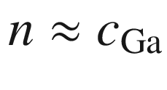

, up to high values in the

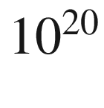

 cm



range [630]. For O-rich (Zn-polar) conditions the growth mode changes to three-dimensional growth and the activation ratio of Ga donors becomes low [631]. Above a gallium content of 2%, the octahedral coordination of gallium and thus the partial segregation into a parasitic ZnGa



O



spinel phase is observed for [Ga]

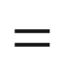

 4% [632].Table 7.7

Maximum electrically active doping concentration for GaAs

| Material | Type | $$N_{\mathrm {c}}$$   (cm  $$^{-3}$$  ) | References |
| --- | --- | --- | --- |
| GaAs:Te | n | $$2.6 \times 10^{19}$$ | [633] |
| GaAs:Si | n | $$1.8 \times 10^{19}$$ | [634] |
| GaAs:C | p | $$1.5 \times 10^{21}$$ | [635] |
| GaAs:Be | p | $$2 \times 10^{20}$$ | [636] |

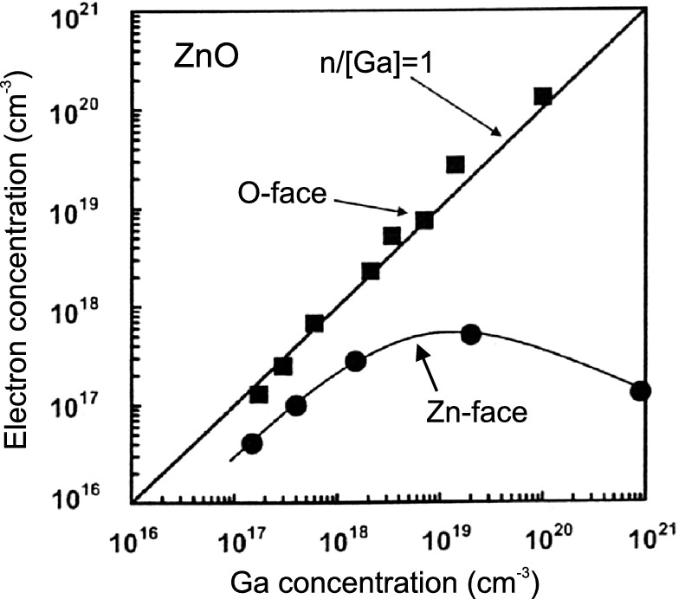

Fig. 7.28

Electron concentration as a function of gallium concentration in MBE grown ZnO:Ga on sapphire for the two different polarities.

Adapted from [630, 631]

The doping of semiconductors beyond the solubility limit is termed ‘hyperdoping’. It involves non-equilibrium preparation methods [637, 638].

### 7.6 Quasi-fermi Levels

The carrier concentrations were given by ([7.6](The_Physics_of_Semiconductors00003.docx#u116076_4_En_7_Chapter-Equ6)) and ([7.7](The_Physics_of_Semiconductors00003.docx#u116076_4_En_7_Chapter-Equ7)). So far, we have only considered semiconductors in thermodynamic equilibrium for which

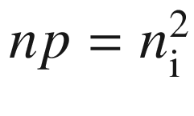

. In a nonequilibrium situation, e.g. for external excitation or carrier injection in a diode, the electron and hole densities can each take arbitrary values, in principle. In particular, *np* will no longer be equal to

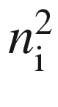

and there is no Fermi level constant throughout the structure. In this case, however, quasi-Fermi levels

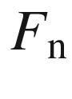

and

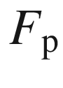

for electrons and holes, respectively, are defined via

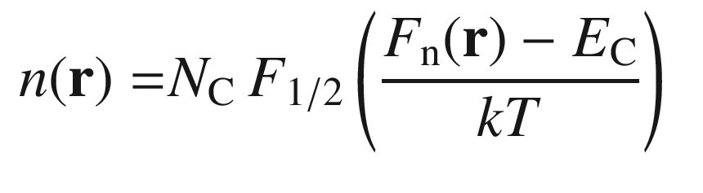

(7.55a)

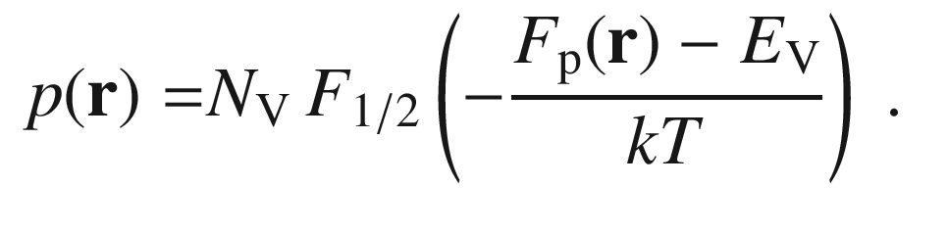

(7.55b)

A quasi-Fermi level is sometimes called imref[5](#u116076_4_En_7_Chapter-Fn5) and can also be denoted as

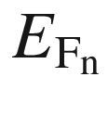

or

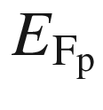

. We emphasize that the quasi-Fermi levels are *only* a means to describe the local carrier density in a logarithmical way. The quasi-Fermi levels can be obtained from the density via

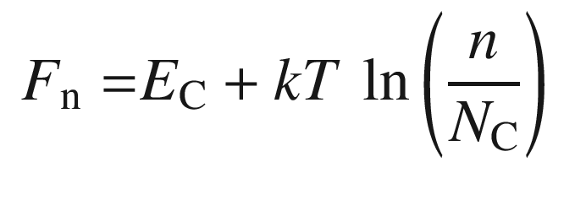

(7.56a)

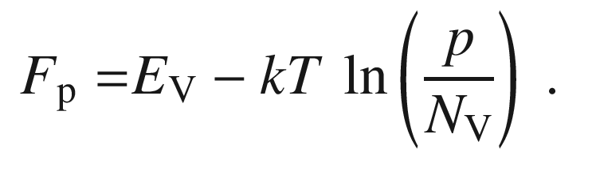

(7.56b)

The quasi-Fermi levels do not imply that the carrier distribution is actually a Fermi distribution. This is generally no longer the case in thermodynamical nonequilibrium. However, in ‘well-behaved’ cases the carrier distribution in nonequilibrium can be approximated locally as a Fermi distribution using a local quasi-Fermi level  and a local temperature, i.e.

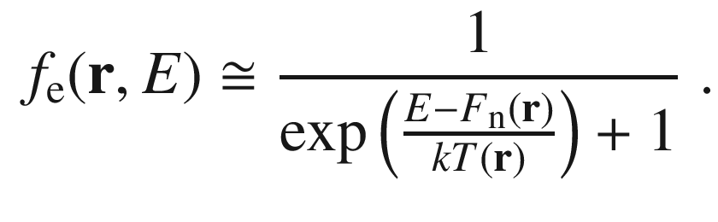

(7.57)

Using the quasi-Fermi levels, *np* is given by

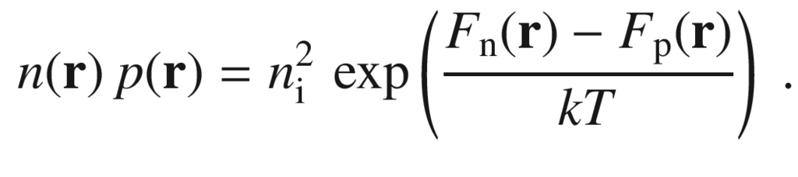

(7.58)

We note that for an inhomogeneous semiconductor or a heterostructure (cf. Chap. [12](The_Physics_of_Semiconductors00005.docx#u116076_4_En_12_Chapter)),

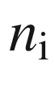

may also depend on the spatial position. In the case of thermodynamic equilibrium the difference of the quasi-Fermi levels is zero, i.e.

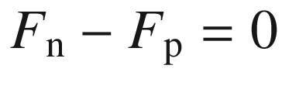

and

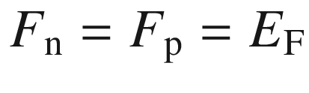

.

### 7.7 Deep Levels

For deep levels the short-range part of the potential determines the energy level. The long-range Coulomb part will only lead to a correction. The term ‘deep level’ implies that the level is within the band gap and far from the band edges. However, some deep levels (in the sense of the potential being determined by the ion core) have energy levels close to the band edges or even within a band. Details can be found in [267, 639–642].

The wavefunction is strongly localized. Thus, it cannot be composed of Bloch functions, as has been done for the shallow levels for the effective-mass impurity. The localization in

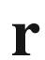

space leads to a delocalization in

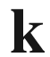

space. Examples are Si:S, Si:Cu or InP:Fe, GaP:N, ZnTe:O. Deep levels can also be due to intrinsic defects such as vacancies or antisite defects.

Due to the larger distance to the band edges, deep levels are not efficient at providing free electrons or holes. Quite the opposite, they rather capture free carriers and thus lead to a reduction of conductivity. Centers that can capture electrons *and* holes lead to nonradiative recombination of electrons through the deep level into the valence band (see also Chap. [10](The_Physics_of_Semiconductors00005.docx#u116076_4_En_10_Chapter)). This can be useful for the fabrication of semi-insulating layers with low carrier concentration and fast time response of, e.g., switches and photodetectors.

While the electronic properties of deep levels can be readily characterized, the microscopic origin is not immediately apparent. Next to theoretical modeling of defects and correlation with experimental results, paramagnetic hyperfine interactions have proven useful to identify the microscopic nature of various defects [643].

#### 7.7.1 Charge States

The deep level can have different charge states depending on the occupancy with electrons. The energy position within the gap varies with the charge state due to the Coulomb interaction. Also, the lattice relaxation around the defect depends on the charge state and modifies the energy level.

The localized charge

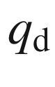

at the defect is the integral over the change

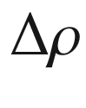

of the charge density compared to the perfect crystal over a sufficiently large volume

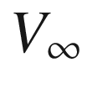

around the defect

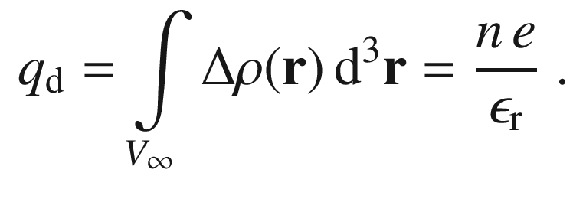

(7.59)

In semiconductors, the charge

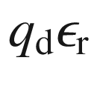

is an integer multiple of the elementary charge. The defect is said to be in the *n*th charge state. Each charge state has a certain stable atomic configuration

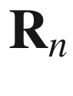

. Each charge state has a ground state and excited states that can each have different stable atomic configurations.

Now, we discuss how the concentration of the various charge states depends on the position of the Fermi level. The overall constraint of global charge neutrality determines the chemical potential of the electron, i.e. the Fermi level in Fermi–Dirac statistics. We use the approximation that the concentration of defects is so small that the mutual interaction of defects becomes negligible.

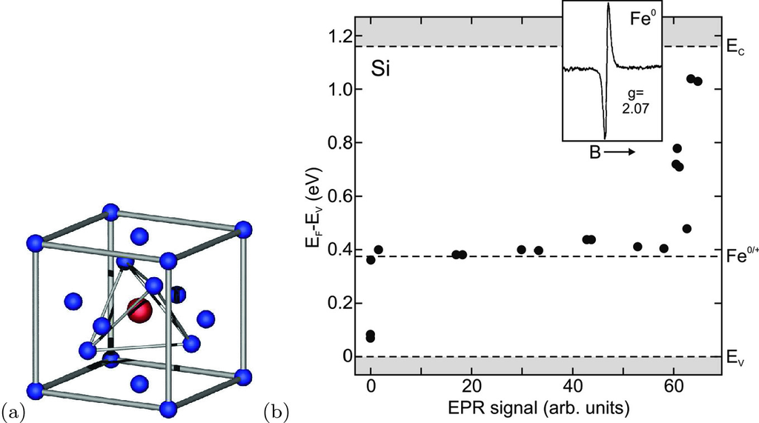

Fig. 7.29

**a** Silicon cubic unit cell with an interstitial iron atom (*red*) at tetrahedral site. **b** EPR intensity (at

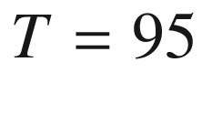

 K from interstitial iron in neutral state, Fe

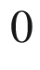

with

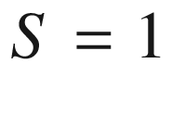

) versus Fermi level position for iron-doped silicon with varying Fermi level due to different amounts of shallow impurity levels from to Al, B and P as labeled. The *shaded areas* indicate the valence and conduction band. The *dashed line* at

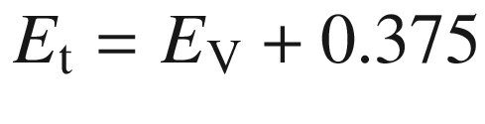

 eV indicates the trap level. The *inset* shows a typical EPR spectrum of Fe

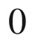

.

Adapted from [649], *inset* adapted from [650]

As an example, we treat the possible reaction

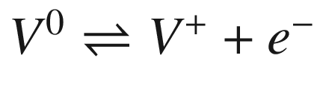

, where

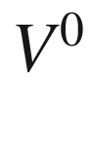

denotes a neutral vacancy and

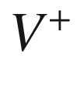

is a positively charged vacancy, created by the ionization of an electron from the vacancy into the conduction band. The free energy *G* depends on the numbers

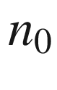

of neutral and

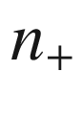

of positively charged vacancies. The minimum condition is met by

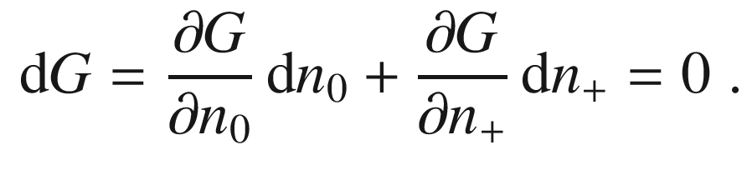

(7.60)

The neutrality constraint is

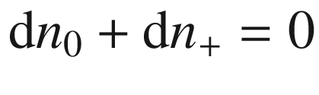

and therefore the minimum condition reads

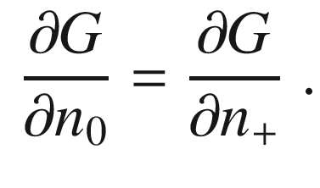

(7.61)

For noninteracting defects and using ([4.​9](The_Physics_of_Semiconductors00002.docx#u116076_4_En_4_Chapter)) we write

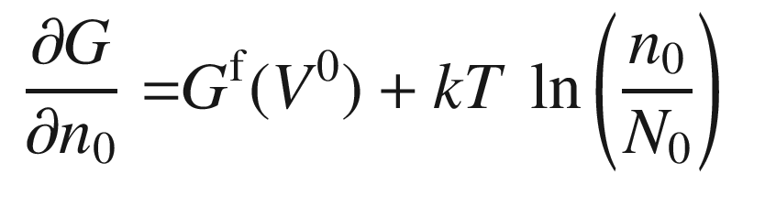

(7.62a)

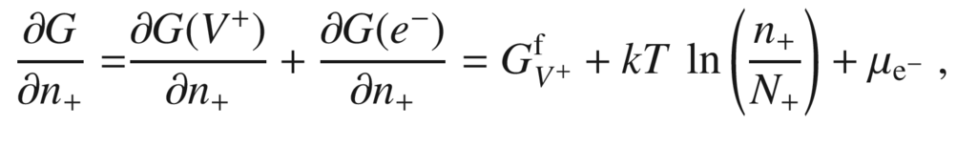

(7.62b)

where

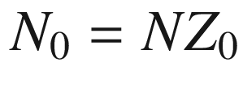

and

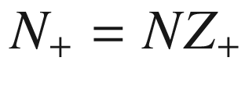

are the number of available sites, given by the number *N* of atomic sites and including possible internal degeneracies

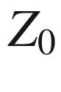

and

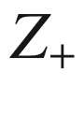

, respectively. Degeneracy factors of deep levels are not a simple subject [601] and, e.g., the degeneracy factors of Au donor and acceptor levels in Si are under discussion [644–646].

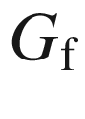

denotes the free enthalpy of formation of the respective defect, as in ([4.​3](The_Physics_of_Semiconductors00002.docx#u116076_4_En_4_Chapter)). We have written the free enthalpy of the separated pair

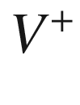

and

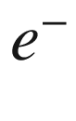

as the sum

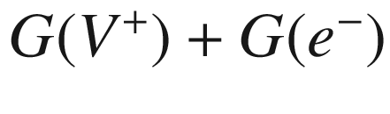

.

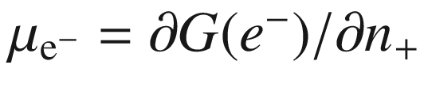

is (by definition) the chemical potential  of the electron, i.e. the Fermi energy

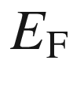

of Fermi–Dirac statistics.[6](#u116076_4_En_7_Chapter-Fn6) From ([7.62a](#u116076_4_En_7_Chapter-Equ67),b) we find for the ratio of the concentrations of defects

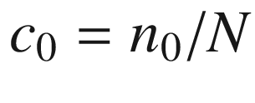

and

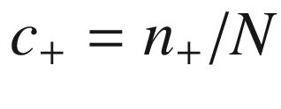

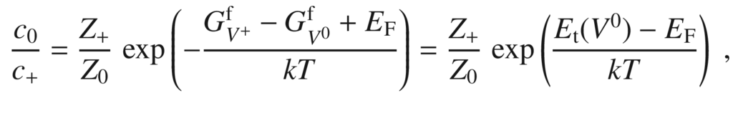

(7.63)

where the trap level energy (for the particular charge transition),

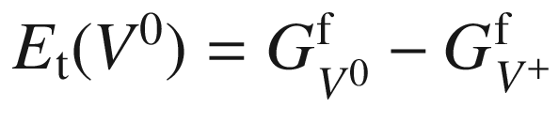

, is the free enthalpy of ionization of

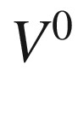

. We note that

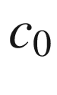

can be obtained from ([4.​9](The_Physics_of_Semiconductors00002.docx#u116076_4_En_4_Chapter)) and

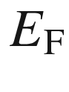

is determined by the charge-neutrality condition.

As example experimental data on the charge transition

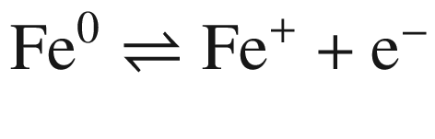

of interstitial iron (in tetrahedral position, Fig. [7.29](#u116076_4_En_7_Chapter-Fig29)a, cmp. Fig. [3.​18](The_Physics_of_Semiconductors00002.docx#u116076_4_En_3_Chapter-Fig18)) in silicon is shown. The concentration of Fe



is tracked via the EPR signal from the neutral

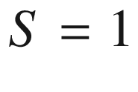

state[7](#u116076_4_En_7_Chapter-Fn7) with *g*-factor

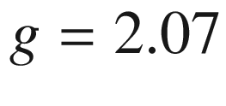

[647]. For n-type samples the iron is in neutral state and the maximum EPR signal is found. For strongly p-type samples, the Fermi energy is below the trap level and all iron is in Fe

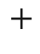

state, yielding no EPR signal at the given *g*-factor. From the investigation of various silicon samples with different doping levels and consequently different position of the Fermi level, the trap (deep donor) energy is found to be

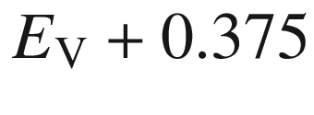

 eV as indicated in Fig. [7.29](#u116076_4_En_7_Chapter-Fig29)b.

#### 7.7.2 Double Donors

An impurity that has two extra electrons available after bonding in the matrix may give rise to a double donor. Typical examples are substitutional chalcogenide atoms (S, Se or Te) in silicon [651] and germanium [652], interstitial impurities such as Mg

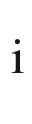

in Si [653], or group-V atoms on a group-III site in a III–V compound (antisite defect), such as P

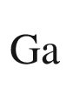

in GaP [654] or As

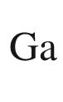

in GaAs [655].

The double donor is electronically similar to a helium atom. Due to the repulsive Coulomb interaction of the two electrons on the neutral double donor, the (single) ionization energy

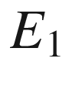

(also often labeled *E*(0, 1) or

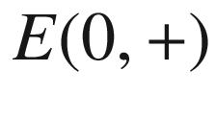

) of D

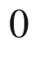

is smaller than that of D

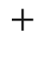

(

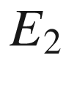

, also labeled *E*(1, 2) or

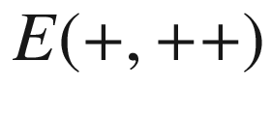

). For He and He

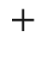

the ratio of ionization energies is 0.45; for chalcogenides in Si and Ge similar ratios have mostly been found (Table [7.8](#u116076_4_En_7_Chapter-Tab8)).

The carrier statistics and the degeneracy factors for a double donor have been discussed in [585, 656]. Typically, the degeneracy factor for the ionization of the double donor

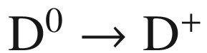

is

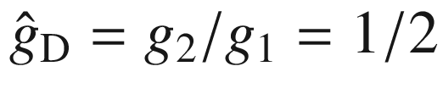

and for the ionization

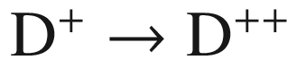

is

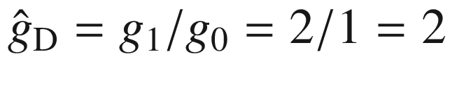

.Table 7.8

Binding energies (to conduction band) of double donor chalcogenide impurities in Si and Ge. All energies in meV, data from [651, 652]

| Host | State | S | Se | Te |
| --- | --- | --- | --- | --- |
| Si | $$\mathrm {D}^0$$ | 318 | 307 | 199 |
| $$\mathrm {D}^+$$ | 612 | 589 | 411 |
| Ge | $$\mathrm {D}^0$$ | 280 | 268 | 93 |
| $$\mathrm {D}^+$$ | 590 | 512 | 330 |

For the probabilities to find a neutral, single and double ionized donor we find following the treatment in [656]

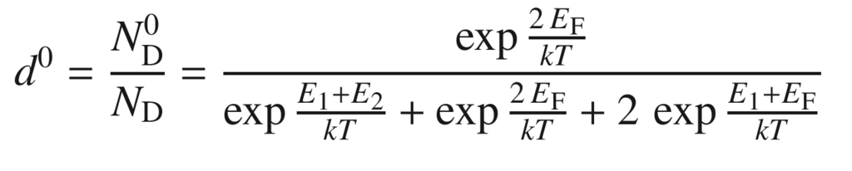

(7.64a)

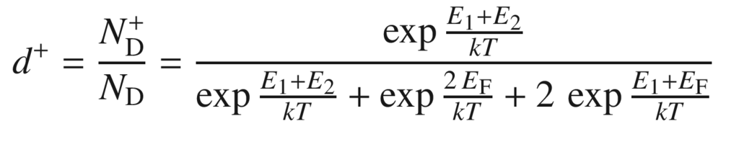

(7.64b)

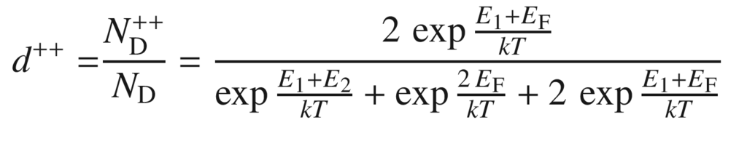

(7.64c)

The probabilities are depicted in Fig. [7.30](#u116076_4_En_7_Chapter-Fig30)a. The maximum of

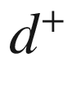

is at the energy

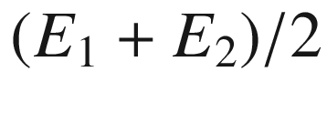

. Its value is

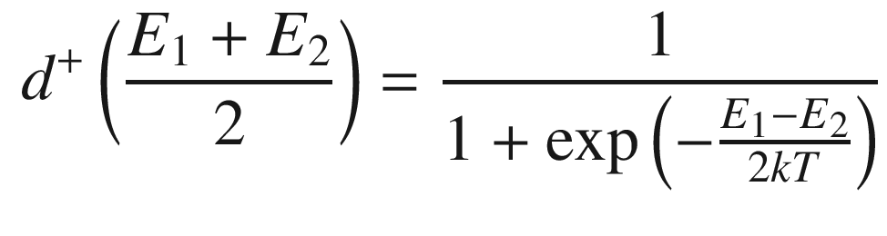

(7.65)

and reaches a value close to one for

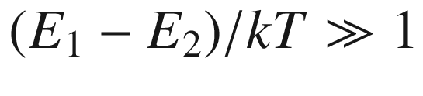

. In Fig. [7.30](#u116076_4_En_7_Chapter-Fig30)b the number of electrons per donor

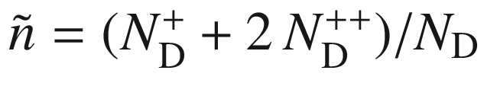

is shown as a function of the Fermi level; at



, exactly

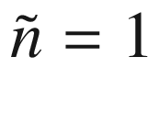

. In Fig.[7.31](#u116076_4_En_7_Chapter-Fig31) the temperature dependent electron concentration in Si:Te is depicted. Up to 570 K the single ionization is visible (other shallow impurities present in the sample in lower concentrations

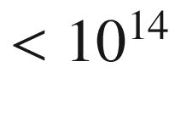

 cm

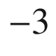

play no role). From the fit

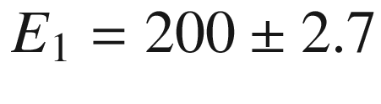

 meV is determined [657]. Single donor models would fail. The second ionization step is somewhat masked by the onset of intrinsic conduction. According to ([7.15](The_Physics_of_Semiconductors00003.docx#u116076_4_En_7_Chapter-Equ15)), the slope of

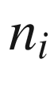

is

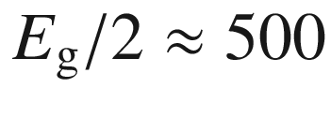

 meV which is similar to

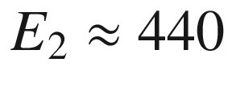

 meV.

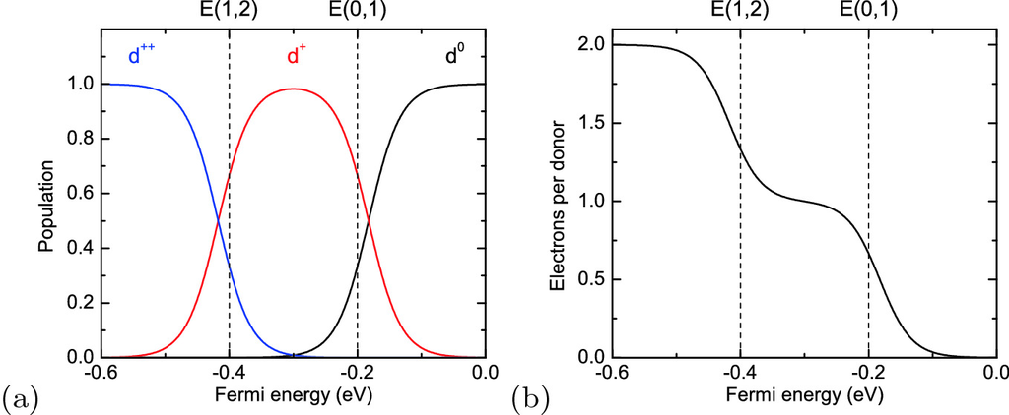

Fig. 7.30

**a** Population of states of a double donor (neutral: *black*, single ionized: *red*, double ionized: *blue*) according to ([7.64a](#u116076_4_En_7_Chapter-Equ70)–c) as a function of the Fermi level. The ionization energies have been chosen as

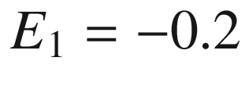

 eV and

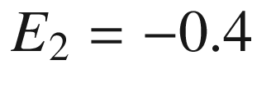

 eV and are indicated by *dashed lines* (

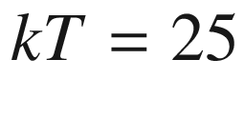

 meV); these energies are similar to Si:Te (cmp. Table [7.8](#u116076_4_En_7_Chapter-Tab8)). The conduction band edge is taken as zero energy. **b** depicts the according number of electrons

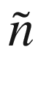

ionized from the donor

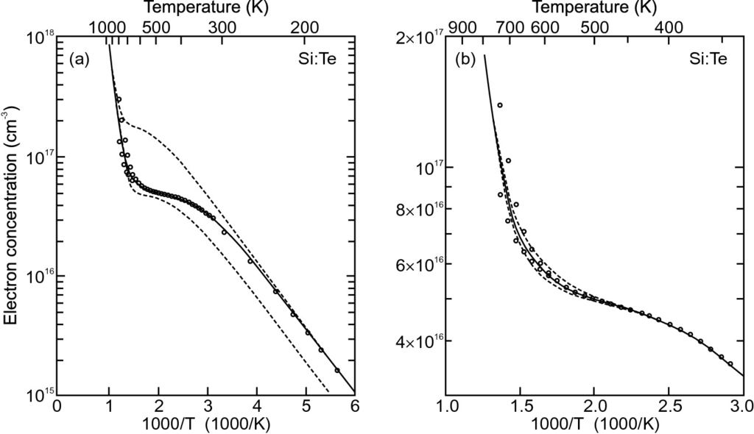

Fig. 7.31

Temperature dependent electron concentration (from Hall data) for Si:Te. **a** Experimental data and fit with double donor model using

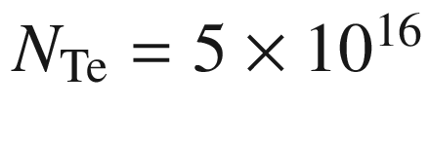

 cm



,

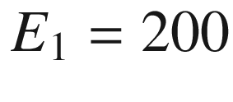

 meV and

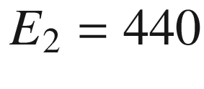

 meV (*solid line*). Single donor models would fail (

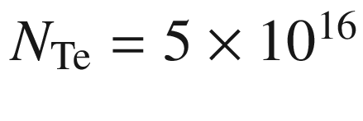

 cm



and

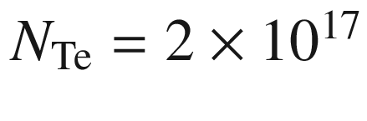

 cm

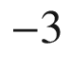

, *dashed lines*). **b** Second ionization step in more detail with fits using different values for

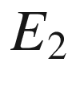

; the *solid line* is for

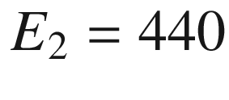

 meV, the other *dashed lines* for

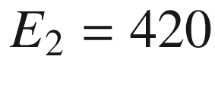

and 460 meV.

Adapted from [657]

#### 7.7.3 Double Acceptors

In analogy to double donor defects, double acceptors can introduce up to two holes into the valence band. A typical example is Zn in silicon [658], exhibiting its ‘normal’ acceptor level (Zn



/Zn

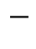

) at

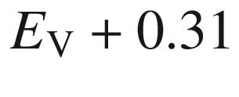

 eV. In moderately n-doped silicon another level (Zn

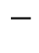

/Zn

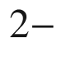

) is observed at

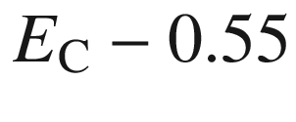

 eV, when the n-doping is sufficient to partially compensate the Zn and supply one electron for each Zn atom but not two (

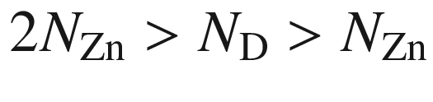

). A similar situation has been observed for Zn in germanium, exhibiting the levels

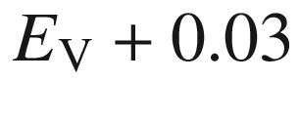

 eV and

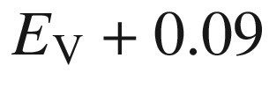

 eV [659]. In Fig. [7.32](#u116076_4_En_7_Chapter-Fig32) three different Ge:Zn samples are compared. If the additional Sb donor concentration (

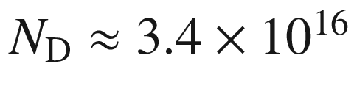

 cm



) is larger than 2

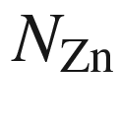

(

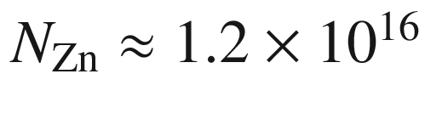

 cm

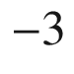

), the sample is n-type (upper curve). The slope is similar to the Ge:Sb donor binding energy (Table [7.2](The_Physics_of_Semiconductors00003.docx#u116076_4_En_7_Chapter-Tab2)). If compensation with donors is weak (

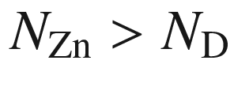

, middle curve) first the shallow donor level with 0.03 eV activation energy is activated and subsequently the deeper one with 0.09 eV activation energy, creating p-conduction with a saturated hole density of

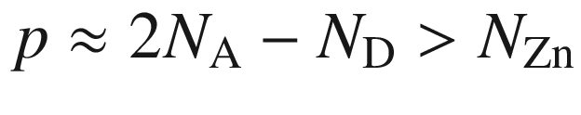

(negative Hall coefficient). The two individual activation processes are sketched as dashed lines in Fig. [7.32](#u116076_4_En_7_Chapter-Fig32). If the Sb concentration is larger than

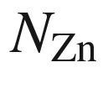

but smaller than

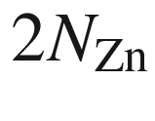

, the shallow acceptor level is filled with electrons, leaving still the only partially filled deeper acceptor level available for ionization (lower curve). In this case the sample is still p-type, but the saturation hole density is

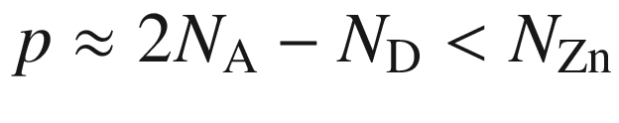

. The degeneracy factors for Zn in Si and Ge have been discussed in [601].

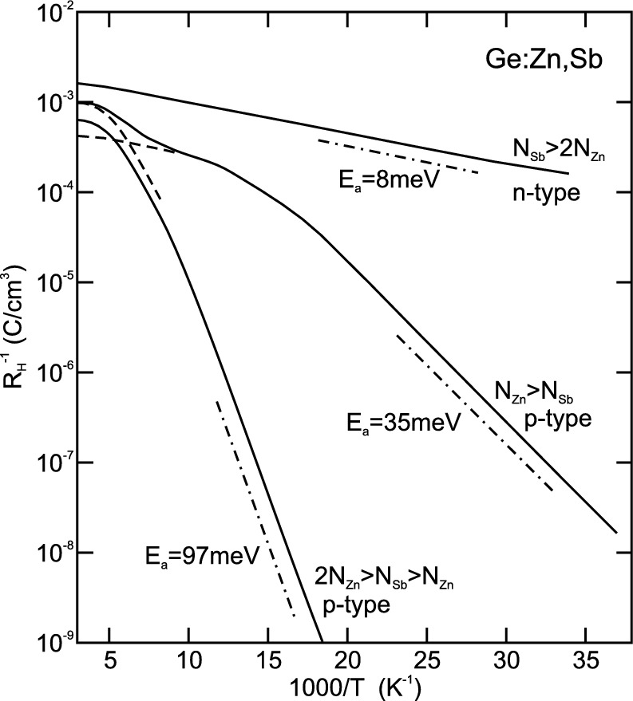

Fig. 7.32

Inverse (absolute) Hall coefficient (cmp. Sect. [15.​2.​1](The_Physics_of_Semiconductors00006.docx#u116076_4_En_15_Chapter))

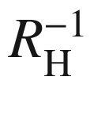

, i.e. charge concentration, for three Ge:Zn samples with different degree of compensation with Sb donors as labeled. The *dash-dotted lines* indicate typical slopes. The *dashed lines* sketch the

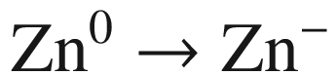

and the

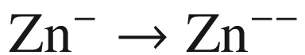

processes.

Adapted from [659]

#### 7.7.4 Jahn–Teller Effect

The lattice relaxation can reduce the symmetry of the defect. Many defects, such as a vacancy, a tetrahedral interstitial or an impurity, occupy initially tetrahedral sites in the zincblende structure. The lattice relaxation reduces the symmetry, e.g. to tetragonal or trigonal, and therefore causes initially degenerate levels to split. Such splitting is called the static Jahn–Teller effect [639, 660]. The energy change in terms of the atomic displacement *Q* can be denoted (using perturbation theory for the simplest, nondegenerate case) as

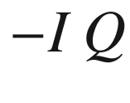

(

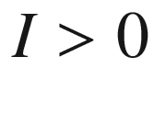

). Including the elastic contribution with a force constant *C*, the energy of a configuration *Q* is

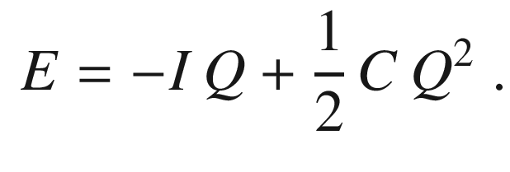

(7.66)

The stable configuration

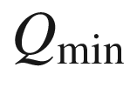

, for which the energy is minimal (

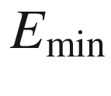

), is therefore given by

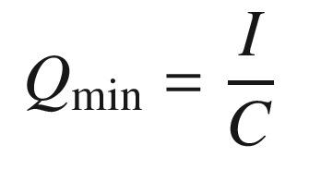

(7.67a)

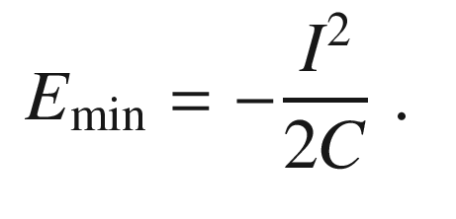

(7.67b)

Several equivalent lattice relaxations may exist, e.g. a 3-fold minimum for remaining

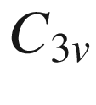

symmetry. The energy barrier between them has a finite height. Therefore, e.g. at sufficient temperature, the defect can switch between different configurations and eventually again becomes isotropic (dynamic Jahn–Teller effect). The experimental observation depends on the relation between the characteristic time of the experiment and the reorientation time constant of the defect.

#### 7.7.5 Negative-U Center

We explain the principle of a so-called negative-*U* center [661] for the Si vacancy [662] (cf. Fig. [4.​2](The_Physics_of_Semiconductors00002.docx#u116076_4_En_4_Chapter-Fig2)). It was first proposed by Anderson to explain the properties of amorphous chalcogenide glasses [663]. Many defects in semiconductors exhibit negative-*U* behavior, e.g. also the boron interstitial in Si [662, 664]. Coulomb energy and the Jahn–Teller effect compete for the position of the occupancy level for different charge states. *U* refers to the additional energy upon charging of the defect with an additional electron. The Coulomb repulsion of electrons leads to an *increase* of the energy, i.e. positive *U*, which has been calculated to be 0.25 eV for the Si vacancy [665] for all charge states. The occupation level (cf. Sect. [4.​2.​2](The_Physics_of_Semiconductors00002.docx#u116076_4_En_4_Chapter))

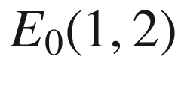

(the index 0 indicates effects only due to many-electron Coulomb interaction), separating the domination of

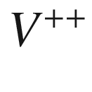

and

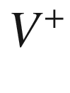

(Fig. [7.33](#u116076_4_En_7_Chapter-Fig33)) is 0.32 eV above the valance-band edge. Therefore, the occupation level

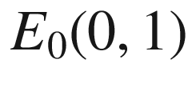

is expected to lie at about 0.57 eV about

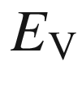

.

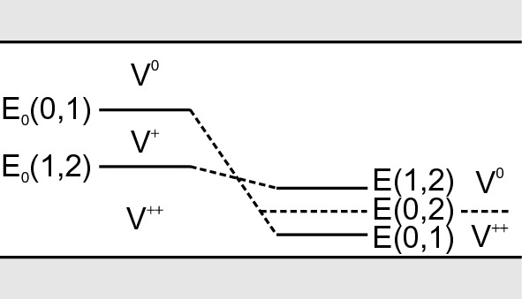

Fig. 7.33

Charge states of the vacancy in silicon. *Left*: level scheme without lattice relaxation, *right*: level scheme including the Jahn–Teller effect. For a Fermi level below (above) *E*(0, 2) the charge state



(

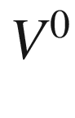

) is dominant

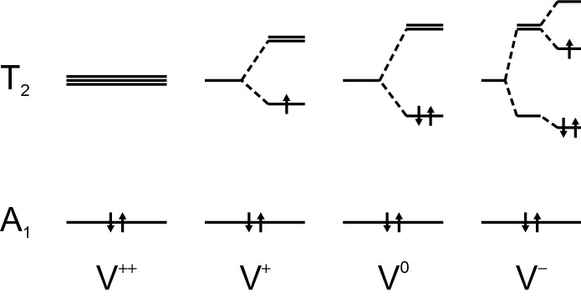

Fig. 7.34

Jahn–Teller splitting for different charge states of the vacancy.

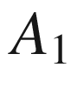

and

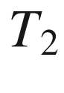

refer to irreducible representations of the

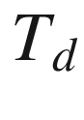

point symmetry group.



is nondegenerate and therefore does not exhibit a Jahn–Teller effect.

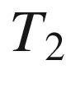

is triply degenerate. The arrows represent electrons and their spin orientation

The Jahn–Teller effect may lead to a splitting of the otherwise 4-fold degenerate states of the vacancy. A detailed experimental study using hyperfine interactions can be found in [666]. The schematic level diagram for the Jahn–Teller splitting is shown in Fig. [7.34](#u116076_4_En_7_Chapter-Fig34). The

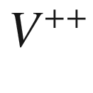

state (



is always populated with two electrons) is resonant with the valence band. The

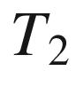

state lies in the band gap. When the Jahn–Teller effect (now on the



state) is included, the energies of the different charge states depend on the configuration coordinate (a mostly tetragonal distortion in the case of the Si vacancy).

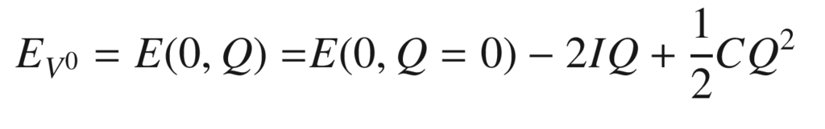

(7.68a)

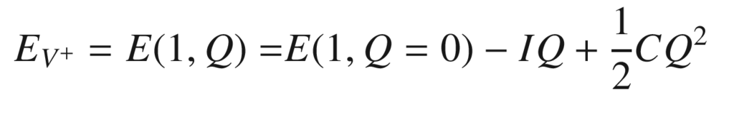

(7.68b)

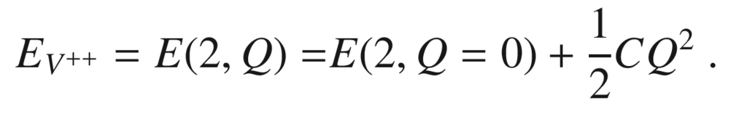

(7.68c)

For the

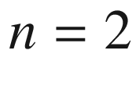

state the



gap state is empty and thus no degeneracy and Jahn–Teller term arises. For

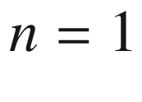

there is a linear Jahn–Teller term. The occupation with two electrons (

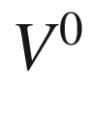

) causes an approximately twice as large Jahn–Teller splitting for the

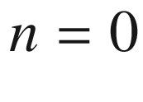

state. The force constant is assumed to be independent of the charge state. The energies for the minimum configurations

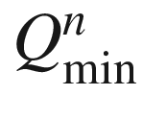

are therefore

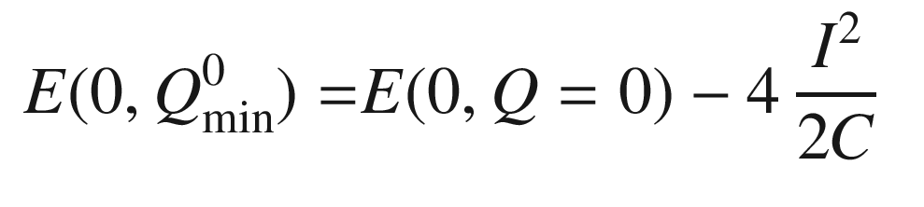

(7.69a)

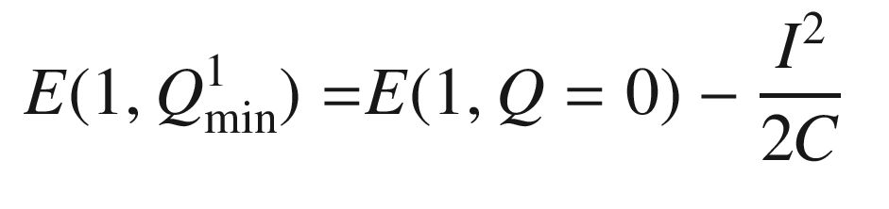

(7.69b)

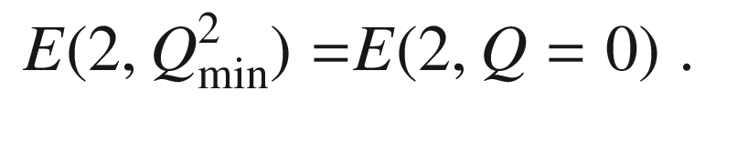

(7.69c)

The Jahn–Teller energy

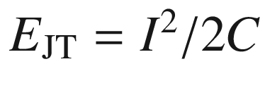

lowers the position of the occupancy levels

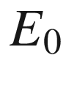

calculated with Coulomb terms only. The occupancy levels *including* the Jahn–Teller contribution are therefore given as

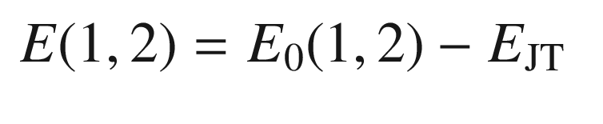

(7.70a)

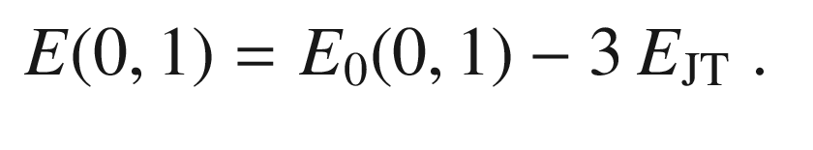

(7.70b)

For the vacancy in silicon the Jahn–Teller energy

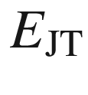

is about 0.19 eV. Thus the *E*(1, 2) level is lowered from 0.32 eV to 0.13 eV. The E(0,1) occupancy level, however, is reduced from 0.57 eV to 0.05 eV [662, 667] (see Fig. [7.33](#u116076_4_En_7_Chapter-Fig33)). The occupancy level *E*(0, 2) is in the middle between *E*(0, 1) and *E*(1, 2) (

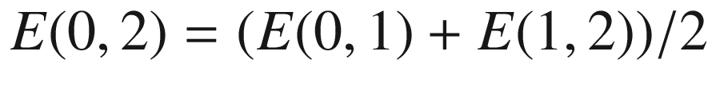

) and indicated in Fig. [7.35](#u116076_4_En_7_Chapter-Fig35)a. At this energy,

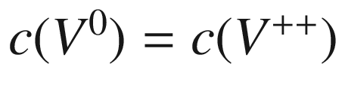

and the value of

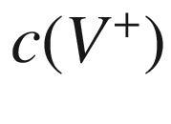

is small (

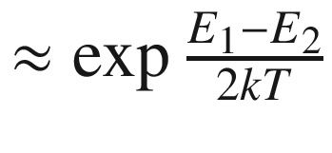

) since

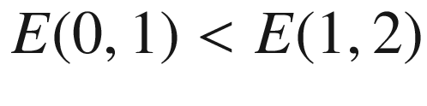

(cmp. ([7.65](#u116076_4_En_7_Chapter-Equ73))).

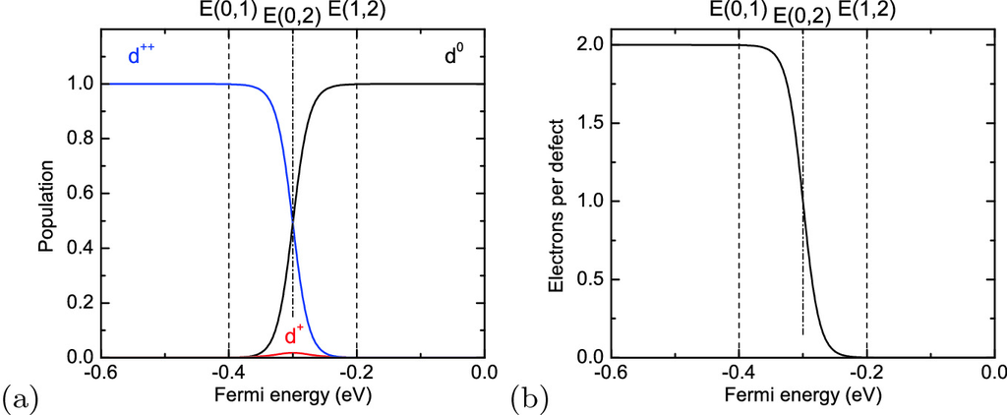

Fig. 7.35

**a** Population of states of a negative-*U* defect (neutral: *black*, single ionized: *red*, double ionized: *blue*) according to ([7.64a](#u116076_4_En_7_Chapter-Equ70)–c) as a function of the Fermi level. The ionization energies have been chosen as

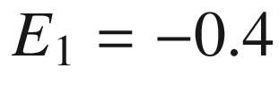

 eV and

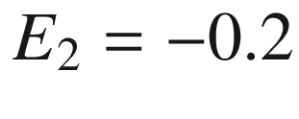

 eV (cmp. Fig. [7.30](#u116076_4_En_7_Chapter-Fig30)) and are indicated by *dashed lines* (

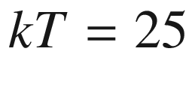

 meV). The occupancy level *E*(0, 2) is indicated with a *dash-dotted line*. The conduction band edge is taken as zero energy. **b** depicts the according number of electrons ionized from the defect

The relative concentrations of the three charge states are determined by ([7.63](#u116076_4_En_7_Chapter-Equ69)) (degeneracy and entropy terms have been neglected)

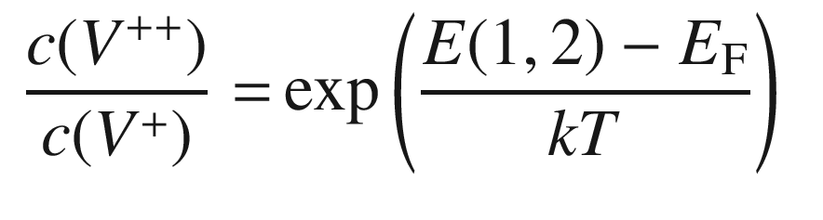

(7.71a)

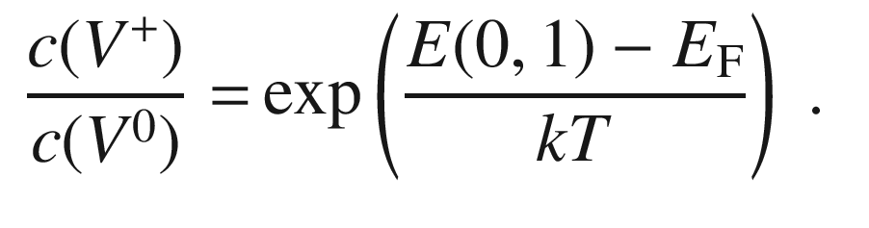

(7.71b)

They are depicted in Fig. [7.35](#u116076_4_En_7_Chapter-Fig35)a in a plot related to Fig. [7.30](#u116076_4_En_7_Chapter-Fig30)a. Therefore,



dominates if

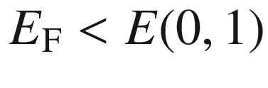

and



dominates for

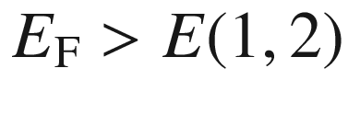

. In the intermediate range

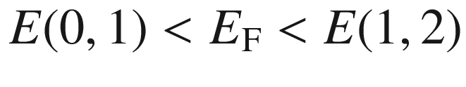

we know from ([7.71a](#u116076_4_En_7_Chapter-Equ85), [b](#u116076_4_En_7_Chapter-Equ86)) that

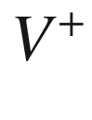

is dominated by

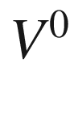

and

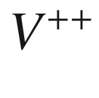

. However, at this point it is not clear whether

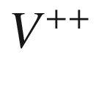

or

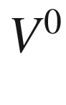

dominates overall. The ratio of the concentrations of



and



is given by

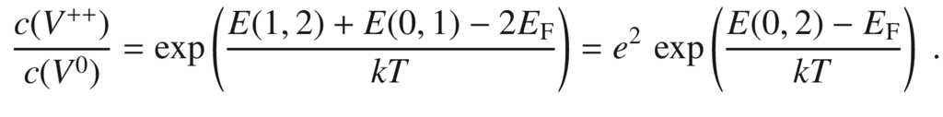

(7.72)

The occupancy level *E*(0, 2) is thus again given as

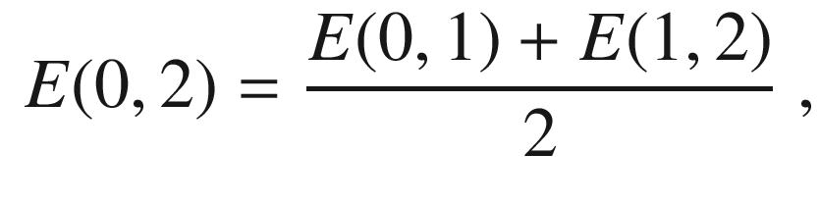

(7.73)

and is shown in Fig. [7.33](#u116076_4_En_7_Chapter-Fig33).

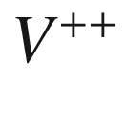

dominates if

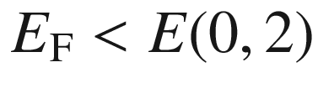

and



dominates for

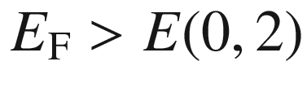

.



is, for no position of the Fermi level, the dominating charge state of the Si vacancy. We note that for n-doped Si the

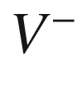

and

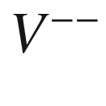

can also be populated. The population of the



state with an extra electron introduces another Jahn–Teller splitting (Fig. [7.34](#u116076_4_En_7_Chapter-Fig34)) that has trigonal symmetry.

Generally, the Jahn–Teller effect can make the addition of an electron cause an effectively negative charging energy; in this case the center is termed a negative-*U* center. We note that the single vacancy in germanium is not a negative-*U* center due to smaller Jahn–Teller distortion and smaller electron-lattice coupling [668].

#### 7.7.6 DX Center

The DX center is a deep level that was first investigated for n-doped (e.g. Si-doped) Al

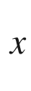

Ga

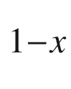

As. It dominates the transport properties of the alloy for

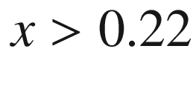

. For smaller Al concentrations and GaAs the DX level lies in the conduction band. DX-type deep levels have also been found for other alloys and dopants, e.g. GaAsP:S.

It is experimentally found that the capture process of electrons into the DX center is thermally activated. The capture energy

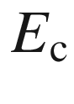

depends on the AlAs mole fraction (Fig. [7.36](#u116076_4_En_7_Chapter-Fig36)). The (average) barrier for electron capture has a minimum of 0.21 eV for

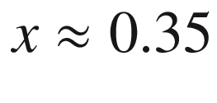

, near the crossover point between direct and indirect band gap (cf. Fig. [6.​24](The_Physics_of_Semiconductors00003.docx#u116076_4_En_6_Chapter-Fig24)). For lower Al concentrations, the capture barrier increases to 0.4 eV for

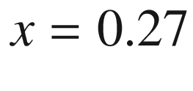

; for

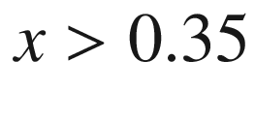

the capture barrier increases to about 0.3 eV for *x* around 0.7 [669]. The barrier for thermally releasing carriers from the DX center has been determined to be about 0.43 eV, independent of the Al mole fraction [669].

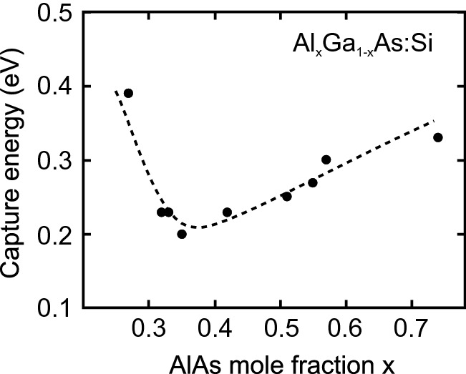

Fig. 7.36

Energy barrier for electron capture

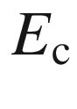

at the Si-DX center in Al

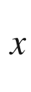

Ga

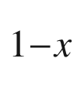

As for various compositions.

Experimental data from [669]

Carriers can be removed from the DX center by optical absorption of photons with energy larger than about 1.2 eV. If carriers are removed by optical excitation at low temperatures the (re-)capture is so slow (

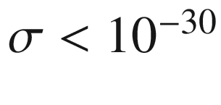

 cm

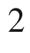

) that the carriers remain in the conduction band and cause persistent photoconductivity (PPC). The PPC is only reduced upon increasing the sample temperature. The concentration of the DX center is about the same as the net doping concentration.

The properties of the DX center are reviewed in [670, 671]. So far, no definite microscopic model of the DX center has been agreed on. Lang [672] proposed that the DX center involves a donor and an unknown defect (probably a vacancy). It probably involves large lattice relaxation as in the configuration coordinates model of Fig. [7.37](#u116076_4_En_7_Chapter-Fig37) where the donor binding energy

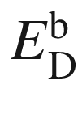

with respect to the conduction-band minimum, the barrier for electron capture

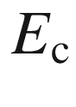

, the barrier for electron emission

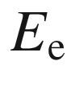

and the optical ionization energy

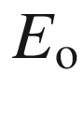

are labeled. The donor binding energy is measured with Hall effect (cf. Sect. [15.​2.​1](The_Physics_of_Semiconductors00006.docx#u116076_4_En_15_Chapter)) at temperatures sufficient to overcome the capture and emission barriers, the emission barrier is measured with deep level transient spectroscopy (DLTS). The capture barrier manifests itself in PPC experiments. We note that the DX center is related to the L-conduction band. For small Al mole fraction, the DX level is degenerate with the

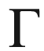

-related conduction band (see Fig. [7.37](#u116076_4_En_7_Chapter-Fig37)b).

Theoretical models and experimental evidence hint at a vacancy-interstitial model for the Si-DX center [673]. The donor (Si) is displaced along the

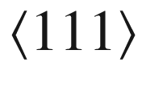

direction from the Ga substitution site. The displacement is predicted to be 0.117 nm and the distorted geometry can be viewed as a Ga vacancy and a Si interstitial. The charge state of the (filled) DX center is proposed to be a two-electron negative-*U* state.

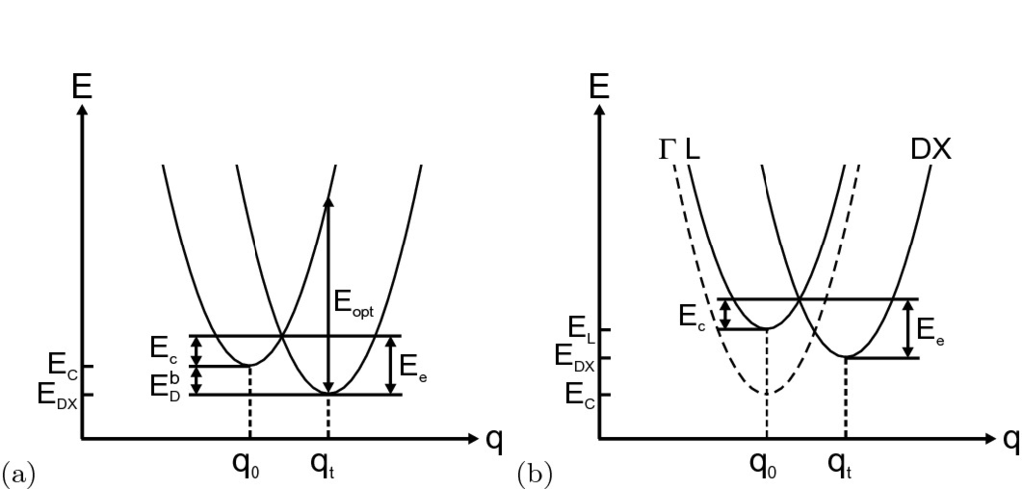

Fig. 7.37

**a** Schematic configuration coordinate diagram for the DX level with large lattice relaxation.

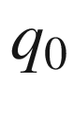

is the configuration of the empty defect,

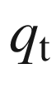

is the configuration of the filled defect. The donor binding energy

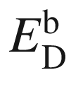

, the barrier for electron capture

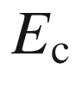

, the barrier for electron emission

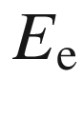

and the optical ionization energy

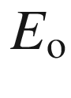

are labeled.

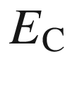

denotes the conduction-band edge. We note that in (Al,Ga)As the DX level is associated with the L conduction band (see Fig. [6.​24](The_Physics_of_Semiconductors00003.docx#u116076_4_En_6_Chapter-Fig24)). **b** Schematic configuration coordinate diagram for the DX level in Al

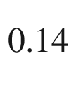

Ga

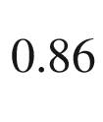

As with the DX level being degenerate with the (

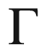

-related) conduction band

#### 7.7.7 EL2 Defect

The EL2 defect is a deep donor in GaAs. It is not related to impurities but occurs for intrinsic material, in particular grown under As-rich conditions. It has physical properties similar to the DX center. The bleaching of absorption due to EL2, i.e. the optical removal of electrons from the defect at low temperatures, is shown in Fig. [7.38](#u116076_4_En_7_Chapter-Fig38). The microscopic model [674] describes the EL2 defect as an arsenic antisite defect, i.e. an arsenic atom on a Ga site, As



. In the charged state the arsenic atom is displaced from the lattice position and a complex of a Ga vacancy (symmetry

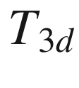

) and an interstitial As (symmetry

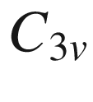

) with 0.14 nm displacement along

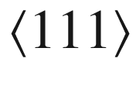

forms (V



-As



). The charged state is filled with two electrons.

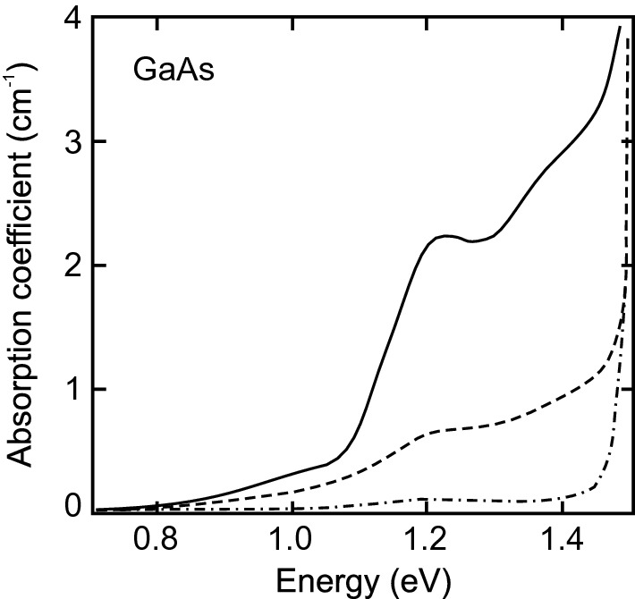

Fig. 7.38

Absorption spectrum of GaAs at low temperatures (

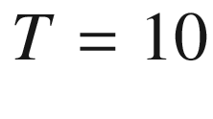

 K) when cooled in the dark (*solid line*). The *dashed* (*dash-dotted*) *line* is the absorption after illuminating the sample for 1 min (10 min) with white light, leading to quenching of the EL2-related absorption.

Adapted from [675]

#### 7.7.8 Semi-insulating Semiconductors

Semiconductors with high resistivity (

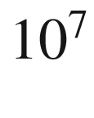

–

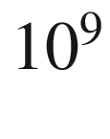

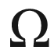

 cm) are called semi-insulating (‘s.i.’ or ‘si’). Semi-insulating substrates are needed for high-speed devices. The high resistivity should stem from a small free-carrier density at finite temperature and not from a small mobility due to poor crystal quality. For sufficiently wide band gap, the intrinsic carrier concentration is small and such pure material is semi-insulating, e.g. GaAs with

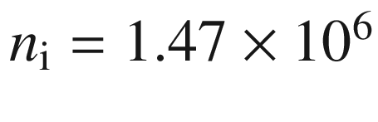

 cm



and

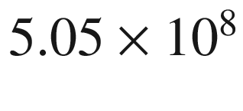

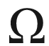

 cm [676]. Since shallow impurities are hard to avoid, another route is used technologically. Impurities that form deep levels are incorporated in the semiconductor in order to compensate free carriers. For example, a deep acceptor compensates all electrons if

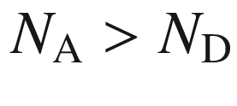

. Since the acceptor is deep (

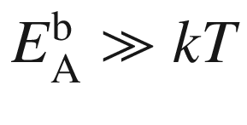

), it does not release holes for reasonable temperatures. Examples of suitable impurities for compensation of electrons are Si:Au [677], GaAs:Cr [678] and InP:Fe [679]. A deep donor, e.g. InP:Cr [680], is necessary to compensate p-type conductivity.

Figure [7.39](#u116076_4_En_7_Chapter-Fig39)a shows the terms of Fe in InP [681, 682]. An overview of transition metals in III–V semiconductors can be found in [683]. The electron configuration of neutral Fe atoms is 3d

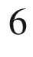

4s

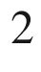

(cf. Table [17.​2](The_Physics_of_Semiconductors00006.docx#u116076_4_En_17_Chapter-Tab2)). The Fe is incorporated on the In site and thus has a Fe

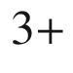

state as a neutral acceptor (A

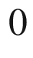

). The Fe

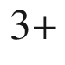

state has the electron configuration 3d

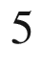

. The arrow in Fig. [7.39](#u116076_4_En_7_Chapter-Fig39)a represents the capture of an electron from the conduction band or from a shallow donor. The charge state of the Fe becomes Fe

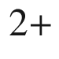

(charged acceptor, A

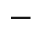

) with the electron configuration 3d

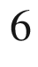

. The cubic crystal field (

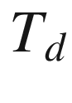

symmetry) splits this

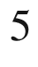

D Fe state[8](#u116076_4_En_7_Chapter-Fn8) into two terms [684] that exhibit further fine structure [682]. The large thermal activation energy of 0.64 eV found in the Hall effect on semi-insulating InP:Fe [679] corresponds to the energy separation of the

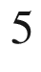

E level and the conduction band.

The maximum electron concentration that can be compensated in this way is limited by the solubility of Fe in InP [685], about

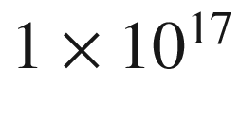

 cm

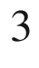

. Higher Fe incorporation leads to the formation of Fe (or FeP) precipitates and degrades the crystal quality. Only a fraction of the incorporated Fe may then be electrically active and contribute to the compensation. The maximum electrically active Fe concentration is found to be 5–6

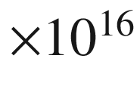

 cm

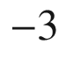

[686]. The compensation can be directly visualized via the depth profile of the electron concentration in a n-si-n structure (Fig. [7.39](#u116076_4_En_7_Chapter-Fig39)b). The poor thermal stability of Fe, i.e. high diffusion coefficient, has evoked proposals for more stable dopants such as InP:Ru [687].

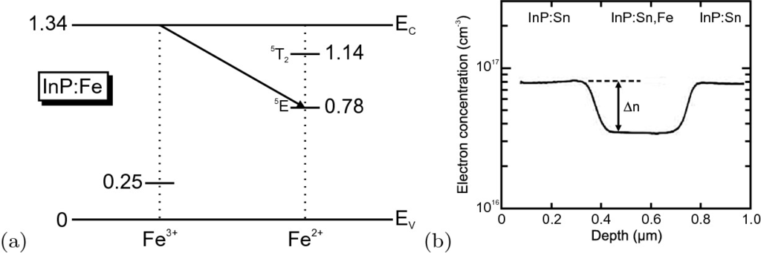

Fig. 7.39

**a** Schematic band diagram of InP with levels of Fe impurities in the

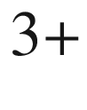

and

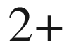

charge states at low temperature. All energies are given in eV. The *arrow* denotes capture of an electron (from the conduction band or a shallow donor) on the deep acceptor. Compare this figure also with Figs. [9.​36](The_Physics_of_Semiconductors00005.docx#u116076_4_En_9_Chapter-Fig36) and [10.​25](The_Physics_of_Semiconductors00005.docx#u116076_4_En_10_Chapter-Fig25). **b** Depth profile of electron concentration in an InP:Sn/InP:Sn,Fe/InP:Sn structure. The change

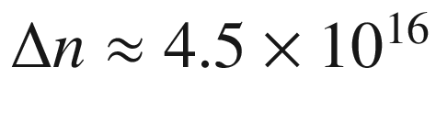

 cm



of electron concentration is due to the compensation by Fe and corresponds to the chemical iron concentration determined by SIMS, [Fe]

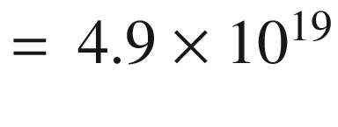

 cm



. Part **b** adapted from [688]

#### 7.7.9 Isoelectronic Impurities

Isoelectronic impurities, generally represent a deep level with a short range potential. The isoelectronic trap introduces a bound state for an electron or a hole. Once a carrier has been captured, the defect becomes charged. The other carrier type is then easily trapped, forming a bound exciton (Sect. [10.​3.​2](The_Physics_of_Semiconductors00005.docx#u116076_4_En_10_Chapter)). The theory of isoelectronic impurities is outlined in [689]. A detailed theoretical treatment of N in GaAs and GaP is given in [544].

In GaP:N, an electron is spatially localized on the N impurity. Most of the wave function is at the X-point. The nitrogen-bound electron level in GaP (A

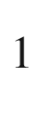

symmetry) is close to the conduction band edge and within the band gap. Important for the energy position is the lattice relaxation, leading to an inward relaxation of the surrounding Ga atoms (Fig. [7.41](#u116076_4_En_7_Chapter-Fig41)). Due to the spatial localization of the wave function it is delocalized in *k*-space (Fig. [7.40](#u116076_4_En_7_Chapter-Fig40)a) and obtains a sizeable component at the

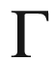

-point, facilitating zero-phonon absorption from the valence band. This effect is present only when the lattice relaxation around the impurity is considered; without relaxation the

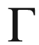

-component is zero, with relaxation about 1% [544]. The



-component of the wave-function is larger for localization at an isoelectronic impurity than at a shallow donor such as sulfur [690]. This way a large oscillator strength for optical transitions occurs (Sects. [9.​7.​9](#u116076_4_En_9_Chapter), [10.​3.​2](The_Physics_of_Semiconductors00005.docx#u116076_4_En_10_Chapter)). The wavefunction of an isolated single N impurity and a neighboring N–N pair (NN

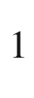

) in GaP are shown in Fig. [7.40](#u116076_4_En_7_Chapter-Fig40)b.

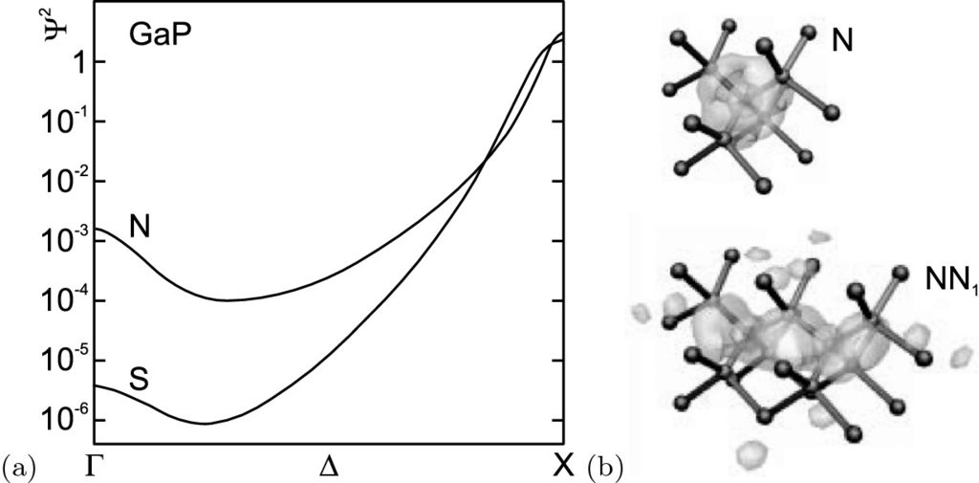

Fig. 7.40

**a** Model calculation of the wave-vector dependence of the probability density of an electron bound to a 10 meV deep isoelectronic trap (N) and to a 100 meV deep shallow donor (S) in GaP. Adapted from [690]. **b** Wavefunction (isosurface at 20% of maximum) of isolated nitrogen (N) and neighboring N–N pair (NN

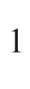

) in GaP.

Adapted from [544]

Isolated nitrogen impurities in (unstrained) GaAs introduce states only within the conduction band (Fig. [7.41](#u116076_4_En_7_Chapter-Fig41)). The reason is that the GaAs conduction band edge is further from the vacuum level than that of GaP (see Fig. [12.​21](The_Physics_of_Semiconductors00005.docx#u116076_4_En_12_Chapter-Fig21)). Only the NN



and NN

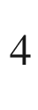

pair levels are theoretically expected to be within the GaAs band gap. The index denotes the *n*th neighbor position. The NN

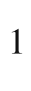

level has been experimentally observed [691, 692]. The isolated nitrogen impurity level is forced into the GaAs band gap upon hydrostatic pressure [692, 693] (Fig. [7.42](#u116076_4_En_7_Chapter-Fig42)). Further levels deeper within the band gap are due to clusters containing more than two nitrogen atoms.

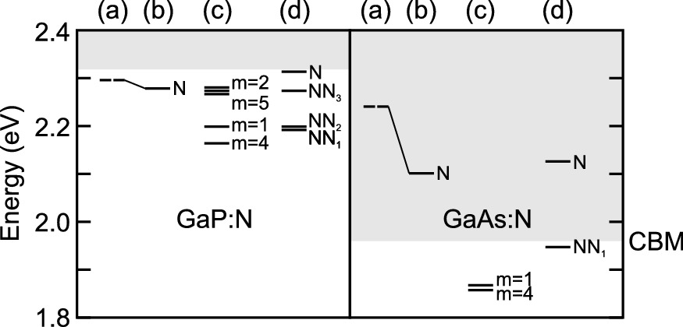

Fig. 7.41

Energy levels of nitrogen impurity states in GaP (*left*) and GaAs (*right*). The energy scale is relative to the bulk GaP valence band maximum, the conduction band minima (CBM) are thus shown relative to the vacuum level. The conduction band is shown in *grey*. For both materials, (a) denotes the isolated N impurity level calculated *without* lattice relaxation (*dashed line*), and (b) *with* lattice relaxation. (c) denotes the position of N–N pair levels, *m* denoting the neighbor. (d) shows selected experimental data. NN



denotes the direct neighbor NN-pair. The other NN

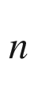

follow the usual nomenclature as in [694]. Data taken from [544]

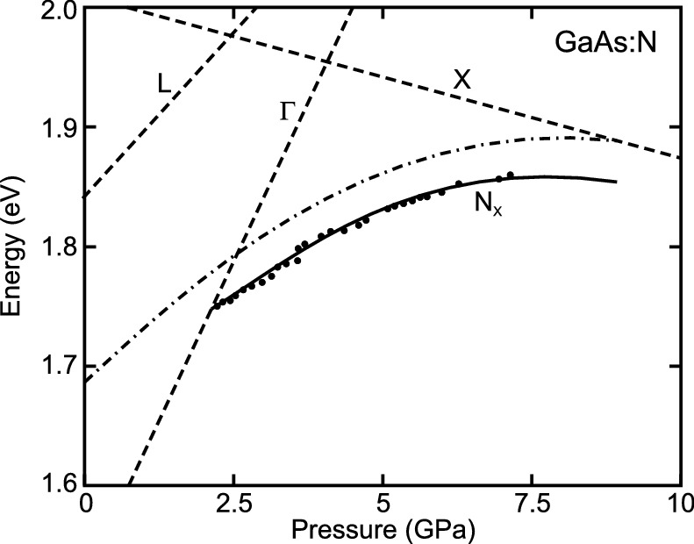

Fig. 7.42

Pressure dependence of the energy of excitons bound to isolated nitrogen impurities in GaAs (*circles*), measured from the top of the GaAs valence band. The *dashed lines* are the pressure dependent GaAs bulk band gaps (cmp. Fig. [6.​49](The_Physics_of_Semiconductors00003.docx#u116076_4_En_6_Chapter-Fig49)). The *solid* (*dash-dotted*) *line* is a theoretical model for the nitrogen-bound exciton (electron) level.

Adapted from [693]

#### 7.7.10 Surface States

The investigation of (semiconductor) surfaces is a large field with sophisticated methods that allow real-space imaging with atomic resolution by scanning probe microscopy and highly depth resolved electronic studies. The surface represents first of all a break in the periodic crystal potential and thus a defect of the bulk crystal. The unsatisfied bonds partly rearrange, e.g. by building dimers, forming a surface reconstruction or remain as dangling bonds. The surface exhibits a surface density of states. Such states can lie in the band gap and capture electrons, leading to recombination and a depletion layer. For a brief introduction on semiconductor surface physics see Chap. [11](The_Physics_of_Semiconductors00005.docx#u116076_4_En_11_Chapter); for more details we refer to [695].

As an example of the formation of electronic states at surface defects we show in Fig. [7.43](#u116076_4_En_7_Chapter-Fig43) the comparison of topography and work function (measured by Kelvin probe force microscopy [696]) at a surface step on a GaP(110) surface that has been prepared by cleaving in-situ in ultrahigh vacuum (UHV). The depletion-type band bending of the surface is about 0.4 eV. The further increase of the position of the vacuum level at the step edge shows the presence of trap states in the band gap causing the conduction band to bend upwards (cf. Sect. [21.​2.​1](The_Physics_of_Semiconductors00007.docx#u116076_4_En_21_Chapter)). Modeling of the effect shows that the charge density at the surface is

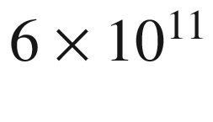

 cm

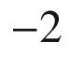

and at the step edge

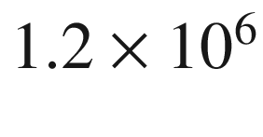

 cm

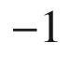

.

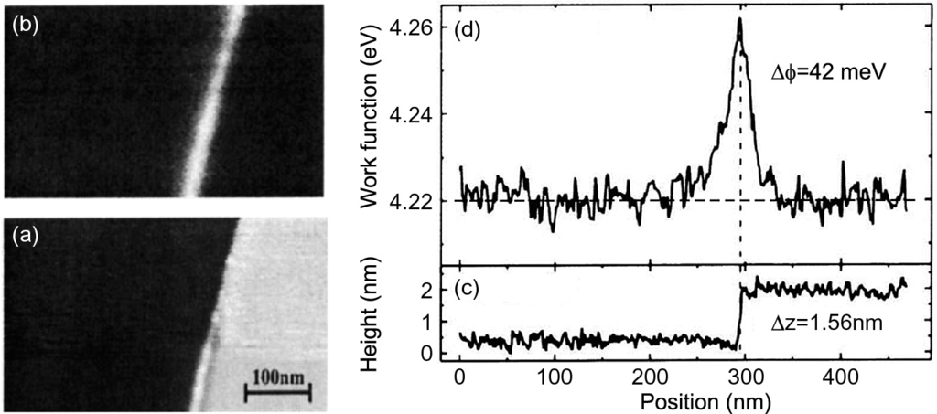

Fig. 7.43

Image of **a** topography (

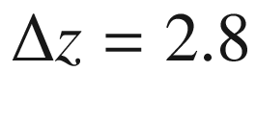

 nm) and **b** work function (

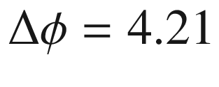

–4.26 eV) of a surface step along [111] on a n-GaP(110) surface cleaved in UHV. Adapted from [696]. **c** and **d** show the corresponding linescans.

Adapted from [696]

### 7.8 The Charge Neutrality Level

The charge neutrality level (CNL) of a semiconductor is defined as the maximum occupied surface state energy at a neutral surface. In this case it is identical with the Fermi level (which renders the surface without a net charge). The CNL is also termed Fermi level stabilization energy [700] or ‘branch point energy’ [697] and marks the energy at which the character of intrinsic defects changes from predominantly donor-like (below CNL) to predominantly acceptor-like (above CNL). If Fermi level in the bulk and CNL deviate, surface charges appear; when the Fermi level is above (below) the charge neutrality level, the surface is negatively (positively) charged. Whether this means a depletion or accumulation layer depends on the conductivity type of the semiconductor. Band bending and space charge regions are discussed in more detail further below (Sect. [12.​3.​4](The_Physics_of_Semiconductors00005.docx#u116076_4_En_12_Chapter), Sect. [21.​2.​1](The_Physics_of_Semiconductors00007.docx#u116076_4_En_21_Chapter)). The position of the CNL can be calculated from the Brillouin zone average of the conduction-to-valence band difference [698, 699].

Experimentally, the Fermi level will be established at the CNL when a lot of deep defects are introduced, e.g. by irradiation. For many semiconductors, the CNL is close to the middle of the band gap (Si, GaAs). Notable exceptions are e.g. InAs or In

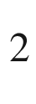

O

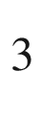

with a CNL within the conduction band leading to n-type surface conduction.

### 7.9 Hydrogen in Semiconductors

The role of hydrogen in semiconductors was first recognized in studies of ZnO [701]. It is now clear that hydrogen plays an important role in the passivation of defects. As a ‘small’ atom, it can attach easily to dangling bonds and form an electron-pair bond. Thus, surfaces, grain boundaries, dislocations and shallow (donor and acceptor) and deep impurity levels become passivated. A good overview and many details of the physics and technological use of hydrogen in semiconductors can be found in [702, 703]. The hydrogen must be typically introduced as atomic species into semiconductors, e.g. from a plasma in the vicinity of the surface or by ion irradiation.

With regard to silicon it is important to note that the Si–H bond is stronger than the Si–Si bond. Thus a silicon surface under atomic hydrogen exhibits Si–H termination rather than Si–Si dimers [704]. Due to the stronger bond, the hydrogenation leads to an increase of the silicon band gap, which can be used for surface passivation [705], leading to reduced reverse diode current.

The hydrogen concentration in amorphous Si (a-Si) can be as high as 50% [706]. Electronic grade a-Si contains typically 10–30 atomic% hydrogen and is thus rather a silicon–hydrogen alloy.

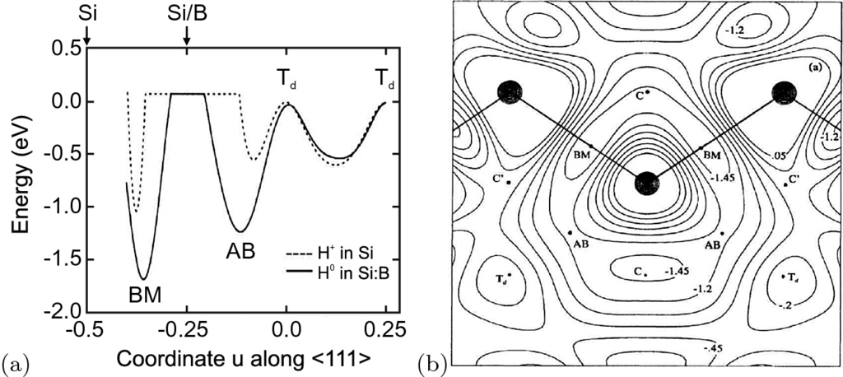

Fig. 7.44

**a** Energy for positions *u* of the hydrogen atom along the

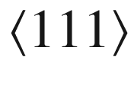

direction for H



in pure Si (Si atom at

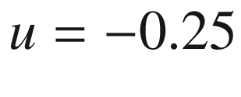

) and neutral hydrogen (B atom at



). *u* is measured in units of

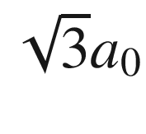

. For all positions of the hydrogen atom the positions of the other atoms have been relaxed in the calculation. Data from [707]. **b** Adiabatic potential energy in the (110) plane for hydrogen in Si:B. ‘BM’ denotes the bond minimum site (high valence electron density), C and C’ are equivalent for pure Si. Reprinted with permission from [707], ©1989 APS

Hydrogen in crystalline silicon occupies the bond-center interstitial position (see Fig. [3.​18](The_Physics_of_Semiconductors00002.docx#u116076_4_En_3_Chapter-Fig18)b) as shown in Fig. [7.44](#u116076_4_En_7_Chapter-Fig44)a. The complexes formed by hydrogen with shallow acceptors and donors have been studied in detail. It is now generally accepted that for acceptors (e.g. boron) in silicon the hydrogen is located close to the bond-center position of the Si–B pair (BM, bond minimum) as sketched in Fig. [7.45](#u116076_4_En_7_Chapter-Fig45)a. The boron atom forms an electron-pair bond with three silicon atoms of the tetrahedra, the fourth silicon bonds to the hydrogen atom. The complex therefore no longer acts as an acceptor. The silicon atoms and the acceptor relax their positions. The adiabatic potential energy surface of hydrogen in Si:B is shown in Fig. [7.44](#u116076_4_En_7_Chapter-Fig44)b. The hydrogen can sit on four equivalent sites (BM) along the



directions of the initial B–Si

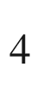

tetrahedron. This reduces the symmetry, e.g. of H–B vibrations [708]. The energetic barrier for the hydrogen orientation has been determined to be 0.2 eV theoretically [707] for a hydrogen motion along the path BM–C–BM in Fig. [7.44](#u116076_4_En_7_Chapter-Fig44)b. Stress (along [100] and [112]) reduces the symmetry and leads to splitting of the local vibrational modes, now showing axial symmetry [709]. However, this preferential orientation disappears with an activation energy of 0.19 eV, close to the theoretical value.

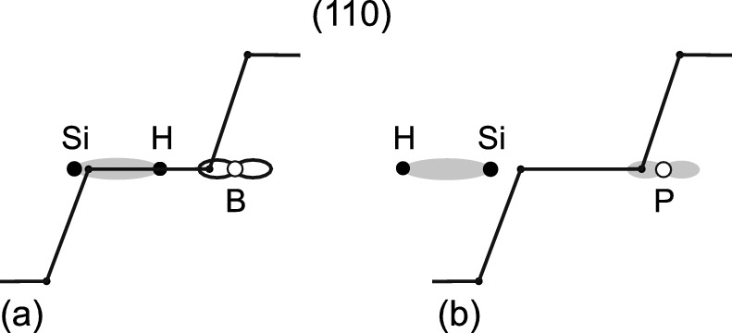

Fig. 7.45

Schematic model for hydrogen in silicon forming a complex with **a** a shallow acceptor (boron, empty orbital) and **b** a shallow donor (phosphorus, double-filled orbital)

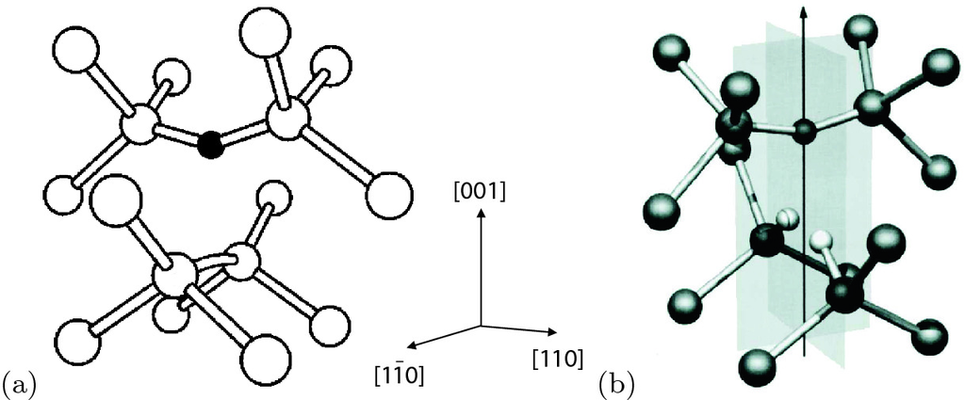

Fig. 7.46

**a** Structure of the V–O complex (A center) in silicon. The *black sphere* represents the oxygen atom. Reprinted with permission from [710], ©2004 APS. **b** Calculated ground-state structure for the V–O–H



center in silicon. Oxygen is over the

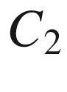

axis, and the two *white* spheres represent hydrogen. Reprinted with permission from [711], ©2000 APS

Hydrogen has experimentally been found to also passivate shallow donors. The microscopic configuration is sketched in Fig. [7.45](#u116076_4_En_7_Chapter-Fig45)b. The hydrogen atom sits on the Si–AB (antibonding) position and forms an electron-pair bond with the silicon atom. The donor, e.g. phosphorus, is left with a double-filled p-orbital (lone pair) whose level is in the valence band and thus no longer contributes to conductivity. Molecular hydrogen can passivate the so-called A center in Si, an oxygen–vacancy complex [711]. The atomistic configuration of the V–O–H



complex is shown in Fig. [7.46](#u116076_4_En_7_Chapter-Fig46). The deep double donor S in Si with a level at 0.3 eV below the conduction-band edge can also be passivated by two hydrogen atoms [712].

Footnotes

[1](The_Physics_of_Semiconductors00003.docx#u116076_4_En_7_Chapter-Fn1_source)

Equation ([7.5](The_Physics_of_Semiconductors00003.docx#u116076_4_En_7_Chapter-Equ5)) is restricted to

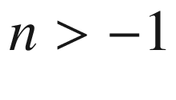

. A form without restriction is

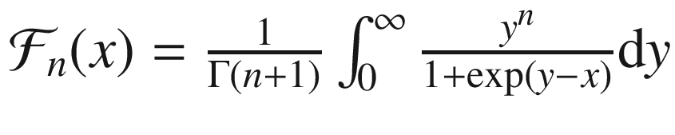

. The factor

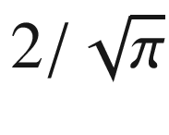

is often omitted but must be then added explicitly in, e.g., ([7.6](The_Physics_of_Semiconductors00003.docx#u116076_4_En_7_Chapter-Equ6)).

[2](The_Physics_of_Semiconductors00003.docx#u116076_4_En_7_Chapter-Fn2_source)

We do not agree with the treatment of the conduction band valley degeneracy in [585] for the donor degeneracy factor for Ge and Si.

[3](The_Physics_of_Semiconductors00003.docx#u116076_4_En_7_Chapter-Fn3_source)

As usual, the Fermi level is determined by the global charge neutrality, see also Sect. [4.​2.​2](The_Physics_of_Semiconductors00002.docx#u116076_4_En_4_Chapter).

[4](The_Physics_of_Semiconductors00003.docx#u116076_4_En_7_Chapter-Fn4_source)

It is given in the third edition of this book.

[5](#u116076_4_En_7_Chapter-Fn5_source)

W. Shockley had asked E. Fermi for permission to use his name reversed. Fermi was not too enthusiastic but granted permission.

[6](#u116076_4_En_7_Chapter-Fn6_source)

The chemical potential in a one-component system is

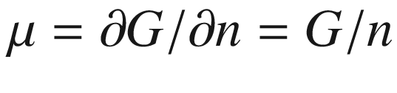

. In a multicomponent system it is, for the *i*th component,

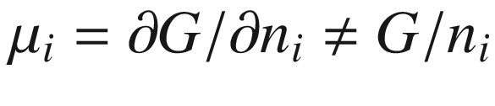

.

[7](#u116076_4_En_7_Chapter-Fn7_source)

The electron configuration is 3d

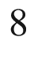

with two paramagnetic electrons. Under uniaxial stress along [100] the EPR line splits into a doublet [647]. Further details can be found in [648].

[8](#u116076_4_En_7_Chapter-Fn8_source)

The notation is

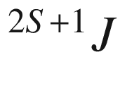

(multiplicity), with *S* being the total spin and *J* being the total angular momentum.

© Springer Nature Switzerland AG 2021

M. Grundmann

The Physics of Semiconductors

Graduate Texts in Physics

<https://doi.org/10.1007/978-3-030-51569-0_8>

## 8. Transport

Marius Grundmann[1](#u116076_4_En_8_Chapter-Aff11)

(1)

Felix Bloch Institute for Solid State Physics, Universität Leipzig, Leipzig, Germany

Marius Grundmann

Email:

[grundmann@physik.uni-leipzig.de](mailto:grundmann@physik.uni-leipzig.de)

*Um über den Temperaturverlauf des Widerstandes Rechenschaft geben zu können, müssen andere Abweichungen von der strengen Periodizität entscheidend sein, nämlich diejenigen, welche von den thermischen Eigenschwingungen des Kristalls herrühren.*

*In order to be able to account for the temperature dependence of the resistivity, other deviations from the strict periodicity must be decisive, namely those which result from the thermal vibrations of the crystal.*

*F. Bloch, 1928* [61]

## Abstract

The physics of transport in semiconductors is treated foremost for charge transport. Band transport and scattering, mobility, low field and high field effects as well as polarons and hopping transport are covered. A short section mentions ionic transport before heat conduction and coupled heat and charge transport including thermopower and Peltier effect are discussed.

### 8.1 Introduction

Charge and heat energy can be transported through the semiconductor in the presence of appropriate (generalized) forces. Such a force can be an electric field or a temperature gradient. Both transport phenomena are coupled since electrons transport energy and charge simultaneously through the crystal. First, we will treat the charge transport as a consequence of a gradient in the Fermi level, then the heat transport upon a temperature gradient and finally the coupled system, i.e. the Peltier and Seebeck effects. Detailed treatments of carrier transport can be found in [713, 714].

Practically all important semiconductor devices are based on the transport of charge, such as diode, transistor, photodetector, solar cell and laser.

Carriers move in the semiconductor driven by a gradient in the Fermi energy. We distinguish

drift, as a consequence of an electric field

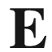

,

diffusion, as a consequence of a concentration gradient

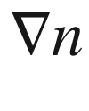

or

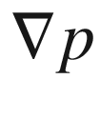

.

In inhomogeneous semiconductors for which the position of the band edges is a function of position, another force occurs. This will not be treated here, since later (cf. Chap. [12](The_Physics_of_Semiconductors00005.docx#u116076_4_En_12_Chapter)) it will be included as an additional, internal electric field.

In Sects. [8.2](#u116076_4_En_8_Chapter-Sec2)–[8.5](#u116076_4_En_8_Chapter-Sec23) we treat band conductivity, i.e. the transport of charge carriers in extended states, the conduction and valence bands characterized by an effective mass. Conductivity is then determined by the carrier concentration (free electrons and holes) and scattering mechanisms (mobility). In disordered semiconductors such as amorphous material, the charge transport due to *hopping* between localized states close to the Fermi level dominates the conductivity which is discussed in Sect. [8.8](#u116076_4_En_8_Chapter-Sec28).

Many semiconductor properties, such as the carrier concentration and the band gap, depend on the temperature. Thus, device properties will also depend on temperature. During operation of a device typically heat is generated, e.g. by Joule heating due to finite resistivity. This heat leads to an increase of the device temperature that subsequently alters the device performance, mostly for the worse. Ultimately, the device can be destroyed. Thus cooling of the device, in particular of the active area of the device, is essential. Mostly the thermal management of device heating limits the achievable performance (and lifetime) of the device. In high-power devices quite high energy densities can occur, e.g. the facet of a high-power semiconductor laser has to withstand an energy density beyond 10 MW cm

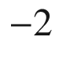

.

### 8.2 Conductivity

Under the influence of an electric field the electrons accelerate according to (cf. ([6.​36](The_Physics_of_Semiconductors00003.docx#u116076_4_En_6_Chapter)))

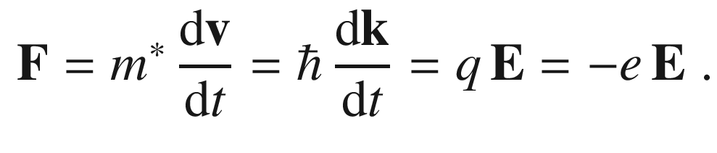

(8.1)

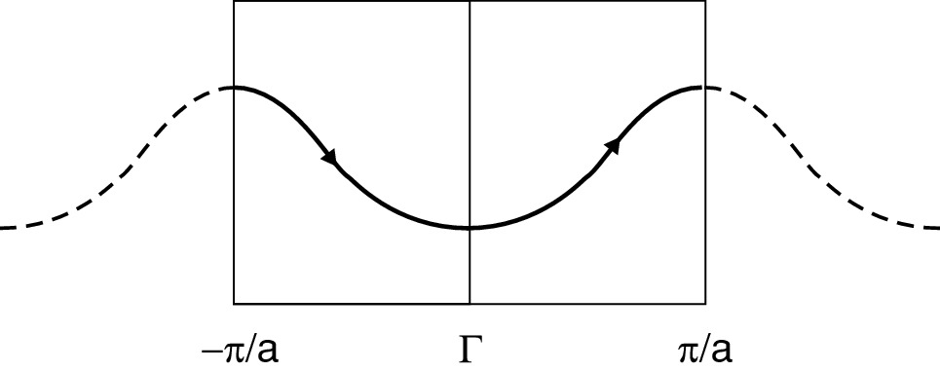

Fig. 8.1

Schematic representation of a Bloch oscillation

In the following, *q* denotes a general charge, while *e* is the (positive) elementary charge. We also consider an isotropic effective mass

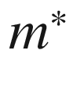

at first. After the time

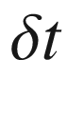

the

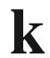

vector of all conduction electrons (and the center of the Fermi sphere) has been shifted by

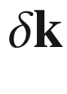

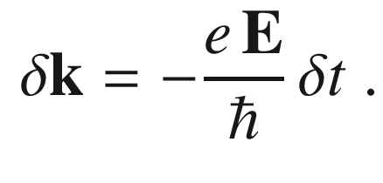

(8.2)

In the absence of scattering processes this goes on further (similar to an electron in vacuum). This regime is called *ballistic* transport. In a (periodic) band structure, the electron will perform a closed cycle as indicated in Fig. [8.1](#u116076_4_En_8_Chapter-Fig1). Such motion is called a Bloch oscillation. However, in a bulk crystal the period *T* of such an oscillation

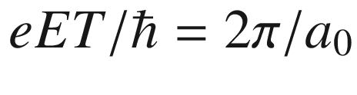

is of the order of 10

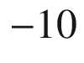

 s for

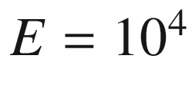

 V/cm. This time is much longer than a typical scattering time of 10

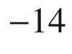

 s. Thus, in bulk material the Bloch electron cannot reach the zone boundary. However, in artificial superlattices (cf. Chap. [12](The_Physics_of_Semiconductors00005.docx#u116076_4_En_12_Chapter)) with larger periodicity (



10 nm), high electric fields (

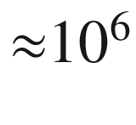

 V/cm) and high quality (reduced collision time) such motion is possible. We note that in the absence of scattering, electrons also perform a periodic oscillation in a magnetic field (cyclotron motion) .

In a real semiconductor, at finite temperatures, impurities, phonons and defects (finally also the surface) will contribute to scattering. In the relaxation-time approximation it is assumed that the probability for a scattering event, similar to friction, is proportional to the (average) carrier velocity. The average relaxation time

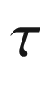

 is introduced via an additional term

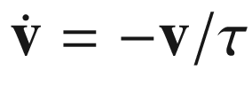

that sums up all scattering events.[1](#u116076_4_En_8_Chapter-Fn1) Thus, the maximum velocity that can be reached in a static electric field is given by (steady-state velocity)

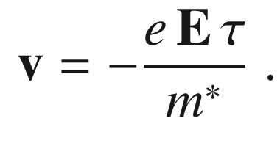

(8.3)

The current density per unit area is then linear in the field, i.e. fulfills Ohm’s law

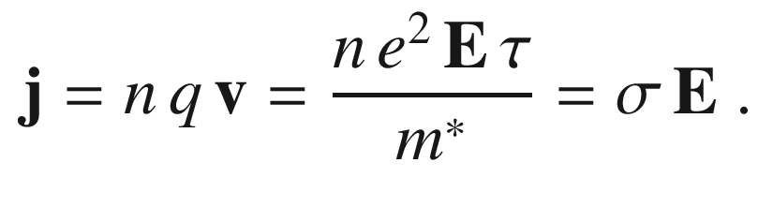

(8.4)

The conductivity

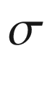

in the relaxation-time approximation is given by

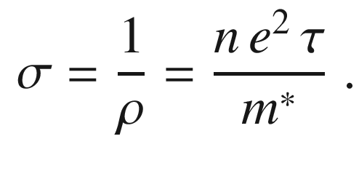

(8.5)

In the case of a cylindrically symmetric mass such as for electrons in silicon or germanium, for the effective mass in ([8.5](#u116076_4_En_8_Chapter-Equ5)) the effective conductivity mass must be used,

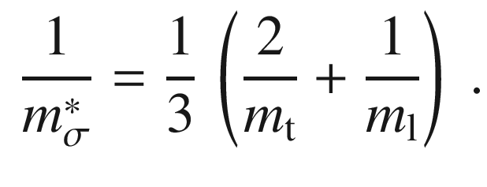

(8.6)

The specific resistivity is the inverse of the conductivity. Metals have a high conductivity (see Table [8.1](#u116076_4_En_8_Chapter-Tab1)), e.g. for Cu at room temperature

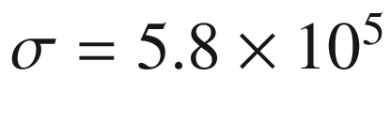

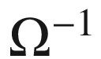

 cm

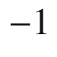

. At low temperatures (4 K) the conductivity is even a factor of

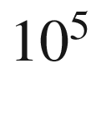

higher. The mean free path

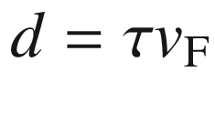

 is

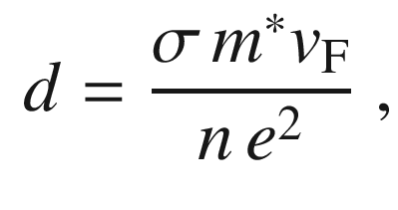

(8.7)

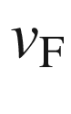

being the Fermi velocity (

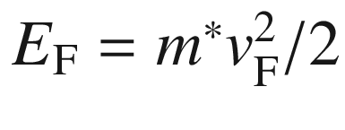

). For copper,

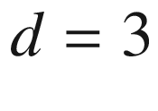

 mm at low temperature (and thus susceptible to the sample geometry) while at room temperature the mean free path is only about 40 nm. However, this becomes an issue when the metal line width and height of interconnects in integrated circuits approaches this length scale [715] (see Sect. [24.​5.​5](The_Physics_of_Semiconductors00009.docx#u116076_4_En_24_Chapter)).

In semiconductors, the carrier concentration depends strongly on the temperature. At zero temperature the conductivity is zero. Also, the scattering processes and thus the relaxation time constant exhibit a temperature dependence. The conductivity spans a large range from insulating to almost metallic conduction (see Table [8.1](#u116076_4_En_8_Chapter-Tab1)). Table 8.1

Conductivity at room temperature for various metals, semiconductors, insulators and liquids

| Material | $$\sigma $$  (  $$\Omega ^{-1}$$   cm  $$^{-1}$$  ) |
| --- | --- |
| Ag | $$6.25 \times 10^{5}$$ |
| Al | $$3.6 \times 10^{5}$$ |
| Au | $$4.35 \times 10^{5}$$ |
| Cu | $$5.62 \times 10^{5}$$ |
| Fe | $$1.1 \times 10^{5}$$ |
| Pt | $$1.02 \times 10^{5}$$ |
| Ge pure (  $$N_{\mathrm {D}} \sim 10^{13}$$   cm  $$^{-3}$$  ) | $$10^{-2}$$ |
| Ge (  $$N_{\mathrm {D}} \sim 10^{15}$$   cm  $$^{-3}$$  ) | 1 |
| Ge (  $$N_{\mathrm {D}} \sim 10^{17}$$   cm  $$^{-3}$$  ) | $$2 \times 10^{1}$$ |
| Ge (  $$N_{\mathrm {D}} \sim 10^{18}$$   cm  $$^{-3}$$  ) | $$2 \times 10^{2}$$ |
| Si pure | $$4.5 \times 10^{-6}$$ |
| Si:As (  $$N_{\mathrm {D}} \sim 3 \times 10^{19}$$   cm  $$^{-3}$$  ) | $$4 \times 10^{2}$$ |
| Si:B (  $$N_{\mathrm {A}} \sim 1.5 \times 10^{19}$$   cm  $$^{-3}$$  ) | $$1.2 \times 10^{2}$$ |
| GaAs pure | $$1.4 \times 10^{-7}$$ |
| ZnO:Al (highly doped) | $${\approx }1\times 10^4$$ |
| Pentacene | $$10^{-8}$$   –  $$10^{-4}$$ |
| SiO  $$_2$$ | $${\approx }10^{-15}$$ |
| Al  $$_2$$  O  $$_3$$ | $${\approx }10^{-16}$$ |
| H  $$_2$$  O pure | $$4 \times 10^{-8}$$ |
| Hexane | $${\approx }10^{-18}$$ |

### 8.3 Low-Field Transport

First we consider only *small* electric fields. The real meaning of this will only become clear in Sect. [8.4](#u116076_4_En_8_Chapter-Sec18) on high-field transport. In the low-field regime the velocity is proportional to the electric field.

#### 8.3.1 Mobility

The mobility is defined (scalar terms) as

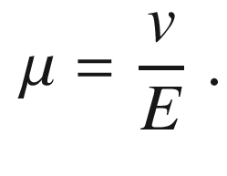

(8.8)

By definition, it is a negative number for electrons and positive for holes. However, the numerical value is usually given as a positive number for both carrier types. In an intrinsic semiconductor the mobility is determined by scattering with phonons. Further scattering is introduced by impurities, defects or alloy disorder. The conductivity is ([8.4](#u116076_4_En_8_Chapter-Equ4))

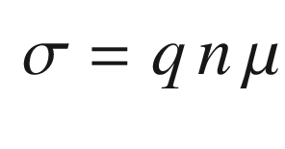

(8.9)

for each carrier type. Using ([8.5](#u116076_4_En_8_Chapter-Equ5)) the mobility in the relaxation time approximation is

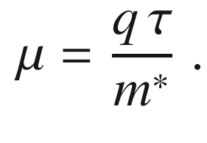

(8.10)

In the presence of both electrons and holes,

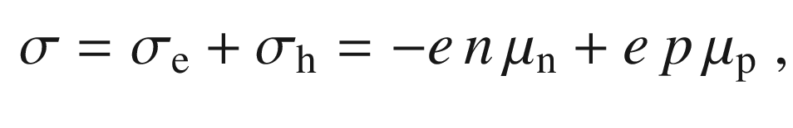

(8.11)

where

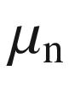

and

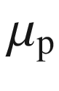

are the mobilities for electrons and holes, respectively. These are given by

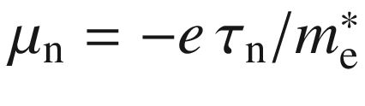

and

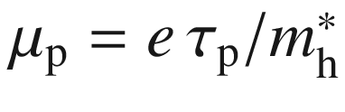

.

As the unit for mobility, usually cm

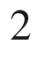

/Vs is used. While Cu at room temperature has a mobility of 35 cm

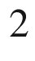

/Vs, semiconductors can have much higher values. In two-dimensional electron gases (cf. Chap. [12](The_Physics_of_Semiconductors00005.docx#u116076_4_En_12_Chapter)), the mobility can reach several

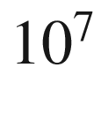

 cm

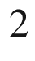

/Vs at low temperature (Fig. [12.​37](The_Physics_of_Semiconductors00005.docx#u116076_4_En_12_Chapter-Fig37)). In bulk semiconductors with small band gap, a high electron mobility is caused by its small effective mass. Some typical values are given in Table [8.2](#u116076_4_En_8_Chapter-Tab2).Table 8.2

Mobilities of electrons and holes at room temperature for various semiconductors

| Material | $$-\mu _{\mathrm {n}}$$  (cm  $$^2$$  /Vs) | $$\mu _{\mathrm {p}}$$  (cm  $$^2$$  /Vs) |
| --- | --- | --- |
| Si | 1300 | 500 |
| Ge | 4500 | 3500 |
| GaAs | 8800 | 400 |
| GaN | 300 | 180 |
| InSb | 77 000 | 750 |
| InAs | 33 000 | 460 |
| InP | 4600 | 150 |
| ZnO | 230 | 8 |

#### 8.3.2 Microscopic Scattering Processes

The relaxation time constant summarizes all scattering mechanisms. If the relaxation times

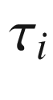

of various processes are independent, the Matthiesen rule can be used to obtain the mobility (

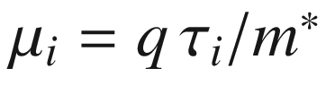

)

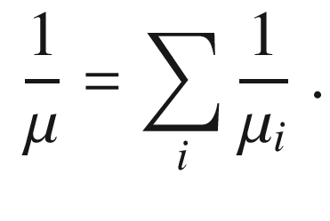

(8.12)

A more detailed book keeping is provided within the framework of the Boltzmann transport theory (Appendix J).

The various scattering mechanisms have quite different temperature dependences such that the mobility is a rather complicated function of temperature. In [716] the mechanisms determining the low and high-field transport properties of (cubic) semiconductors are reviewed. A schematic overview of the various carrier scattering processes discussed in the following is shown in Fig. [8.2](#u116076_4_En_8_Chapter-Fig2).

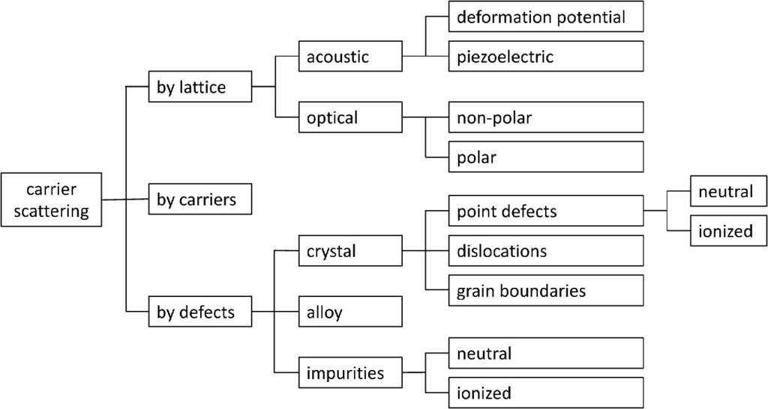

Fig. 8.2

Scheme of microscopic carrier scattering mechanisms

#### 8.3.3 Ionized Impurity Scattering

Theoretically, this problem is treated similar to Rutherford scattering. A screened Coulomb potential is assumed, as the scattering potential

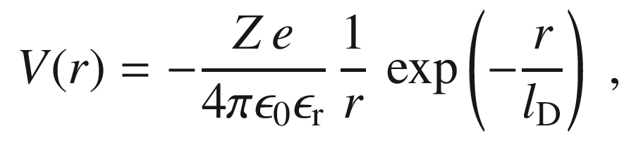

(8.13)

where

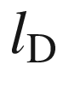

is the screening length. The problem has been treated classically by Conwell and Weisskopf [717] and quantum mechanically by Brooks [718] and Herring. An expression for the mobility that encompasses the Conwell–Weisskopf and Brooks–Herring results is derived in [719]. Further details are given in [720, 721]. For the mobility it is found that

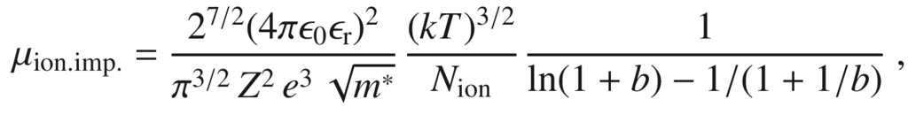

(8.14)

with

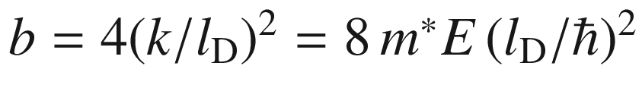

. In the Thomas-Fermi screening model

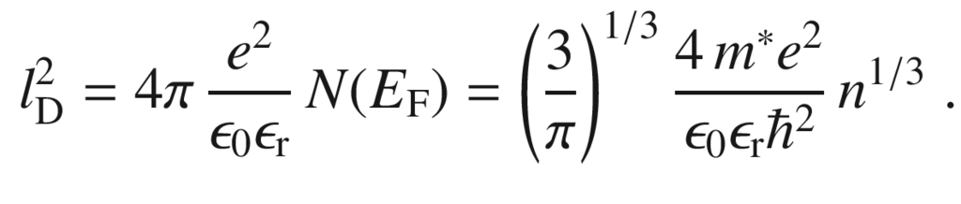

(8.15)

The formula ([8.14](#u116076_4_En_8_Chapter-Equ14)) is valid only for

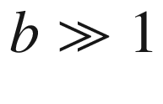

, i.e. small carrier densities. A similar formula from [720] is

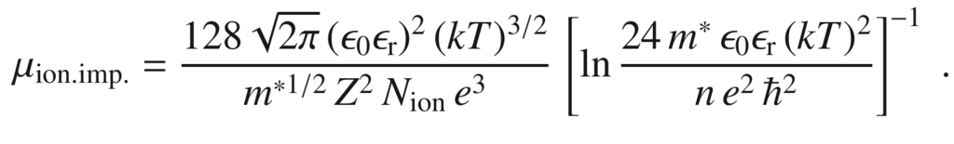

(8.16)

For large ionized impurity (and carrier) density (

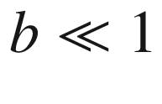

), the mobility is given by [555]

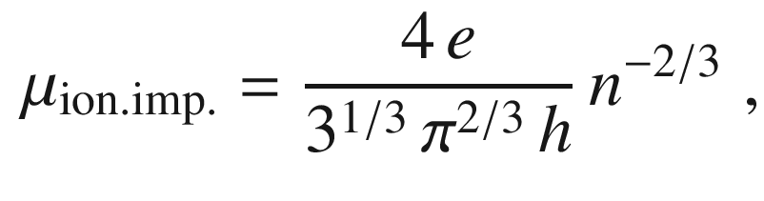

(8.17)

the value of the pre-factor being about

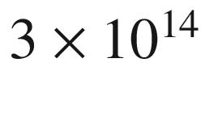

 (Vs)



.

The scattering time depends like

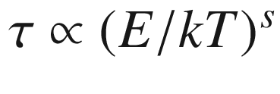

on the kinetic energy; for moderate or weak scattering

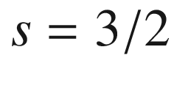

, for very strong scattering,

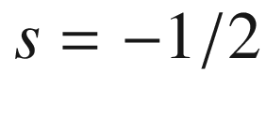

[714].

For typical substitutional impurities, the charge of the scattering center is

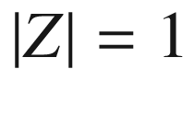

; in oxides, oxygen vacancies may have

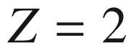

. At high impurity densities, impurity clusters may form with

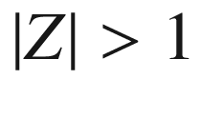

; this will have a strong influence on the scattering rate since it proportional to

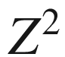

. The decrease of mobility for

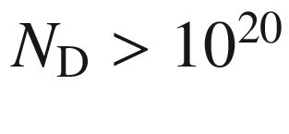

 cm

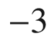

(Fig. [8.3](#u116076_4_En_8_Chapter-Fig3)a) is attributed to such effect which can be described with an effective impurity clustering charge

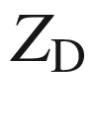

(Fig. [8.3](#u116076_4_En_8_Chapter-Fig3)b) [722, 723].

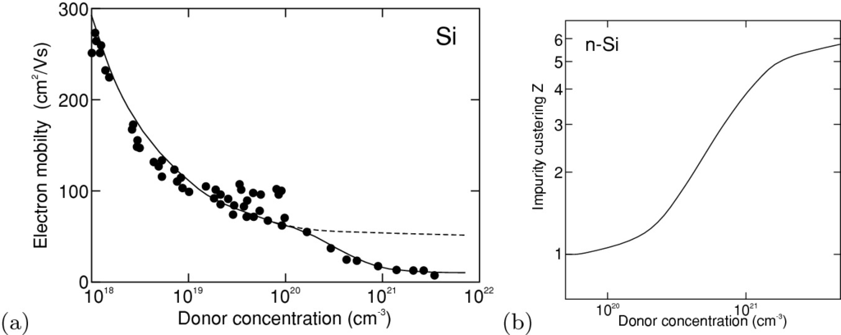

Fig. 8.3

**a** Electron mobility in highly doped silicon. Experimental data (*symbols*) from various sources and modeling with ionized impurity scattering with (*solid line*) and without (*dashed line*) considering impurity clustering. **b** Effective impurity cluster charge

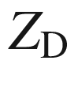

.

Adapted from [722]

#### 8.3.4 Deformation Potential Scattering

Acoustic phonons with small wavevector, i.e. a wavelength large compared to the unit cell, can have TA or LA character. The TA phonons represent a shear wave (with zero divergence), the LA phonons are a compression wave (with zero rotation) . The LA is a plane wave of displacement

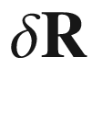

parallel to the *k*-vector

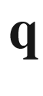

,

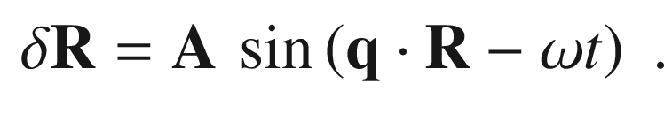

(8.18)

The strain tensor is given by

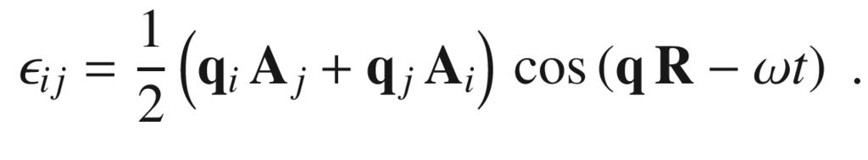

(8.19)

It has a diagonal form

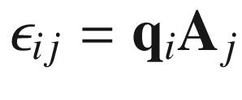

for



and

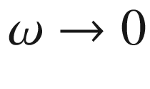

. Therefore, the LA phonon creates an oscillatory volume dilatation (and compression) with amplitude

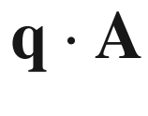

. This volume modulation affects the position of the band edges. For the conduction-band edge the energy change is related to the volume change by the hydrostatic deformation potential

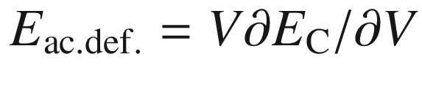

. Since the modulation is small compared to the energy of the charge carriers, it is mostly an elastic scattering process . The Hamilton operator for the LA scattering is

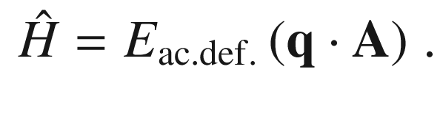

(8.20)

The size of the LA amplitude is given by the number of phonons in the mode that is given by the Bose–Einstein distribution,

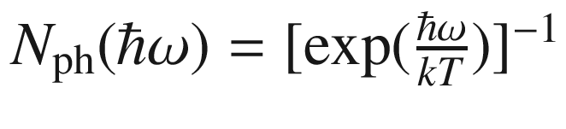

. The mobility due to acoustic deformation potential scattering is found to be

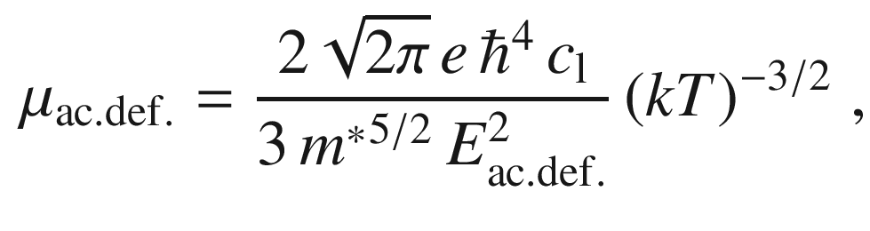

(8.21)

where

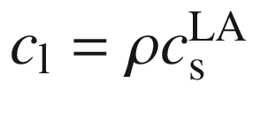

,

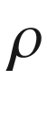

being the density and

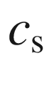

being the sound velocity. The scattering time increases like

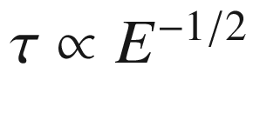

with the kinetic energy [714].

The acoustical deformation potential scattering is important at high temperatures. It is dominating in nonpolar semiconductors (Ge, Si) at high temperatures (typically at and above room temperature).

#### 8.3.5 Piezoelectric Potential Scattering

In piezoelectric crystals (see Sect. [16.​4](The_Physics_of_Semiconductors00006.docx#u116076_4_En_16_Chapter)), i.e. crystals that show an electric polarization upon strain, certain acoustic phonons lead to piezoelectric fields. In GaAs, with

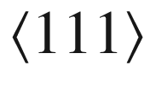

being the piezoelectric directions, this is the case for shear waves. In strongly ionic crystals, e.g. II–VI semiconductors, the piezoelectric scattering can be stronger than the deformation potential scattering. The mobility due to piezoelectric potential scattering is

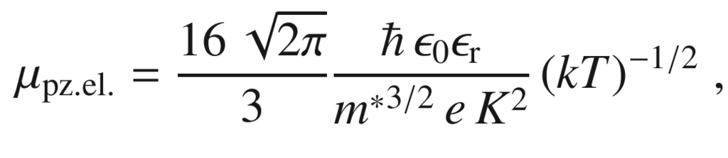

(8.22)

with

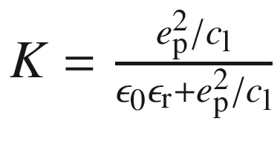

,

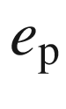

being the piezoelectric coefficient.

#### 8.3.6 Polar Optical Scattering

LO phonons are connected with an electric field antiparallel to the displacement ([9.​29](#u116076_4_En_9_Chapter)). In the scattering mechanism the absorbed or emitted phonon energy

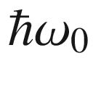

is comparable to the thermal energy of the carriers. Therefore, the scattering is inelastic and the relaxation-time approximation does not work. The general transport theory is complicated. If the temperature is low compared to the Debye temperature,

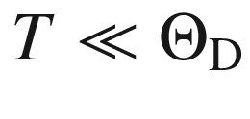

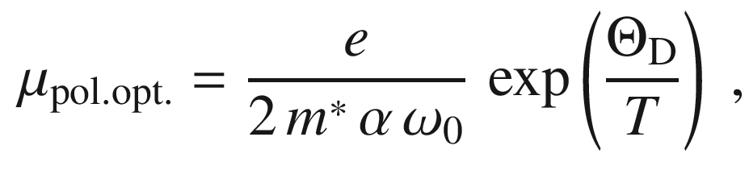

(8.23)

where

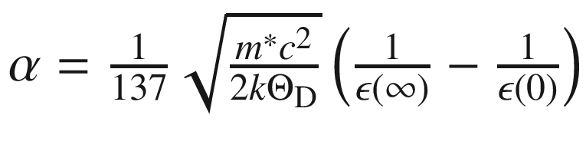

is the dimensionless polar constant.

#### 8.3.7 Dislocation Scattering

Dislocations can contain charge centers and thus act as scattering centers citeyou. This has been first demonstrated for n-Ge crystals that have been deformed [725, 726]. The deformation has introduced acceptor-type defects reducing the mobility in particular at low temperatures (similar to ionized impurity scattering). The mobility due to dislocation scattering in an n-type semiconductor is given by [727, 728]

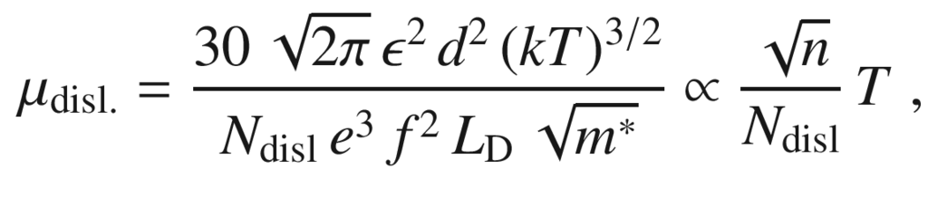

(8.24)

*d* being the average distance of acceptor centers along the dislocation line, *f* their occupation rate,

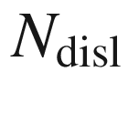

the area density of dislocations and

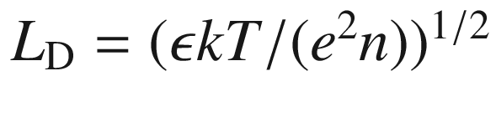

the Debye screening length. The relation

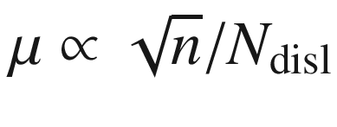

has been confirmed for various n-type GaN samples [729].

#### 8.3.8 Grain Boundary Scattering

The lowering of mobility due to transport across grain boundaries is an important effect in polycrystalline materials, such as poly-silicon for solar cells or thin film transistors [730–733]. Grain boundaries contain electronic traps whose filling depends on the doping of the bulk of the grains. Charges will be trapped in the grain boundaries and a depletion layer will be created.[2](#u116076_4_En_8_Chapter-Fn2) At low doping the grains are fully depleted and all free carriers are trapped in the grain boundaries. This means low conductivity, however, no electronic barrier to transport exists. At intermediate doping, traps are partially filled and the partial depletion of the grain leads to the creation of an electronic barrier

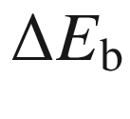

(Fig. [8.4](#u116076_4_En_8_Chapter-Fig4)a) hindering transport since it must be overcome via thermionic emission. At high doping the traps are completely filled and the barrier vanishes again. Accordingly the mobility goes through a minimum as a function of the doping concentration (Fig. [8.4](#u116076_4_En_8_Chapter-Fig4)b) [730]. In [734] these data have been modeled with a 20 nm grain size, the value found in [730] from TEM analysis.

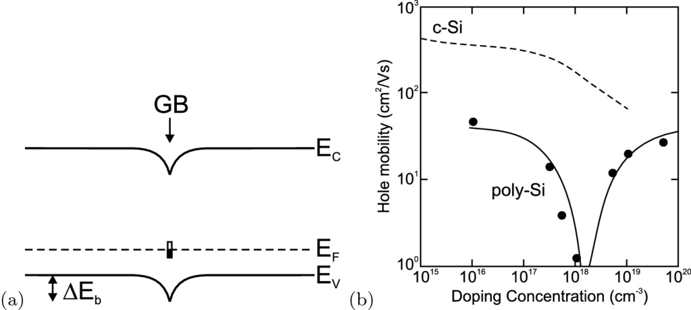

Fig. 8.4

**a** Electronic barrier (

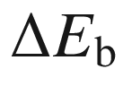

) for (hole) transport at a grain boundary (GB). **b** Average hole mobility in poly-silicon, experimental data (*symbols*) and theoretical model (*solid line*). The dependence for monocrystalline silicon is shown for comparison as *dashed line*.

Adapted from [730]

The expression for the limitation of the mobility due to scattering at grain boundaries is given by [733, 735]

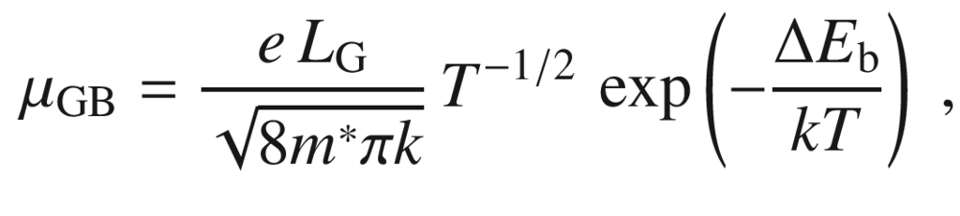

(8.25)

where

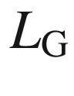

is the grain size.

#### 8.3.9 Alloy Scattering

The random population of lattice sites represents disorder from a perfectly periodic lattice. The charge carrier mobility in an alloy A

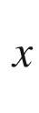

B

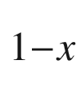

due to scattering in this potential is proportional to the alloy scattering potential

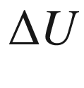

 [590],

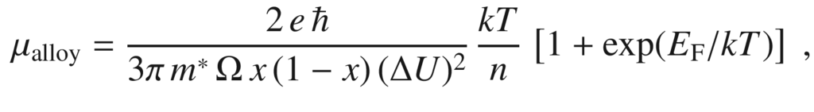

(8.26)

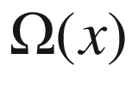

being the volume of the unit cell over which the alloy-scattering potential is effective. Such effect is present in any alloy such as In

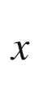

Ga

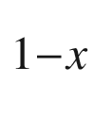

As [591] of Al

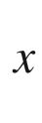

Ga

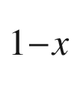

N [592]. For the latter material, see also the following section.

#### 8.3.10 Dipole Scattering

In alloys of *polar* semiconductors (Chap. [16](The_Physics_of_Semiconductors00006.docx#u116076_4_En_16_Chapter)), i.e. lower-symmetric (non-cubic) semiconductors with an electric polarization, the additional potential due to the random variation of the polarization introduces an additional scattering mechanism, the so-called dipole scattering [592]. Dipole scattering originally has been studied in the context of scattering in highly compensated semiconductors due to ionized donor-acceptor pairs [593].

#### 8.3.11 Temperature Dependence

The sum of all scattering processes leads to a fairly complicated temperature dependence of the mobility

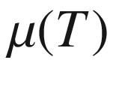

. In covalent semiconductors (Si, Ge) the most important processes are the ionized impurity scattering (

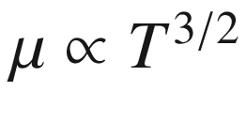

) at low temperatures and the deformation potential scattering (

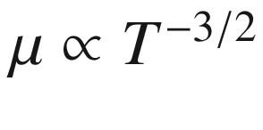

) at high temperatures (Fig. [8.5](#u116076_4_En_8_Chapter-Fig5)a). In polar crystals (e.g. GaAs) at high temperatures the polar optical scattering is dominant (Fig. [8.5](#u116076_4_En_8_Chapter-Fig5)b).

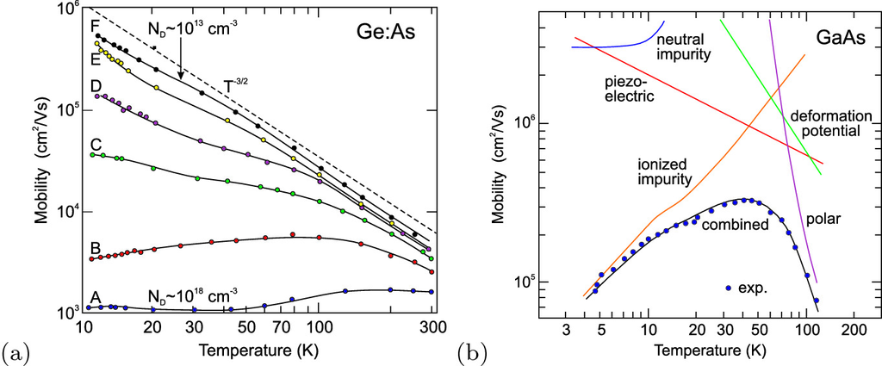

Fig. 8.5

**a** Temperature dependence of the electron mobility in n-doped Ge (for various doping levels from

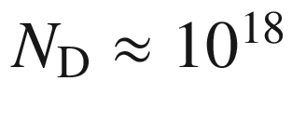

for sample A to 10

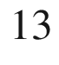

 cm

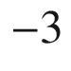

for sample F in steps of a factor of ten). *Dashed line* indicates

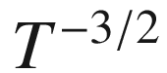

dependence of deformation potential scattering, *solid lines* are guides to the eye. Adapted from [594]. **b**

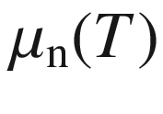

for n-type GaAs (

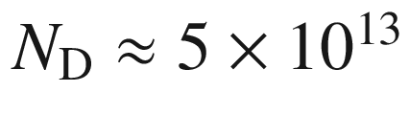

 cm

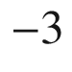

,

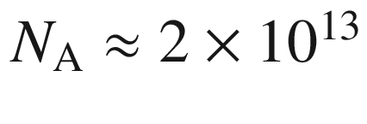

 cm

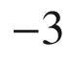

). *Solid lines* are theoretical mobilities for various scattering mechanisms and combined mobility according to ([8.12](#u116076_4_En_8_Chapter-Equ12)).

Adapted from [736]

In Fig. [8.6](#u116076_4_En_8_Chapter-Fig6) the electron mobility of bulk and thin-film ZnO is compared. Since ZnO is polar the mobility at room temperature is limited by polar optical phonon scattering. In the thin film, grain-boundary scattering (Sect. [8.3.8](#u116076_4_En_8_Chapter-Sec11)) additionally occurs and limits the mobility.

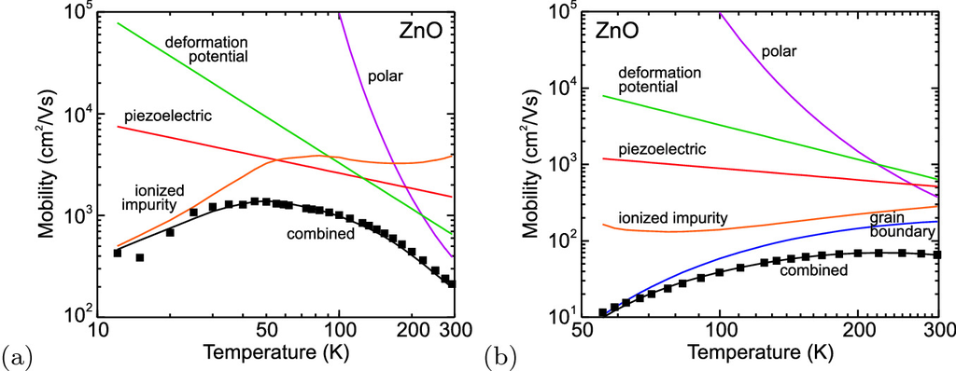

Fig. 8.6

Temperature dependence of the electron mobility in n-type **a** bulk ZnO and **b** a PLD-grown ZnO thin film on sapphire. In the latter, grain-boundary scattering is limiting the mobility. *Squares* are experimental data, *solid lines* are theoretical mobilities for various scattering mechanisms and combined mobility according to ([8.12](#u116076_4_En_8_Chapter-Equ12)).

Experimental data from [737]

In Fig. [8.7](#u116076_4_En_8_Chapter-Fig7) the temperature dependence of the mobility is depicted for an alloy of polar semiconductors, namely Al

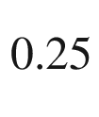

Ga

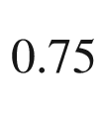

N. The contributions of alloy scattering and dipole scattering determine the mobility [592].

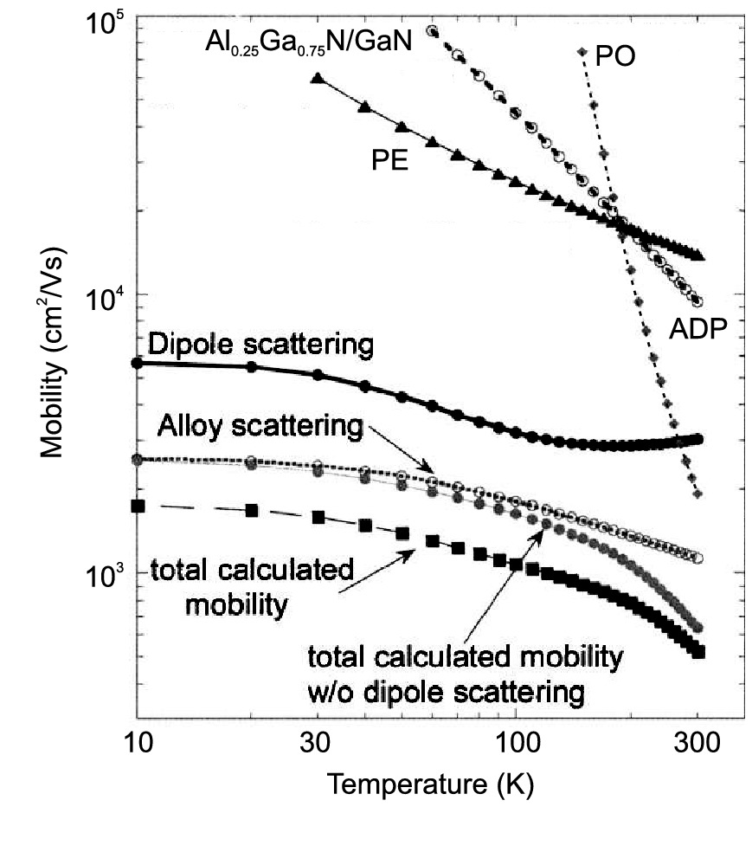

Fig. 8.7

Calculated temperature dependence of the electron mobility in n-type Al

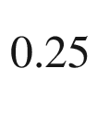

Ga

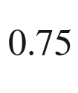

N, (

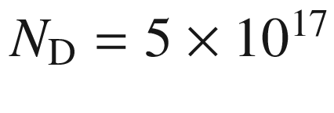

 cm

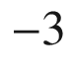

). PO: polar optic scattering, PE: piezoelectric scattering, ADP: acoustic deformation potential scattering.

Adapted from [592]

Since the carrier concentration increases with increasing temperature and the mobility decreases, the conductivity has a maximum, typically around 70 K (see Fig. [8.8](#u116076_4_En_8_Chapter-Fig8)). At very high temperature, when intrinsic conduction starts,

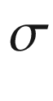

shows a strong increase due to the increase in *n*.

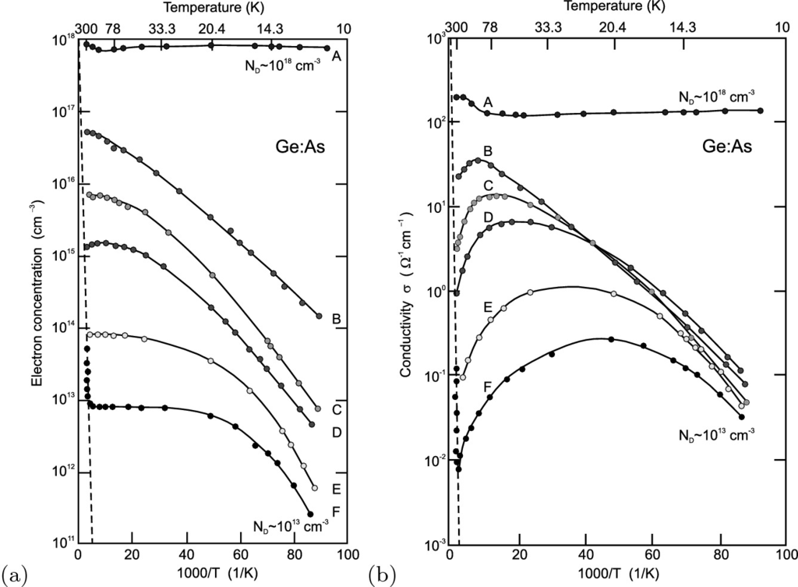

Fig. 8.8

**a** Carrier concentration and **b** conductivity of n-type Ge as a function of temperature. The doping level varies from

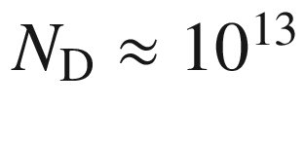

to 10

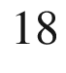

(samples A–F as in Fig. [8.5](#u116076_4_En_8_Chapter-Fig5)a where the mobility of the same samples is shown). The *dashed lines* are for intrinsic Ge. The *solid lines* are guides to the eye.

Adapted from [594]

At low temperature, the disorder due to doping (random positions of the impurity atoms) leads to a temperature driven metal–insulator transition as depicted in Fig. [8.21](#u116076_4_En_8_Chapter-Fig21).

#### 8.3.12 Doping Dependence

The mobility decreases with increasing dopant concentration as already shown in Figs. [8.3](#u116076_4_En_8_Chapter-Fig3) and [8.5](#u116076_4_En_8_Chapter-Fig5)a. In Fig. [8.9](#u116076_4_En_8_Chapter-Fig9)a the low doping limit is due to deformation potential scattering; the decrease with doping is due to ionized impurity scattering. At high doping level, it becomes more important at room temperature than (acoustical or optical) phonon scattering [738]. The mobility of carriers in n- and p-type silicon with very high carrier concentrations is depicted in Fig. [8.9](#u116076_4_En_8_Chapter-Fig9)b.

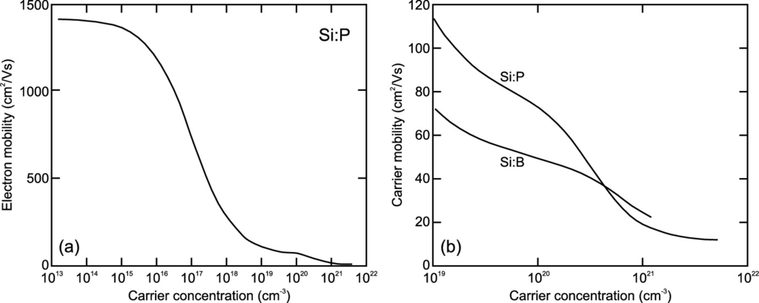

Fig. 8.9

**a** Electron mobility in Si:P at room temperature over a wide range of carrier concentrations. **b** Electron mobility in Si:P and hole mobility in Si:B for various high carrier concentrations.

Adapted from [739]

Thus, for bulk material high carrier density and high mobility are contrary targets and cannot be achieved simultaneously. A solution will be provided with the concept of *modulation* doping where the dopants and the (two-dimensional) carrier gas will be spatially separated in a heterostructure (cf. Sect. [12.​3.​4](The_Physics_of_Semiconductors00005.docx#u116076_4_En_12_Chapter)).

At high doping, the substitutional character of the impurities may be lost and secondary phases can arise, e.g. as observed for highly doped ZnO:Ga, exhibiting octahedral coordination of gallium in a parasitic ZnGa

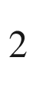

O

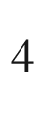

spinel phase for [Ga]=4% [632]. The onset of such segregation phenomena is accompanied with the decrease of mobility and conductivity.

#### 8.3.13 Superconductivity

It has been found that highly doped semiconductors do not only behave like metals in the sense that the carrier concentration is largely independent of temperature but that they can also exhibit superconductivity. Theoretical and early experimental investigations suggested the possibility of such behavior [740–743] even when the electron concentration is much smaller than one per atom. Experimentally, robust superconductivity in semiconductors has been found more recently for a number of semiconductors [744, 745], namely boron-doped diamond (C:B) [746] (Fig. [8.10](#u116076_4_En_8_Chapter-Fig10)), Si:B [747] and Ge:Ga [748]. The preparation of superconducting semiconductors with critical temperature above 1 K typically involves hyperdoping with impurity concentrations of several atomic percent. The detailed physics of these materials, such as the superconductor type (type-II behavior was found for C:B) or the electron coupling mechanism (generally, phonon-assisted pairing is assumed), are still under debate.

Another type of superconducting semiconductor structure are twisted monolayers in Van-der-Waals heterostructures for particular values of twist angle and carrier concentration (cf. Sect. [13.​3](The_Physics_of_Semiconductors00006.docx#u116076_4_En_13_Chapter)).

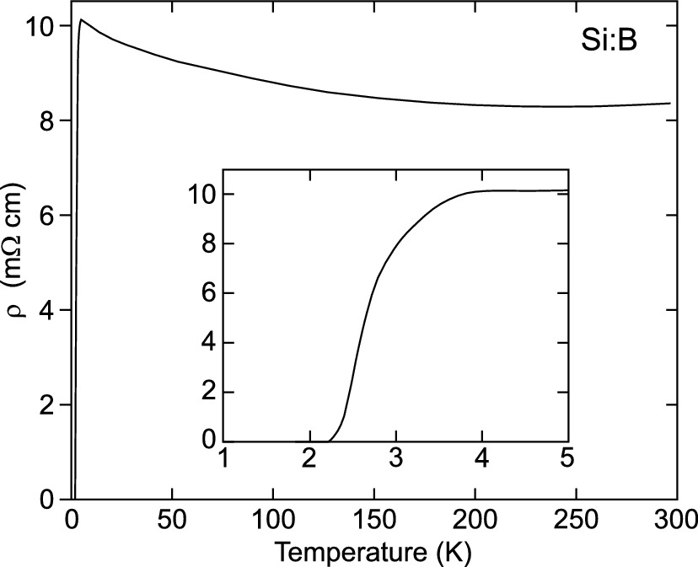

Fig. 8.10

Conductivity of B-doped diamond as a function of temperature.

Adapted from [746]

#### 8.3.14 Piezoresistivity

The dependence of resistivity on stress or strain is known as piezoresistive effect, first described in [749]. It is a consequence of the modification of the band structure upon stress and the change of effective masses (Sect. [6.​12.​2](The_Physics_of_Semiconductors00003.docx#u116076_4_En_6_Chapter)). In a cubic material, the resistivity

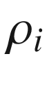

for transport in cartesian direction *i* changes compared to the unstrained state in a phenomenological description according to

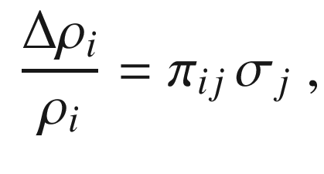

(8.27)

where

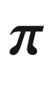

is the piezoresistivity tensor ([8.28](#u116076_4_En_8_Chapter-Equ28)) and the

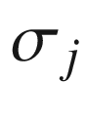

form the six-component stress tensor ([5.​55](The_Physics_of_Semiconductors00002.docx#u116076_4_En_5_Chapter)),

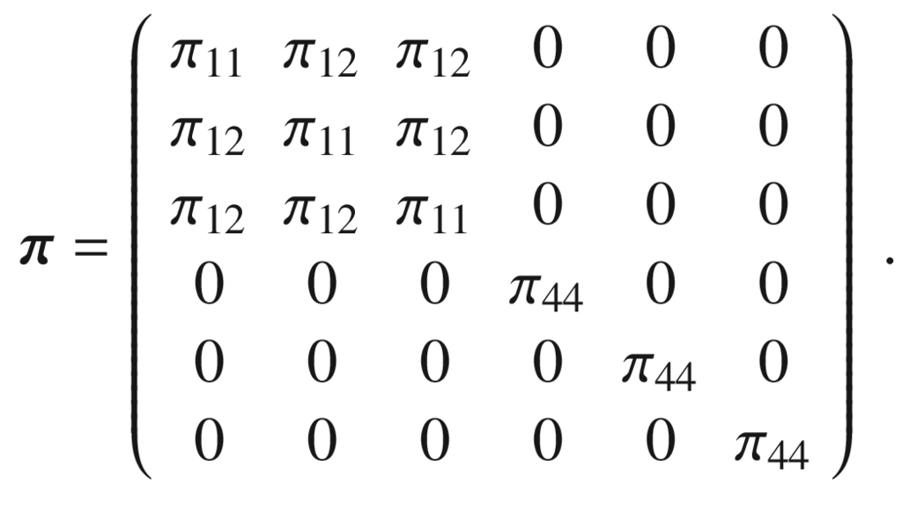

(8.28)

Values for the piezoelectric coefficients are given in Table [8.3](#u116076_4_En_8_Chapter-Tab3) for Si, Ge and GaAs.

The piezoelectric effect has been discussed in detail [750] and modeled for p-type Si [751]. We shall only give a simple example which is particularly relevant for advanced CMOS design (Sect. [24.​5.​5](The_Physics_of_Semiconductors00009.docx#u116076_4_En_24_Chapter)); the directional dependence of the piezoresistive coefficient of silicon is shown for uniaxial stress within in the (001) plane in Fig. [8.11](#u116076_4_En_8_Chapter-Fig11). Uniaxial tensile stress increases hole resistivity along

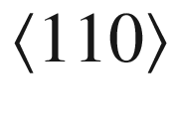

stress directions, compressive stress thus increases hole conductivity.

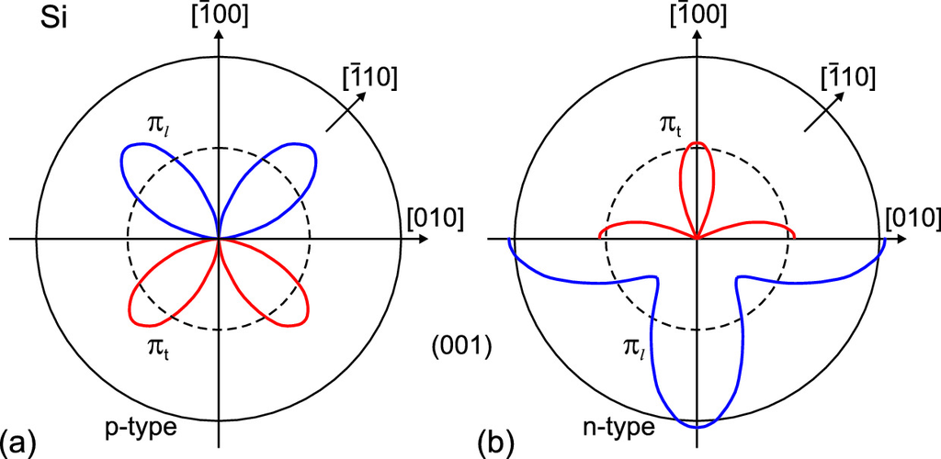

Fig. 8.11

Piezoresistive coefficient for current parallel (perpendicular) to the stress

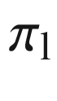

as *blue lines* (

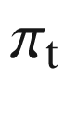

, *red lines*) for uniaxially stressed Si (001) at room temperature, **a** for p-type Si, **b** for n-type Si. The *upper* (*lower*) halves of the graphs show positive (negative) values of the piezoresistive coefficient, i.e. resistivity increases (decreases) with tensile stress. The *solid circle* indicates the value of

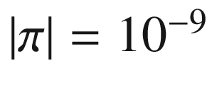

 Pa

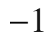

, the *dashed circle* half that value.

Adapted from [752]

Table 8.3

Piezoresistivity coefficients (in

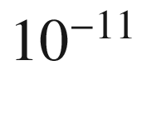

 Pa

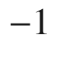

) for Si, Ge and GaAs at room temperature

| Material | $$\rho $$  (  $$\varOmega $$   cm) | $$\pi _{11}$$ | $$\pi _{12}$$ | $$\pi _{44}$$ | References |
| --- | --- | --- | --- | --- | --- |
| p-Si | 7.8 | 6.6 | $$-1.1$$ | 138.1 | [749] |
| n-Si | 11.7 | $$-102.2$$ | 53.4 | $$-13.6$$ | [749] |
| p-Ge (Ge:Ga) | 15.0 | $$-10.6$$ | 5.0 | 98.6 | [749] |
| n-Ge (Ge:As) | 9.9 | $$-4.7$$ | $$-5.0$$ | $$-137.9$$ | [749] |
| p-GaAs | $${\sim }10^{-3}$$ | $$-12.0$$ | $$-0.6$$ | 46 | [753] |
| n-GaAs | $${\sim }10^{-3}$$ | $$-3.2$$ | $$-5.4$$ | $$-2.5$$ | [753, 754] |

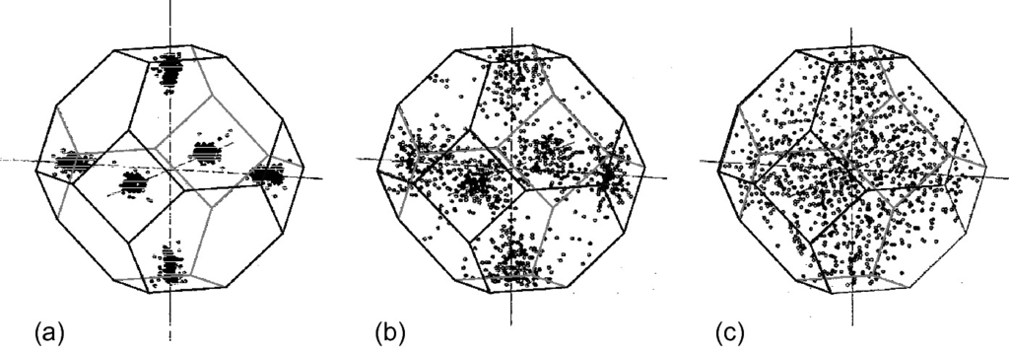

Fig. 8.12

Distribution of electrons in silicon in momentum space (cmp. Fig. [6.​35](The_Physics_of_Semiconductors00003.docx#u116076_4_En_6_Chapter-Fig35)c) for electric fields of **a** 10 kV/cm, **b**

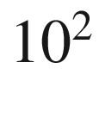

 kV/cm and **c**

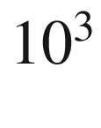

 kV/cm.

Adapted from [756]

### 8.4 High-Field Transport

In the case of small electric fields the scattering events are elastic. The drift velocity is linearly proportional to the electric field. The average thermal energy is close to its thermal value 3*kT*/2 and the carriers are close to their band edges (Fig. [8.12](#u116076_4_En_8_Chapter-Fig12)a). The scattering efficiency, however, is reduced already at moderate fields. Then, the electron temperature [755] becomes larger than the lattice temperature. With increasing electrical field the carriers can gain more and more energy and will on average populate higher states, assuming a non-Boltzmann (and non-Fermi) statistical distribution [756]. The electron distribution in

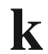

-space is depicted for silicon for three different electric fields in Fig. [8.12](#u116076_4_En_8_Chapter-Fig12)b,c. Hot carriers suffer additional scattering processes that are discussed in the following, namely optical phonon emission, intervalley scattering and impact ionization.

#### 8.4.1 Drift-Saturation Velocity

If the carrier energy is large enough it can transfer energy to the lattice by the emission of an optical phonon. This mechanism is very efficient and limits the maximum drift velocity. Such behavior is non-ohmic. The limiting value for the drift velocity is termed the *drift-saturation velocity*. It is given by [757]

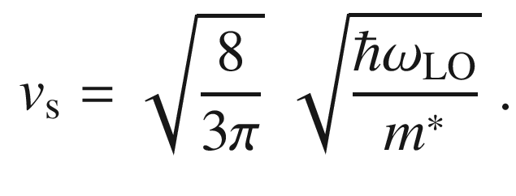

(8.29)

This relation can be obtained from an energy-balance consideration. The energy gain per unit time in the electric field is equal to the energy loss by the emission of an optical phonon.

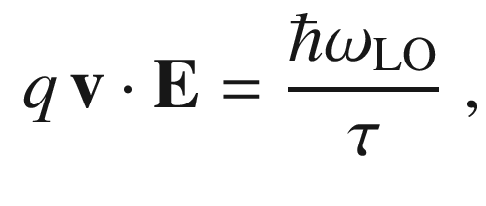

(8.30)

where

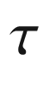

is the typical relaxation time constant for LO phonon emission. Together with ([8.3](#u116076_4_En_8_Chapter-Equ3)) we find ([8.30](#u116076_4_En_8_Chapter-Equ30)) except for the pre-factor, which is close to 1. The exact pre-factor results from a quantum-mechanical treatment. For Ge the drift-saturation velocity at room temperature is

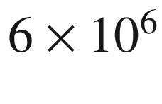

 cm/s, for Si it is

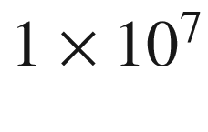

 cm/s (Fig. [8.13](#u116076_4_En_8_Chapter-Fig13)a). The carrier velocity also depends on the crystallographic direction [758].

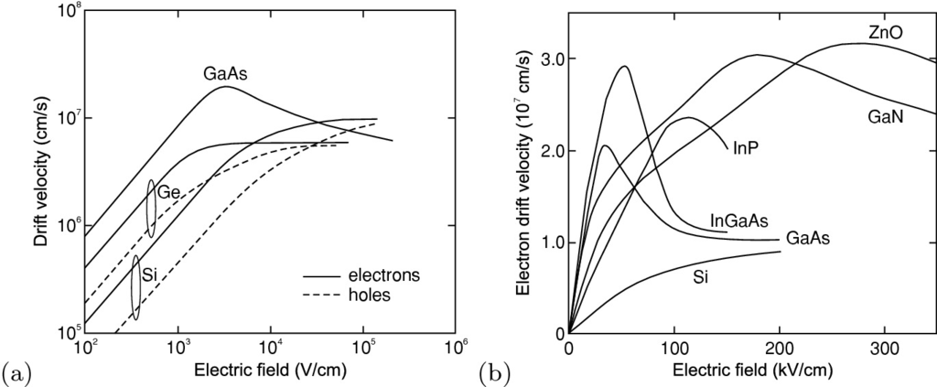

Fig. 8.13

Drift velocity at room temperature as a function of applied electric field for **a** high-purity Si, Ge, and GaAs on a double-logarithmic plot and **b** on linear plots for Si [759], Ge [760], GaAs [676], InP [761], (In, Ga)As [762], GaN and ZnO [763]

#### 8.4.2 Negative Differential Resistivity

In GaAs, the initially linear regime (constant mobility) saturates at a maximum drift velocity of about

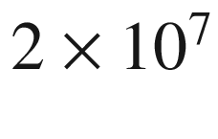

 cm/s for about 3 kV/cm; for higher fields, a reduction in drift velocity (with increasing field!) is present (

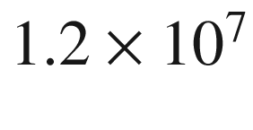

 cm/s at 10 kV/cm,

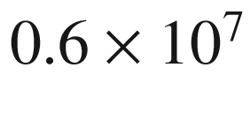

 cm/s at 200 kV/cm), as shown in Fig. [8.13](#u116076_4_En_8_Chapter-Fig13)a. This regime, above the threshold field of

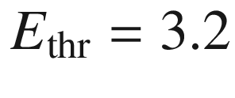

 kV/cm in GaAs, is called *negative differential resistivity* (NDR) and was predicted in [764]. This phenomenon can be used in microwave oscillators, e.g. the Gunn element (Sect. [21.​5.​11](The_Physics_of_Semiconductors00007.docx#u116076_4_En_21_Chapter)).

The effect occurs in a multi-valley band structure (see Fig. [8.14](#u116076_4_En_8_Chapter-Fig14), for values cf. Table [8.4](#u116076_4_En_8_Chapter-Tab4)), e.g. in GaAs or InP, when the carrier energy is high enough to scatter (Fig. [8.14](#u116076_4_En_8_Chapter-Fig14)c,d) from the

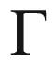

minimum (small mass and high mobility) into the L valley (large mass and low mobility) [765].Table 8.4

Material parameters for multi-valley bandstructure of GaAs and InP.

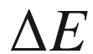

denotes the energetic separation of the two lowest valleys of the conduction band,

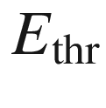

the threshold field for NDR and

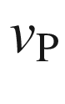

the peak velocity (at

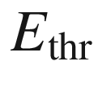

). Most values from [766]

| Material |  | | | | Lower valley (  $$\Gamma $$  ) | | Upper valley (L) | |
| --- | --- | --- | --- | --- | --- | --- | --- | --- |
| $$E_{\mathrm {g}}$$  (eV) | $$\Delta E$$  (eV) | $$E_{\mathrm {thr}}$$  (kV/cm) | $$v_{\mathrm {P}}$$  (10  $$^7$$   cm/s) | $$m^*$$  (  $$m_0$$  ) | $$\mu _{\mathrm {n}}$$  (cm  $$^2$$  /Vs) | $$m^*$$  (  $$m_0$$  ) | $$\mu _{\mathrm {n}}$$  (cm  $$^2$$  /Vs) |
| GaAs | 1.42 | 0.36 | 3.2 | 2.2 | 0.068 | $${\approx }8000$$ | 1.2 | $${\approx }180$$ |
| InP | 1.35 | 0.53 | 10.5 | 2.5 | 0.08 | $${\approx }5000$$ | 0.9 | $${\approx }100$$ |

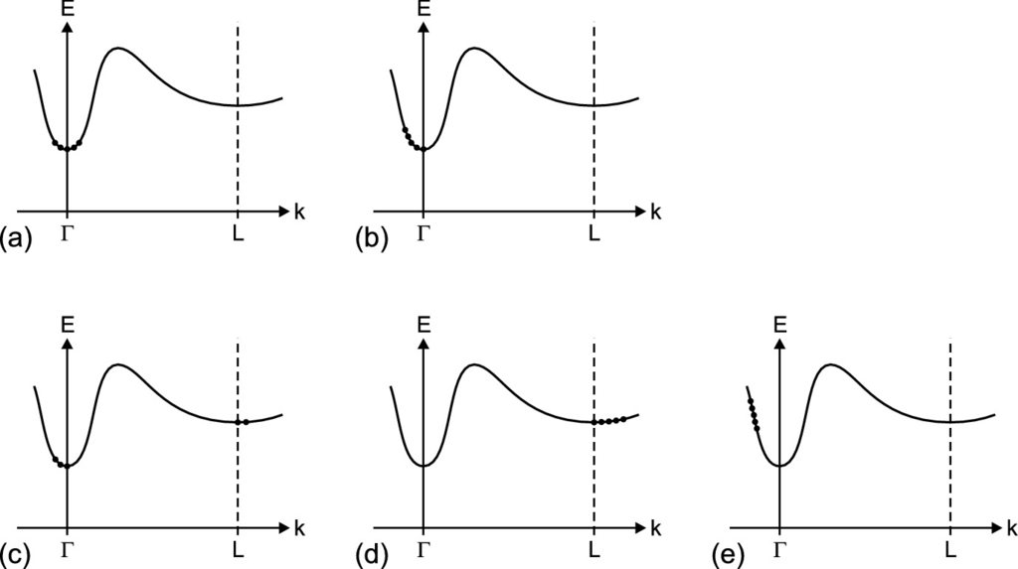

Fig. 8.14

Charge-carrier distribution in a multi-valley band structure (e.g. GaAs, InP) for **a** zero, **b** small (

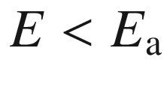

), **c** intermediate and **d** large (

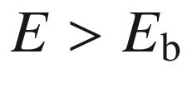

) field strength. The situation shown in **e** is reached temporarily during velocity overshoot (see also Fig. [8.16](#u116076_4_En_8_Chapter-Fig16))

The temperature dependence of the saturation velocity is shown in Fig. [8.15](#u116076_4_En_8_Chapter-Fig15). With increasing temperature the saturation velocity decreases since the coupling with the lattice becomes stronger.

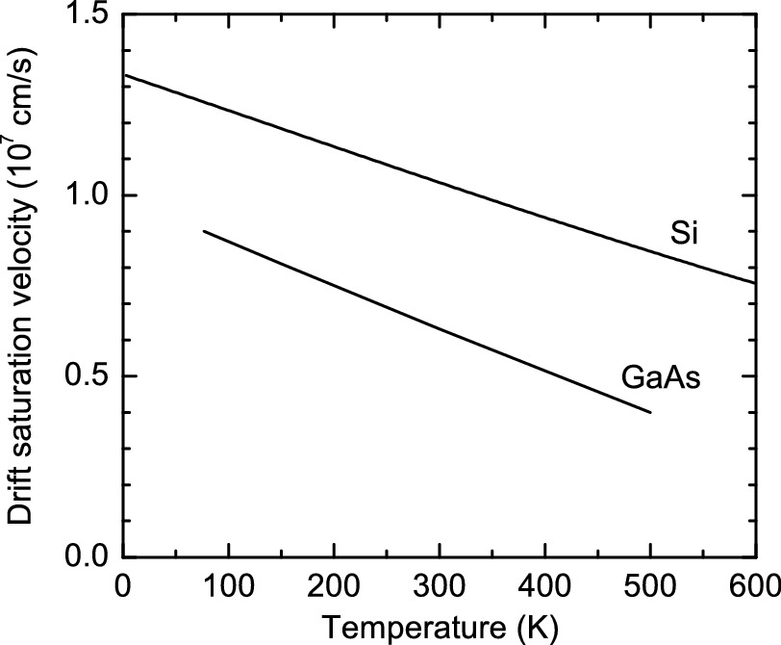

Fig. 8.15

Temperature dependence of the saturation velocity for Si (following

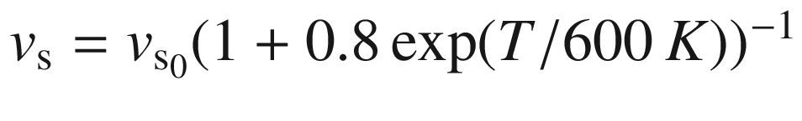

with

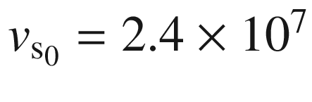

 cm/s from [759]) and GaAs [676, 767, 768]

#### 8.4.3 Velocity Overshoot

When the electric field is switched on, the carriers are at first in the

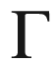

minimum (Fig. [8.14](#u116076_4_En_8_Chapter-Fig14)a). Only after a few scattering processes are they scattered into the L minimum. This means that in the first moments transport occurs with the higher mobility of the lowest minimum (Fig. [8.14](#u116076_4_En_8_Chapter-Fig14)e). The velocity is then larger than the (steady-state) saturation velocity in a dc field. This phenomenon is called *velocity overshoot* and is a purely dynamic effect (Fig. [8.16](#u116076_4_En_8_Chapter-Fig16)). Velocity overshoot in GaN is discussed in [769]. It is an important effect in small transistors.

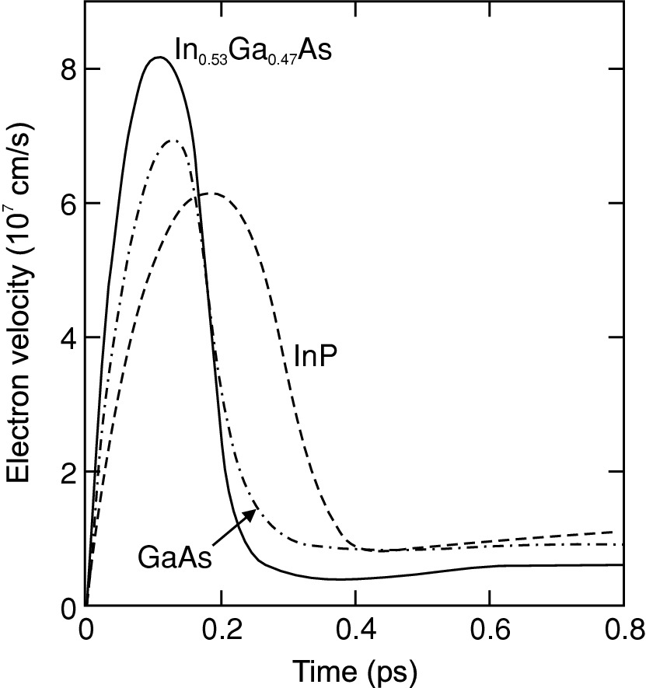

Fig. 8.16

Time dependence of the electron velocity at room temperature upon a step-like electric field (40 kV/cm) for GaAs (*dash-dotted line*), InP (*dashed line*) and In

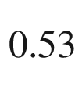

Ga

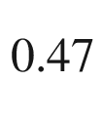

As (*solid line*)

#### 8.4.4 Impact Ionization

If the energy gain in the field is large enough to generate an electron–hole pair, the phenomenon of impact ionization occurs. The kinetic energy is

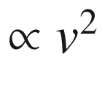

. Momentum and energy conservation apply. Thus, at small energies (close to the threshold for impact ionization) the vectors are short and collinear to fulfill momentum conservation. At higher energy, larger angles between the velocity vectors of the impact partners can also occur. If the process is started by an electron (Fig. [8.17](#u116076_4_En_8_Chapter-Fig17)a) the threshold energy is given by [770]

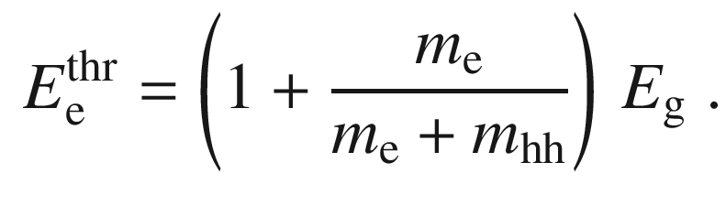

(8.31)

If the process starts with a heavy hole, the threshold [770],

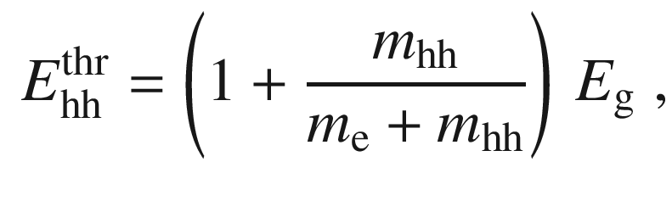

(8.32)

is larger because of the larger hole mass.

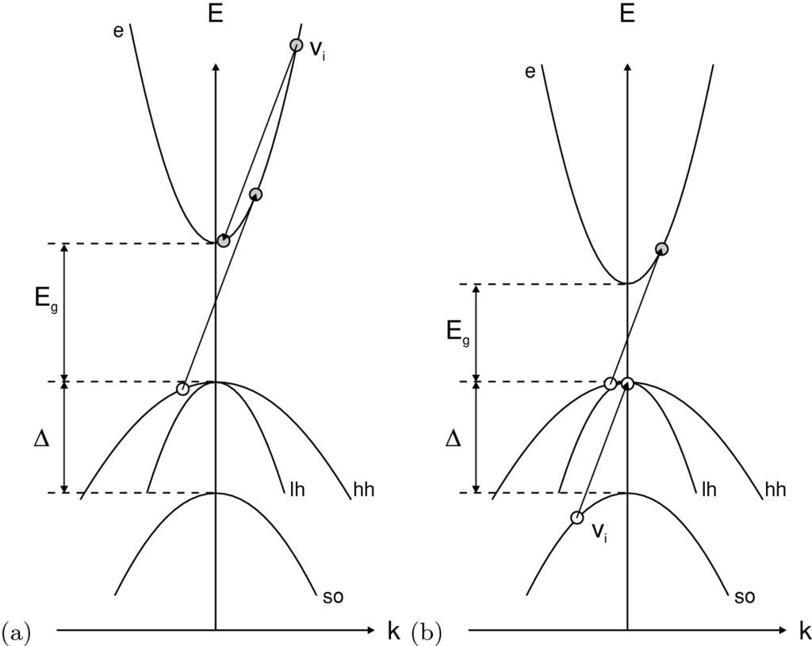

Fig. 8.17

Electron and hole transitions for impact ionization close to the threshold energy. Ionization is triggered by **a** an electron and **b** a split-off hole of velocity

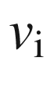

The threshold for impact ionization triggered by a split-off hole (shown schematically in Fig. [8.17](#u116076_4_En_8_Chapter-Fig17)b) is [771]

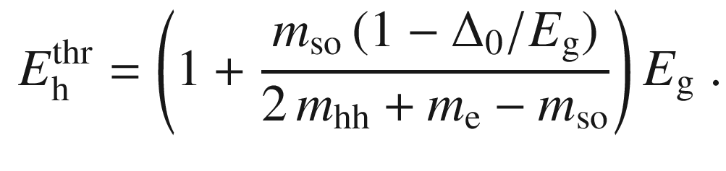

(8.33)

Thus so-holes have typically the smaller threshold.[3](#u116076_4_En_8_Chapter-Fn3) At energies where impact ionization occurs, non-parabolicities are typically important, thus ([8.31](#u116076_4_En_8_Chapter-Equ31))–([8.33](#u116076_4_En_8_Chapter-Equ33)) are only indicative. The threshold behavior and the dependence of the scattering rate as a function of the primary carrier energy in Si, calculated considering the detailed band structure, is shown in Fig. [8.18](#u116076_4_En_8_Chapter-Fig18).

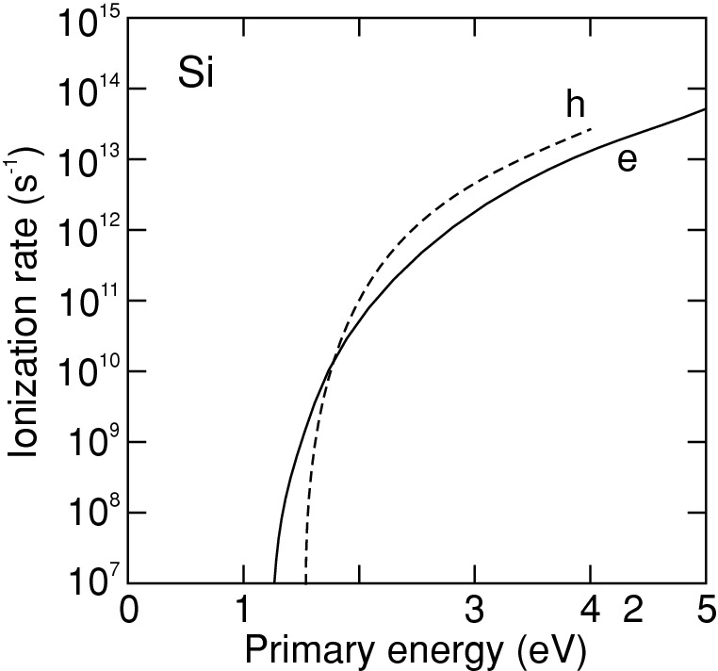

Fig. 8.18

Impact ionization rate as a function of primary carrier energy for electrons (*solid line*) and holes (*dashed line*) in silicon at room temperature. The curves are fit to results from a Monte-Carlo simulation.

Adapted from [772, 773]

The generation rate *G* of electron–hole pairs during impact ionization is given by

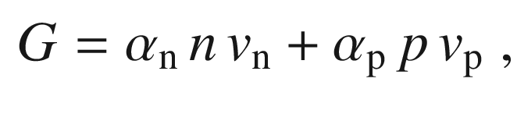

(8.34)

where

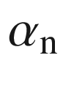

is the electron ionization coefficient. It describes the generation of electron–hole pairs per incoming electron per unit length.

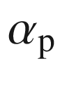

denotes the hole ionization coefficient. The coefficients depend strongly on the applied electric field. They are shown in Fig. [8.19](#u116076_4_En_8_Chapter-Fig19). They also depend on the crystallographic direction.

The impact ionization initiated by electrons and holes in silicon has been calculated considering the full band structure using a Monte Carlo technique in [772] and [773], respectively. In both cases the impact ionization rate is anisotropic for excess energies smaller than 3 eV and become isotropic above. The average energies at the moment of generation of secondary generated carriers depends linearly on the primary electron or hole energy.

The energy dependence of the electron initiated impact ionization rate has been calculated for GaAs, GaN and ZnS considering details and anisotropy of the band structure in [774]. The rates averaged over the Brillouin zone are compared in Fig. [8.20](#u116076_4_En_8_Chapter-Fig20). Because of the large band gap of GaN, impact ionization can only be generated by electrons in higher conduction bands. The sharp increase of ionization rate for GaN around 5.75 eV correlates with a large valence band DOS from hole states at the zone boundary.

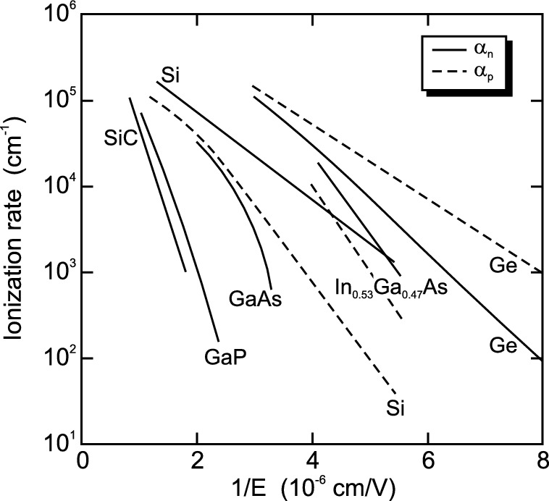

Fig. 8.19

Impact ionization rates for electrons and holes as a function of the inverse electric field for Si, Ge and other compound semiconductors at 300 K.

Adapted from [574]

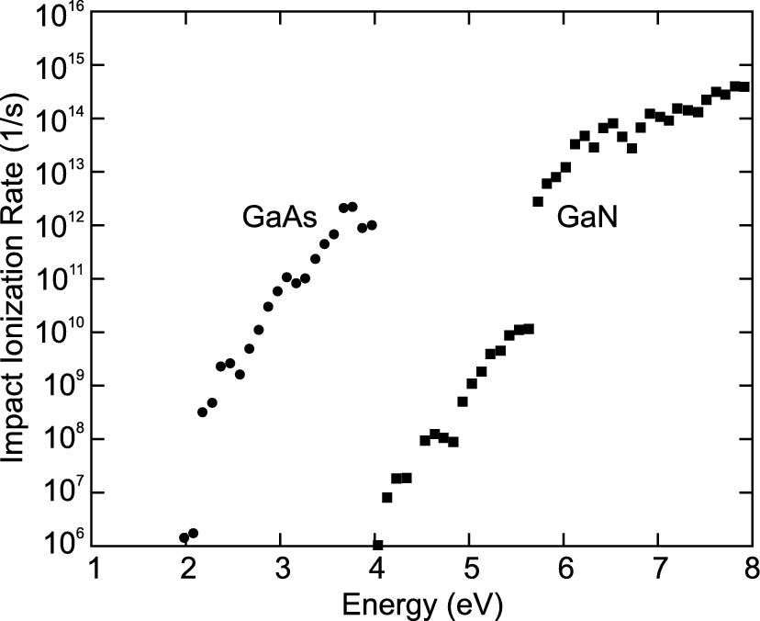

Fig. 8.20

Averaged rates for electron initiated impact ionization in GaAs (*circles*) and GaN (*squares*).

Adapted from [774]

### 8.5 High-Frequency Transport

The above consideration pertained to dc (or slowly varying) fields. Now, we consider an ac field. It accelerates the carriers but at the same time the dissipative force in the relaxation-time approximation is present, i.e. (for electrons)

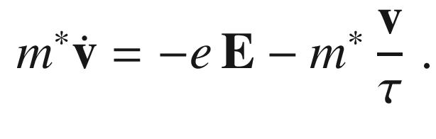

(8.35)

For a harmonic field

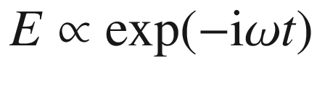

the complex conductivity (

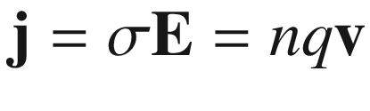

) is

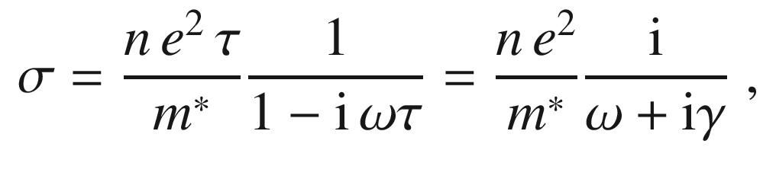

(8.36)

with

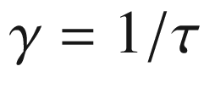

being the damping constant. Splitting into real and imaginary parts yields

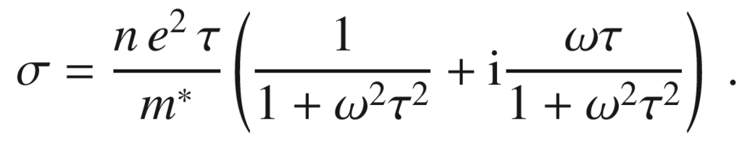

(8.37)

For small frequencies (

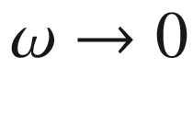

) the dc conductivity from ([8.5](#u116076_4_En_8_Chapter-Equ5)) is recovered, i.e.

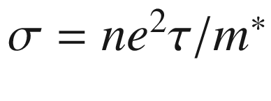

. For high frequencies (

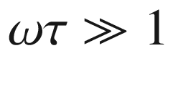

)

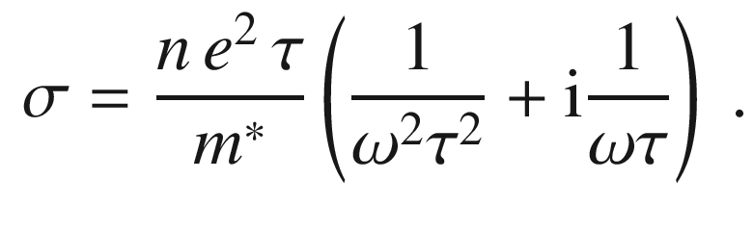

(8.38)

### 8.6 Impurity Band Transport

In Sect. [7.​5.​7](The_Physics_of_Semiconductors00003.docx#u116076_4_En_7_Chapter), the formation of an impurity band in the presence of high doping and overlap of impurity wave functions was discussed. The hopping (tunneling) transport of carriers from impurity to impurity leads to an additional transport channel termed ’impurity band conduction’[775–777]. The phenomenon has been found for many doped semiconductors, among them more recently GaAs:Mn [778] or Ga



O

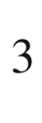

:Sn [779] where at low temperatures a constant carrier concentration is attributed to the impurity band conduction effect.

The random distribution of dopants essentially makes a doped semiconductor a disordered system. The physics of electronic states in disordered systems has been reviewed in [780]. A metal–insulator transition is observed at a certain value of doping (

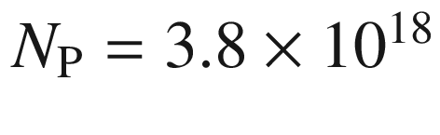

 cm



), as shown in Fig. [8.21](#u116076_4_En_8_Chapter-Fig21) for Si:P [781]. For a certain value of disorder all states become localized (Anderson localization [782, 783], cmp. Sect. [8.9](#u116076_4_En_8_Chapter-Sec29)).

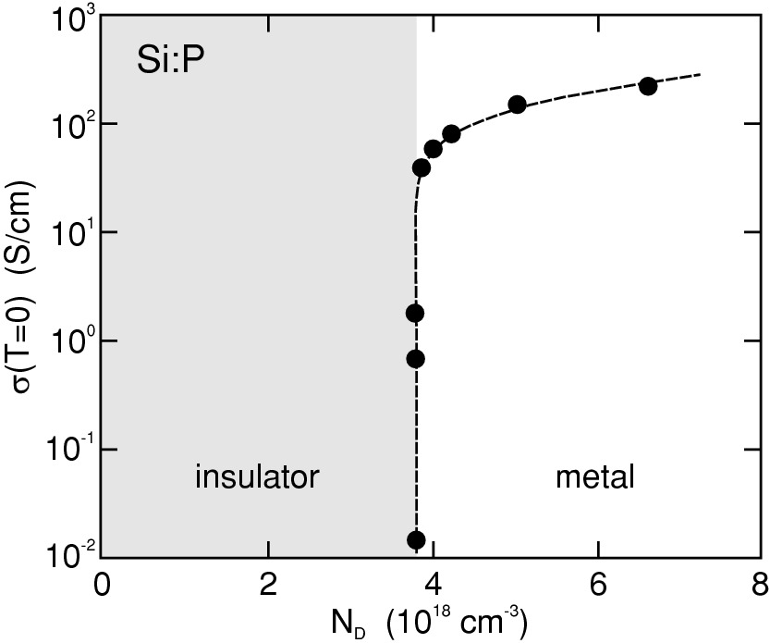

Fig. 8.21

Zero temperature conductivity of Si:P for various (donor) doping concentrations. Experimental data (*symbols*) and guide to the eye (*dashed line*).

Adapted from [781]

### 8.7 Polarons

In an ionic lattice, the electron polarizes the ions and causes a change of their equilibrium position. Depending on the severity of this effect, the lattice polarization leads to a modification of carrier (electron or hole) mass during band transport (Sect. [8.7.1](#u116076_4_En_8_Chapter-Sec26)) (*large* polarons) or the lattice deformation is so strong that it leads to carrier localization on the length scale of the lattice constant. Such self-trapped carriers are termed *small* polarons and discusssed in Sect. [8.7.1](#u116076_4_En_8_Chapter-Sec26). Reviews are given in [784, 785].

#### 8.7.1 Large Polarons

When  the electron moves through the ionic crystal and must drag an ion displacement with it, the effective electron mass changes to the ‘polaron mass’

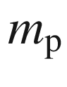

,[4](#u116076_4_En_8_Chapter-Fn4)

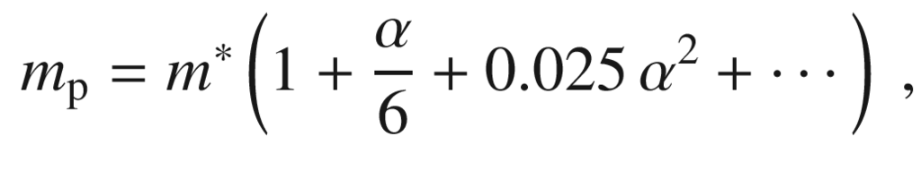

(8.39)

for

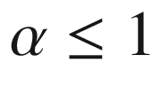

, with

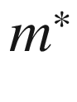

being the band mass as defined in Sect. [6.​9.​2](The_Physics_of_Semiconductors00003.docx#u116076_4_En_6_Chapter) and

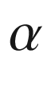

the Fröhlich coupling constant[5](#u116076_4_En_8_Chapter-Fn5)

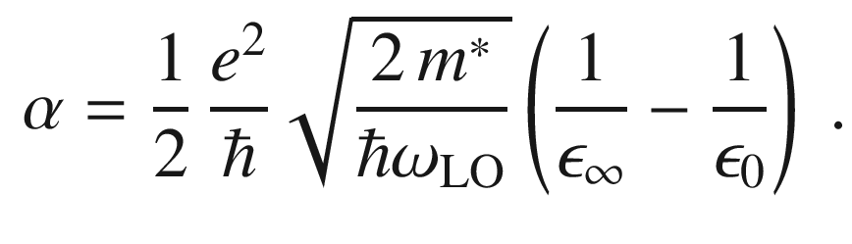

(8.40)

This process it called the *polaronic* effect and requires additional energy [786, 789]. Often, the polaron mass is given as

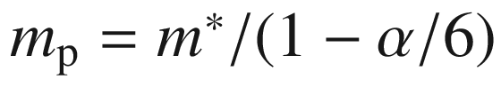

which is the result of perturbation theory [789] and an approximation to ([8.39](#u116076_4_En_8_Chapter-Equ39)) for small

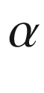

.

For large coupling parameter,

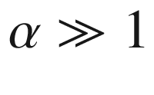

, the polaron mass is given by [787]

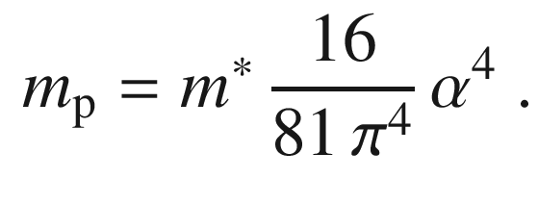

(8.41)

The energy of the electron is lowered due to the interaction with the lattice. The energy

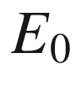

for

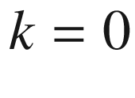

is given, relative to the uncoupled case, by

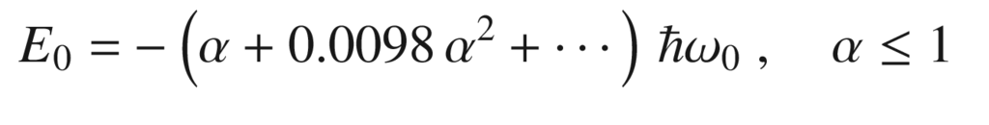

(8.42a)

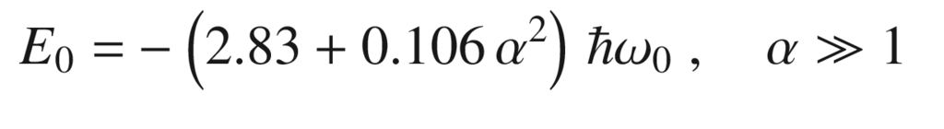

(8.42b)

Numerical results are reported in [790].

Polarons in semiconductors are typically ‘large’ or Fröhlich-type polarons, i.e. the coupling constant is small (Table [8.5](#u116076_4_En_8_Chapter-Tab5)). The dressing with phonons (as the ion displacement is called in a quantum-mechanical picture) is then only a perturbative effect and the number of phonons per electron (

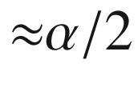

) is small. If

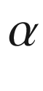

becomes large (

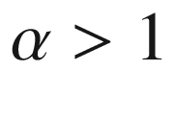

,

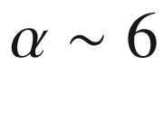

), as is the case for strongly ionic crystals such as alkali halides, the polaron becomes localized by the electron–phonon interaction[6](#u116076_4_En_8_Chapter-Fn6) and hopping occurs infrequently from site to site.Table 8.5

Fröhlich coupling constant



for various semiconductors. Data from [165]

|  |  |  |  |  |  |  |  |
| --- | --- | --- | --- | --- | --- | --- | --- |
| GaSb | GaAs | GaP | GaN | InSb | InAs | InP | InN |
| 0.025 | 0.068 | 0.201 | 0.48 | 0.022 | 0.045 | 0.15 | 0.24 |
| 3C-SiC | ZnO | ZnS | ZnSe | ZnTe | CdS | CdSe | CdTe |
| 0.26 | 1.19 | 0.63 | 0.43 | 0.33 | 0.51 | 0.46 | 0.35 |

#### 8.7.2 Small Polarons

In a polaron, the charge carrier (electron or hole) sits in a potential well resulting from the ionic displacements it created. In some materials, the shape and strength of this potential well is such that the charge is confined to a volume of approximately one unit cell or less. In this case, the polaron is called a small polaron. An example of a hole polaron in rutile TiO

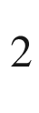

:Nb is depicted in Fig. [8.22](#u116076_4_En_8_Chapter-Fig22). In oxides often the hole from an acceptor is bound to oxygen, e.g. in BaTiO

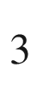

:Na, as reviewed in [791]. In Fig. [8.23](#u116076_4_En_8_Chapter-Fig23) the lattice relaxation due to a hole bound to oxygen in the monoclinc unit cell of

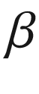

-Ga

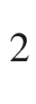

O

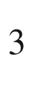

is depicted directly using aberration corrected TEM. The bonding of the hole to the oxygen atom breaks the bond to a Ga atom which moves by 0.1 nm from its equilibrium position [792].

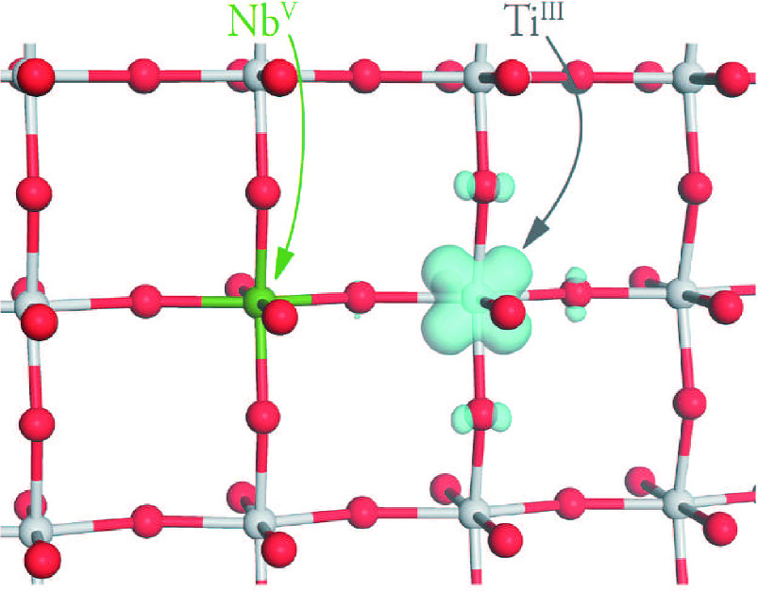

Fig. 8.22

Hole from Nb acceptor localized on Ti site (small polaron) in rutile TiO



.

Adapted from [793]

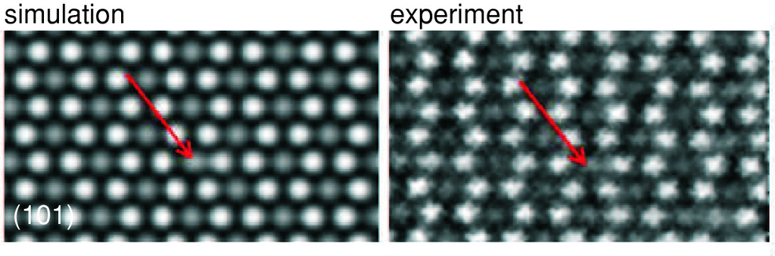

Fig. 8.23

Simulated and experimental TEM images of

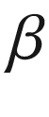

-Ga

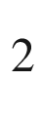

O



in (101) projection. The *arrow* denotes the position of a polaron.

Adapted from [792]

A proper theoretical analysis of a small polaron requires ab initio techniques that account for the motion of each atom in the few unit cells nearest the electron.[7](#u116076_4_En_8_Chapter-Fn7)

The transport of small polarons occurs generally via thermally-activated hopping (cmp. Sect. [8.8](#u116076_4_En_8_Chapter-Sec28)). Under certain conditions the following mobilities for drift and Hall effect have been given [784]:

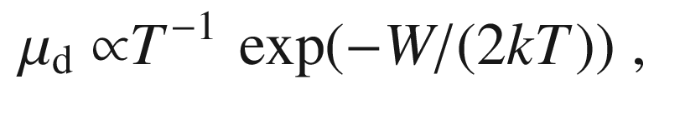

(8.43)

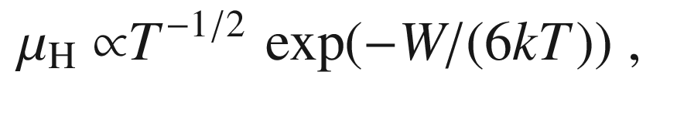

(8.44)

*W* being the polaron binding energy. Generally, materials with small polaron transport exhibit high carrier density, often due to structural defects, and low mobility.

### 8.8 Hopping Transport

Disordered solids such as amorphous semiconductors, films containing quantum dots or material with many defects are characterized by a large density of localized states which can form band tails or a large density of states within the band gap. Hopping conduction is the tunneling between localized states and has been treated with various models [795–797].

A commonly observed phenomenon is the variable range hopping with a conductivity given by

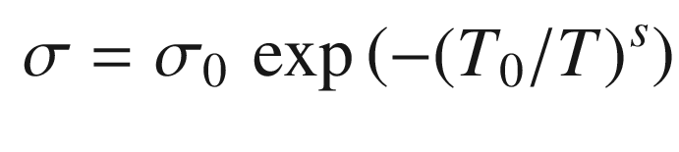

(8.45)

with

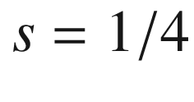

. Such law is fulfilled for amorphous silicon (Fig. [8.24](#u116076_4_En_8_Chapter-Fig24)). Mott has derived [799] the exponent

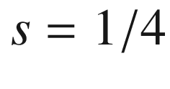

using the following argument: The probability *p* to hop from one localized site to another is proportional to

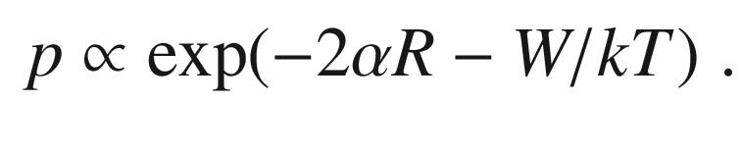

(8.46)

The first term stems from the probability to find the electron within radius *R* from its initial site,

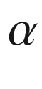

being the decay constant of its wave function,

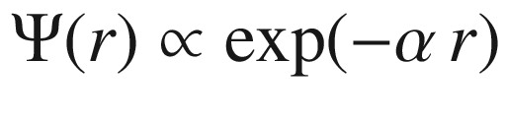

. The second term is the Boltzmann factor for bridging the energy mismatch *W* between localized states with a phonon-assisted process, assuming a low temperature limit (

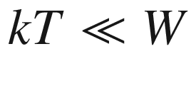

). There is a trade-off between hopping to levels closer in energy but spatially further away (on average), preferred at low temperature and the hopping to energy levels with larger *W* but spatially closer at higher temperatures. Thus the hopping range changes with temperature, giving the mechanism its name.

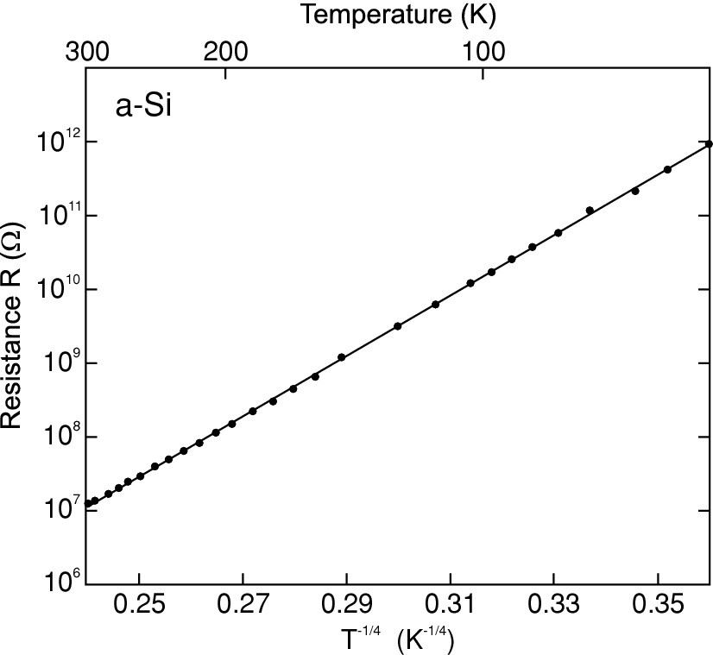

Fig. 8.24

Temperature dependence of the planar resistance for Si films deposited at room temperature. *Solid line* is linear fit with

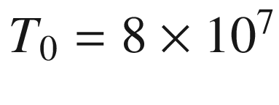

 K according to ([8.45](#u116076_4_En_8_Chapter-Equ46)) (

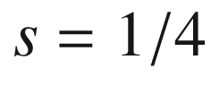

).

Adapted from [798]

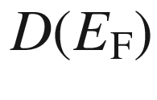

shall be the (constant) density of localized states around the Fermi level. Within a radius *R*, there is on average one state of energy between 0 and *W*(*R*) when (for three-dimensional bulk material)

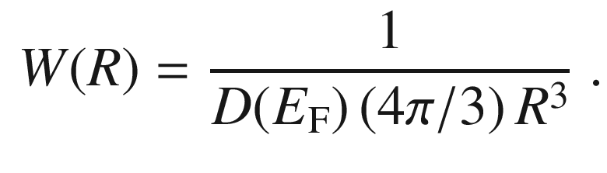

(8.47)

Substituting ([8.47](#u116076_4_En_8_Chapter-Equ48)) in ([8.45](#u116076_4_En_8_Chapter-Equ46)) and searching for the maximum yields the most probable hopping distance

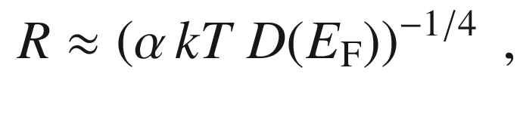

(8.48)

showing again, the varying range of hopping with temperature. Thus we find for

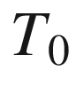

in ([8.45](#u116076_4_En_8_Chapter-Equ46)),

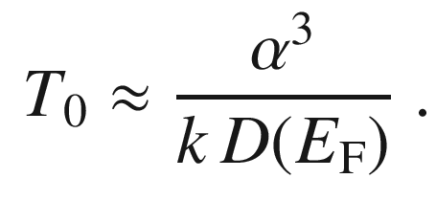

(8.49)

Other types of hopping mechanisms are the Efros–Shklovskii variable range hopping (

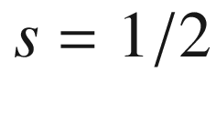

), emerging for an energy dependent density of states

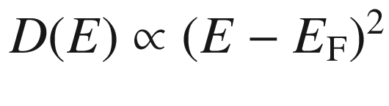

due to Coulomb interaction between hopping sites [800], or the next neighbor hopping (

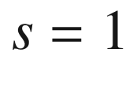

).

From ([8.45](#u116076_4_En_8_Chapter-Equ46)) one can rewrite for

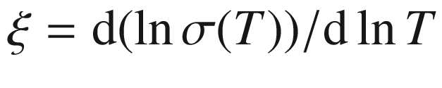

,

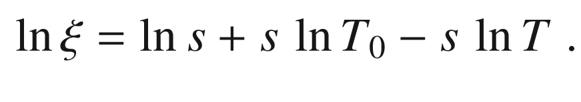

(8.50)

Thus in a plot of

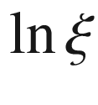

vs.

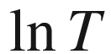

, the exponent *s* can be determined from the slope. As can be seen in Fig. [8.25](#u116076_4_En_8_Chapter-Fig25), for the conductivity of a hydrogenated amorphous silicon thin film the transition of hopping mechanism from Efros–Shklovskii variable range hopping (

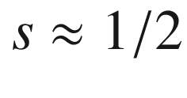

) to next neighbor hopping (

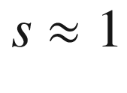

) takes place around

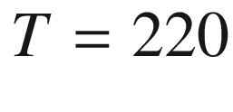

 K, as discussed in detail in [801].

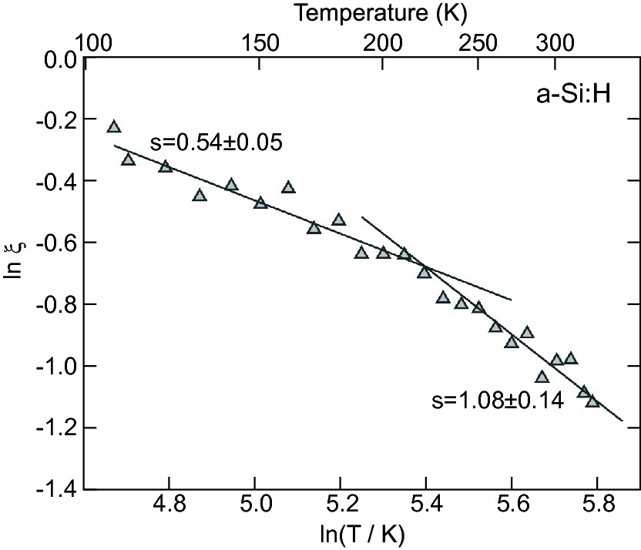

Fig. 8.25

Temperature dependence of conductivity of a hydrogenated amorphous Si thin film, plotted as

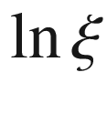

vs.

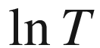

([8.50](#u116076_4_En_8_Chapter-Equ51)). *Solid lines* are linear fits for constant *s* according to ([8.50](#u116076_4_En_8_Chapter-Equ51)) as labelled.

Adapted from [801]

### 8.9 Transport in Amorphous Semiconductors

Many models have been presented for the carrier transport in amorphous semiconductors [203]. The most important concept is that of a *mobility edge*, an energy separating localized from delocalized states [547, 548, 802]. This is schematically depicted in Fig. [8.26](#u116076_4_En_8_Chapter-Fig26). The carrier transport between localized states is mediated via tunneling (hopping) which has been described in the previous section (Sect. [8.8](#u116076_4_En_8_Chapter-Sec28)). The localization of carriers in random lattices has been treated by Anderson [782] and reviewed in [780]. If the degree of disorder surpasses a certain value, diffusion is suppressed (at

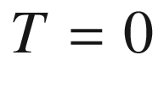

) and conductivity vanishes altogether (Anderson metal–insulator transition).

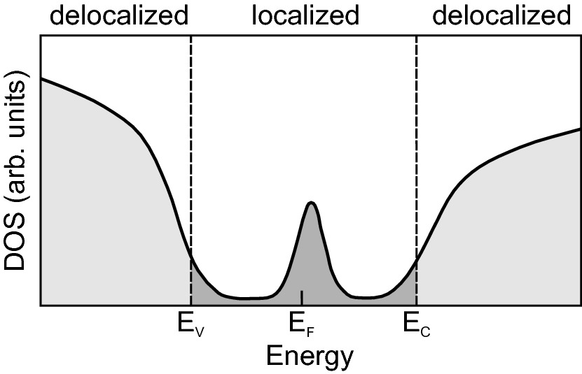

Fig. 8.26

Schematic density of states of amorphous semiconductor with band tails and deep levels. The localized (delocalized) states are shown in *dark* (*light*) *grey*. The mobility edges for electrons and holes are indicated by *dashed lines*

The transport in delocalized states is similar to band transport. The conductivity (for electrons) is given as

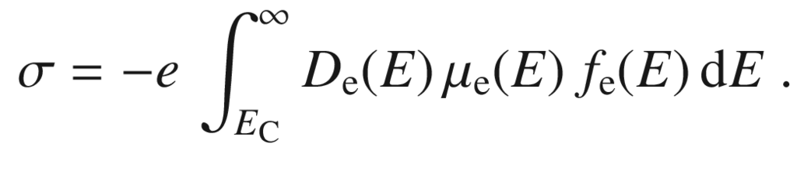

(8.51)

If the Fermi energy is close to the middle of the gap, pinned to deep states, the Fermi-Dirac distribution can be replaced by the Boltzmann factor. Assuming a constant density of states and mobility for the delocalized states,

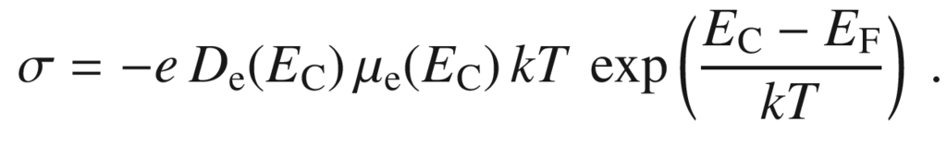

(8.52)

Charge carriers from localized states in the tails can be thermally excited into delocalized states and contribute to conductivity (thermally activated hopping). The mobility then contains an exponential thermal activation term [203].

### 8.10 Ionic Transport

Ionic transport is the movement of ions upon application of a voltage. Here, we discuss only solid electrolytes. The transport can include the motion of one or several of the constituents of the lattice and the transport of other ions (e.g. hydrogen ions (protons), oxygen ions) through the crystal. Related to this is the diffusive ionic movement of impurities or defects through the crystal (cmp. Sect. [4.​2.​3](The_Physics_of_Semiconductors00002.docx#u116076_4_En_4_Chapter)). Ionic conduction of the lattice constituents under dc voltage will eventually destroy the crystal.

In typical semiconductors like silicon or gallium arsenide, the conductivity is entirely due to electronic conduction. A typical solid electrolyte is zirconia (ZrO

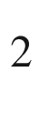

) doped with yttria, so-called yttria-stabilized zirconia (YSZ) that takes on a cubic fluorite lattice (see Sect. [3.​4.​8](The_Physics_of_Semiconductors00001.docx#u116076_4_En_3_Chapter)). It can conduct oxygen ions via the mobility of oxygen vacancies for use in solid-oxide fuel cells (SOFC) [803]. The conductivity is about 0.01 S/cm at a temperature around 1000 K, almost entirely due to ionic transport. Doping with calcium oxide results in an oxygen conductor that is used in oxygen sensors in automobiles (lambda sensor). The ionic conductivity can be significantly increased, compared to bulk material, along interfaces [804, 805].

Other typical solid electrolytes are copper iodide (CuI) [568] and also AgI. In the high temperature cubic phase (



-polymorph), the iodide ions form a fairly rigid cubic framework and the metal ions are mobile; the copper diffusion pathways have been discussed [806, 807]. The temperature dependence of conductivity of CuI is shown in Fig. [8.27](#u116076_4_En_8_Chapter-Fig27).

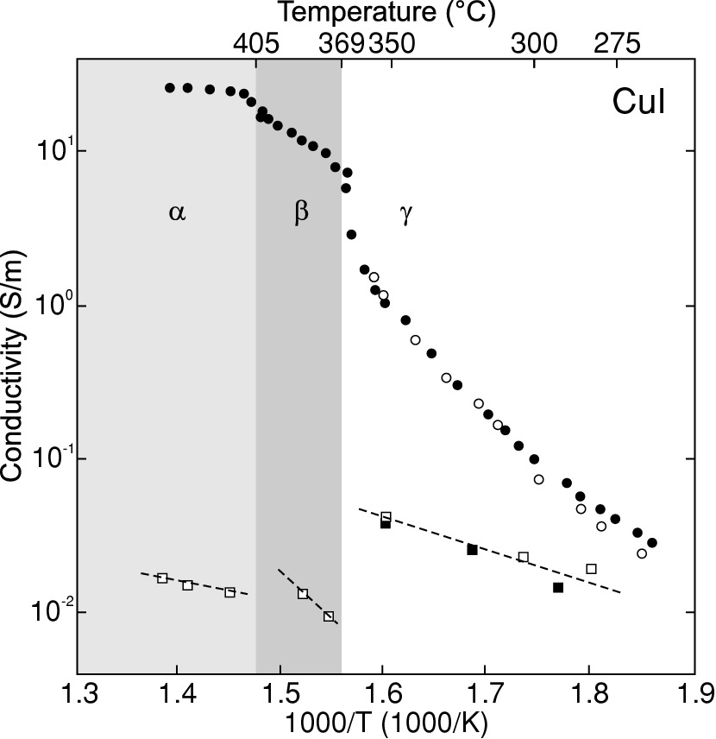

Fig. 8.27

Total (*circles*) and electronic (*squares*) conductivity of CuI coexisting with copper. *Filled* (*empty*) symbols refer to polycrystalline (single crystal) samples. The different structural phases (

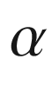

(cubic),



(wurtzite),

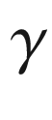

(zincblende)) are indicated by shaded areas as labeled. *Dashed lines* are guides to the eye.

Adapted from [808]

### 8.11 Diffusion

A gradient of a particle concentration *n* leads to a particle current proportional to

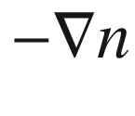

. This diffusion law (Fick’s law) corresponds microscopically to a random walk. The gradients of the semiconductor carrier densities

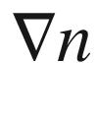

or

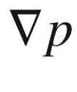

thus lead to electron and hole currents, respectively:

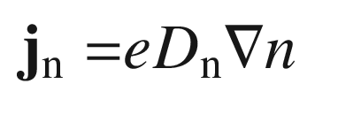

(8.53a)

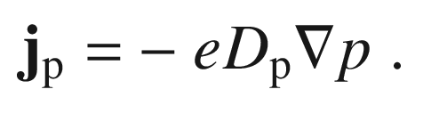

(8.53b)

The coefficients

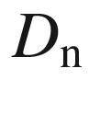

and

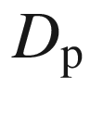

are called the electron and hole diffusion coefficient, respectively. Thus the total electron and hole currents in the presence of an electric field

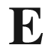

and diffusion are

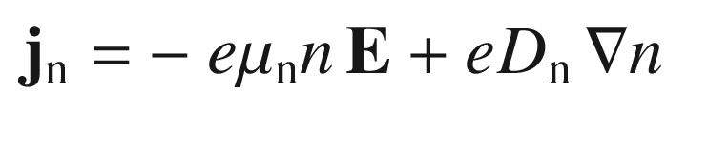

(8.54a)

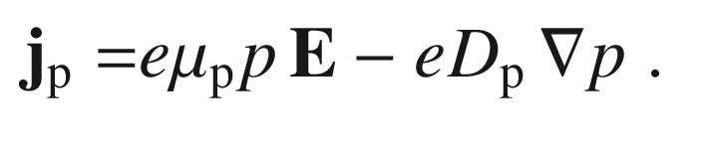

(8.54b)

This relation can also be deduced more generally from the gradient of the Fermi level as

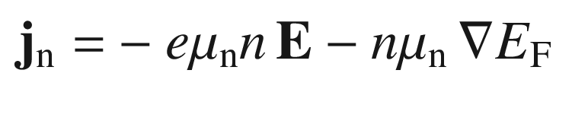

(8.55a)

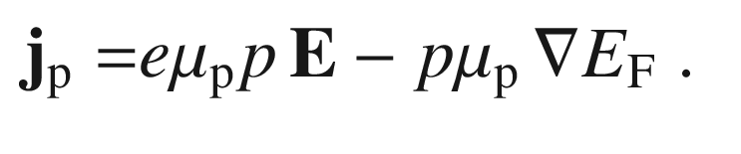

(8.55b)

Using ([7.​6](The_Physics_of_Semiconductors00003.docx#u116076_4_En_7_Chapter)) and ([7.​7](The_Physics_of_Semiconductors00003.docx#u116076_4_En_7_Chapter)) for the concentrations (valid also in the case of degeneracy) and using

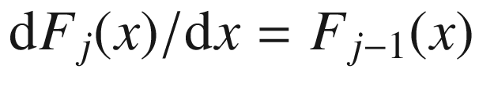

we obtain

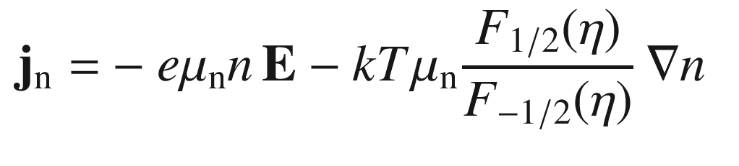

(8.56a)

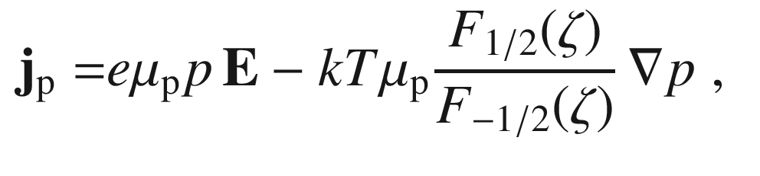

(8.56b)

with

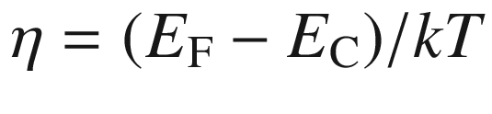

and

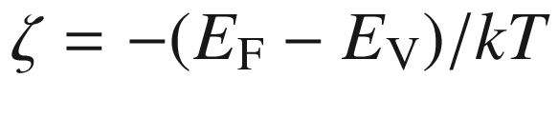

. If the pre-factor of the density gradient is identified as the diffusion coefficient we find the (generalized) so-called ‘Einstein relations’ (

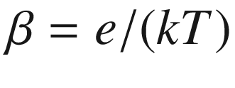

) [608, 809]:

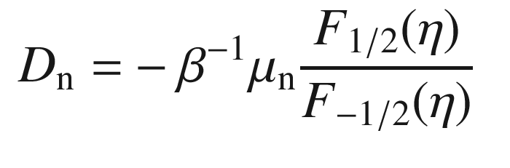

(8.57a)

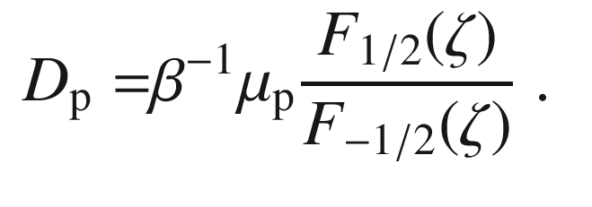

(8.57b)

The effect of non-parabolicity has been included in [810].

Useful analytical approximations have been discussed in [811]. We note that, e.g., ([8.57a](#u116076_4_En_8_Chapter-Equ62)) can also be written as [812, 813]

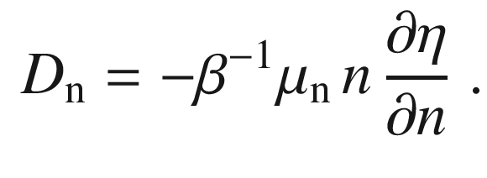

(8.58)

In the case of nondegeneracy, i.e. when the Fermi level is within the band gap and not closer than about 4*kT* to the band edges,

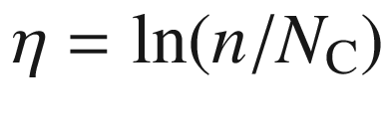

. Then

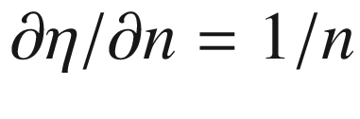

, and the equation simplifies to

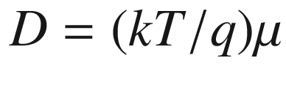

, i.e. the ‘regular’ Einstein-relations,

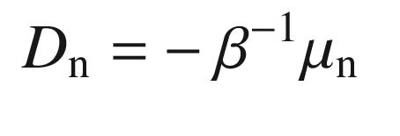

(8.59a)

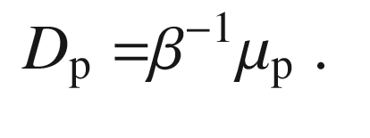

(8.59b)

In this case, ([8.54a](#u116076_4_En_8_Chapter-Equ56),b) read

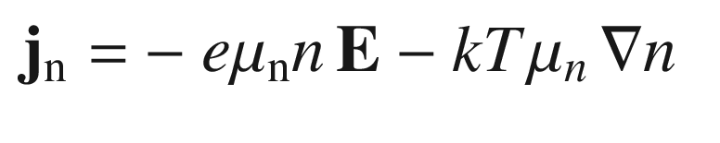

(8.60a)

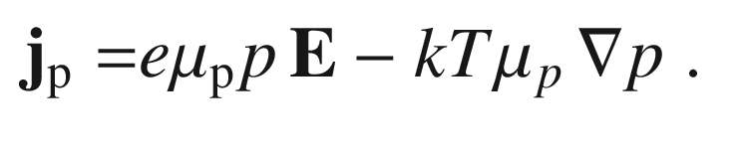

(8.60b)

We recall that both diffusion coefficients are positive numbers, since

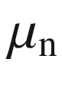

is negative. Generally, the diffusion coefficient depends on the density. A Taylor series of the Fermi integral yields

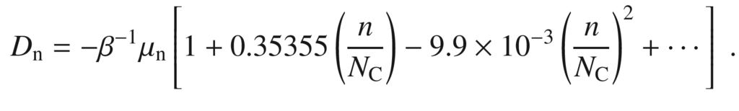

(8.61)

### 8.12 Continuity Equation

The balance equation for the charge is called the continuity equation. The temporal change of the charge in a volume element is given by the divergence of the current and any source (generation rate *G*), e.g. an external excitation, or drain (recombination rate *U*). Details about recombination mechanisms are discussed in Chap. [10](The_Physics_of_Semiconductors00005.docx#u116076_4_En_10_Chapter). Thus, we have

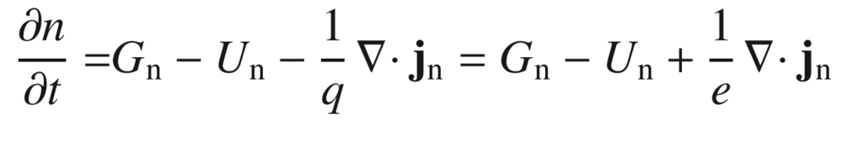

(8.62a)

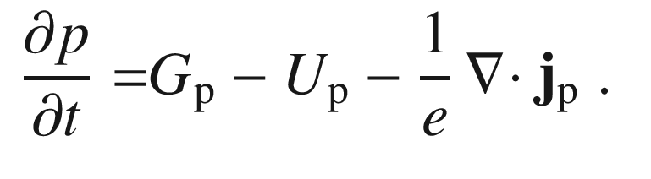

(8.62b)

In the case of nondegeneracy we find, using ([8.54a](#u116076_4_En_8_Chapter-Equ56)b)

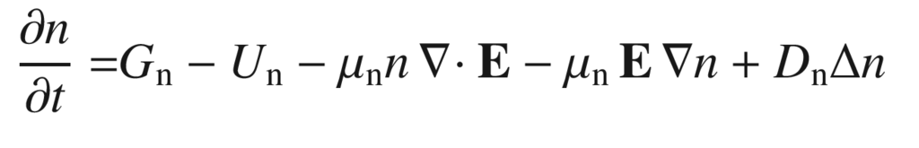

(8.63a)

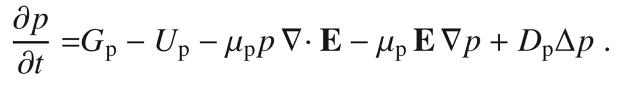

(8.63b)

In the case of zero electric field these read

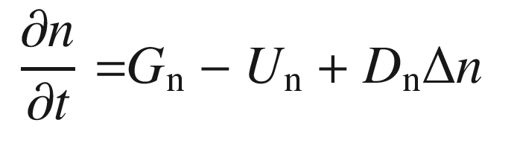

(8.64a)

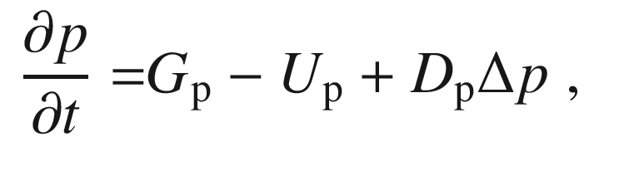

(8.64b)

and if the stationary case also applies:

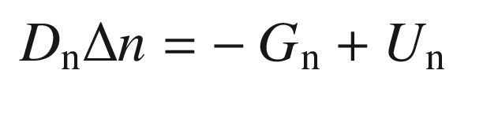

(8.65a)

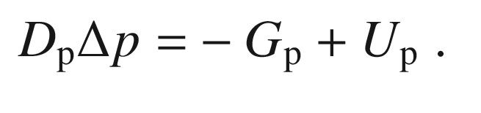

(8.65b)

### 8.13 Heat Conduction

We consider here the heat transport [814] due to a temperature gradient. The heat flow

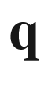

, i.e. energy per unit area per time in the direction

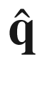

, is proportional to the local gradient of temperature. The proportionality constant

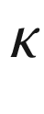

is called, heat conductivity,

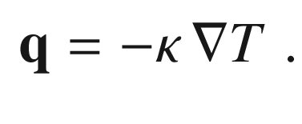

(8.66)

In crystals, the heat conductivity can depend on the direction and thus

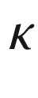

is generally a tensor of rank 2. In the following,

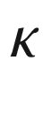

will be considered as a scalar quantity. The quite generally valid Wiedemann–Franz law connects the thermal and electrical conductivities

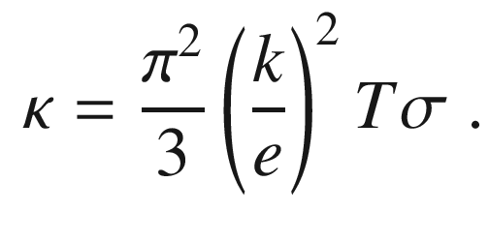

(8.67)

The balance (continuity) equation for the heat energy *Q* is

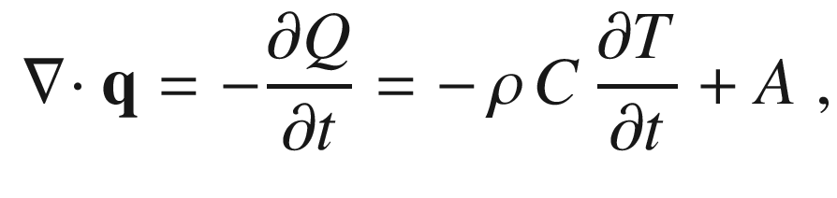

(8.68)

where

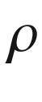

denotes the density of the solid and *C* the heat capacity. *A* denotes a source or drain of heat, e.g. an external excitation. Combining ([8.66](#u116076_4_En_8_Chapter-Equ78)) and ([8.68](#u116076_4_En_8_Chapter-Equ80)), we obtain the equation for heat conductivity

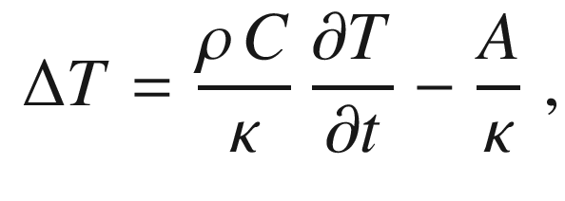

(8.69)

which simply reads

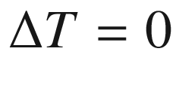

for a stationary situation without sources.

The random mixture of various atoms in natural elements represents a perturbation of the perfectly periodic lattice. Since the mass of the nuclei varies, in particular lattice vibrations will be perturbed. Thus we expect an effect on the heat conductivity. In Fig. [8.28](#u116076_4_En_8_Chapter-Fig28), the thermal conductivity of crystals from natural Ge and enriched

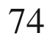

Ge are compared [815], the latter having, as expected, the higher heat conductivity, i.e. less scattering. The

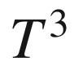

-dependence of the heat conductivity at low temperature has been attributed to scattering of phonons at the sample boundary [816]. The thermal conductivity of isotopically pure

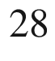

Si thin films has been measured to be 60% greater than natural silicon at room temperature and at least 40% greater at 100

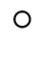

C, a typical chip operating temperature [817, 818].

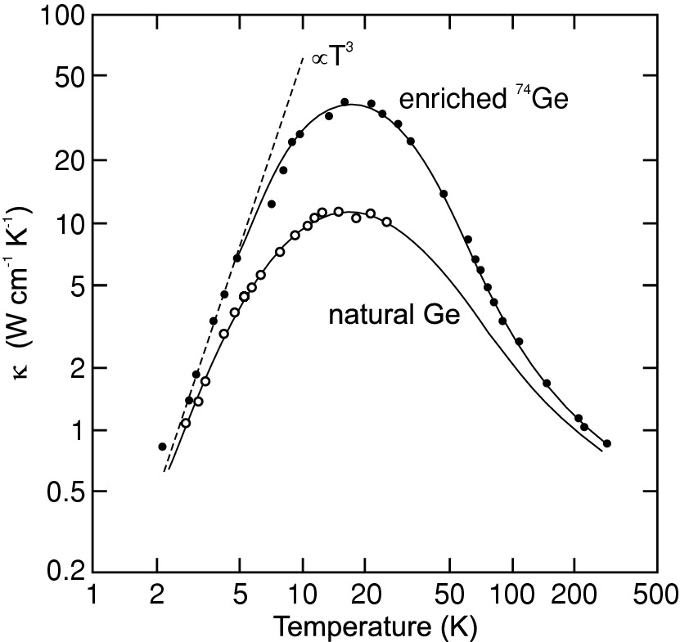

Fig. 8.28

Thermal conductivity of Ge vs. temperature. The enriched Ge consists of 96%

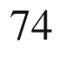

Ge while the natural isotope mix is 20%

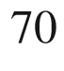

Ge, 27%

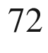

Ge, 8%

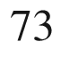

Ge, 27%



Ge and 8%

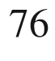

Ge. The *dashed line* shows a

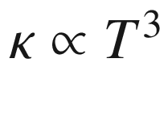

dependence at low temperatures.

Adapted from [815]

### 8.14 Coupled Heat and Charge Transport

The standard effect of coupled charge and heat transport is that a current heats its conductor via Joule heating. However, more intricate use of thermoelectric effects can also be employed to cool certain areas of a device. For further details see [819, 820].

For the analysis of coupled charge and heat transport we first sum the electric field and the concentration gradient to a new field

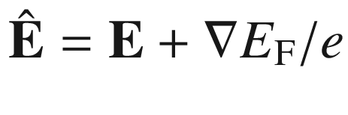

. Then, the heat flow and charge current are

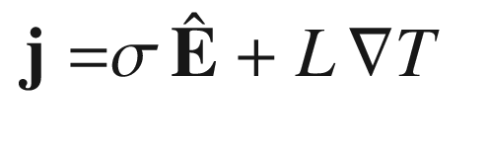

(8.70)

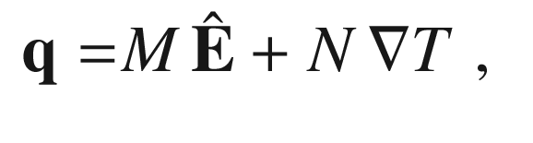

(8.71)

where

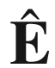

and

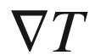

are the stimulators for the currents. From the experimental point of view there is interest to express the equations in

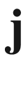

and

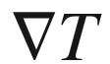

since these quantities are measurable. With new coefficients they read

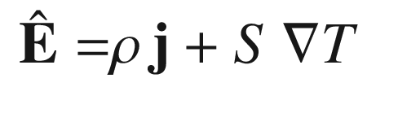

(8.72)

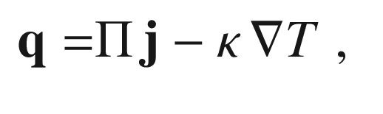

(8.73)

where

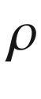

, *S* and

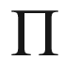

are the specific resistance, thermoelectric power and Peltier coefficient (transported energy per unit charge), respectively. The relations with the coefficients

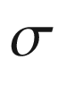

, *L*, *M*, and *N* are given by

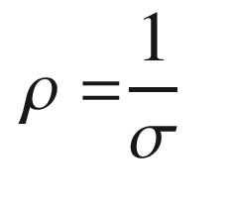

(8.74a)

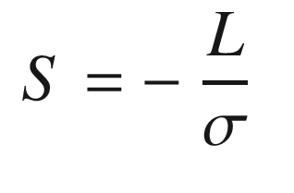

(8.74b)

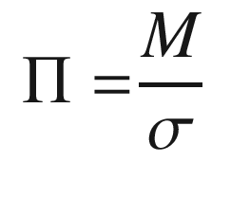

(8.74c)

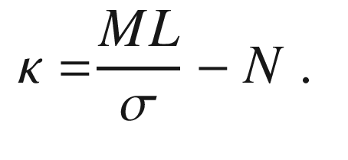

(8.74d)

#### 8.14.1 Thermopower and Seebeck Effect

A semiconductor shall have two ends at different temperatures

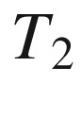

and

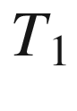

and a temperature gradient in between in an open circuit, i.e.

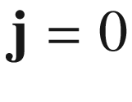

. Then a field

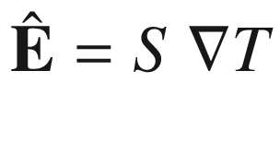

and a voltage

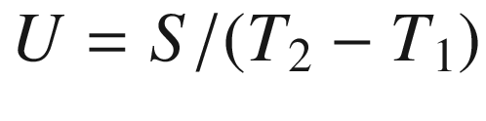

will arise. This effect is called the thermoelectric or Seebeck effect. *S* is termed the Seebeck coefficient or the *thermoelectric power* , often also denoted as *Q* in the literature. The voltage can be measured and used to determine the temperature at one end if the temperature at the other end is known, forming a thermometer. The Seebeck coefficient is positive if the electric field is in the same direction as the temperature gradient.

A famous relation from irreversible thermodynamics connects it to the Peltier coefficient via

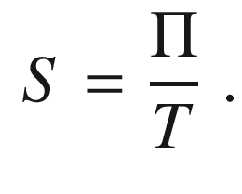

(8.75)

The Seebeck coefficient is related to the energy transport by charge carriers. The heat (energy) flow is obviously from the hot to the cold end (assuming here

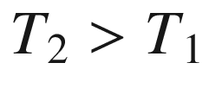

), so is the flow of charge carriers. In a simple picture, if the energy is carried by (hot) holes, the current (by definition the direction of positive charge carriers) is from the hot to the cold end (

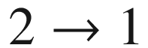

); if the energy flow is carried by electrons, the current flows from the cold to the hot end (

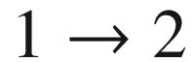

). Accordingly, energy transport by electrons and holes gives rise to different signs of the thermoelectric coefficient (Fig. [8.29](#u116076_4_En_8_Chapter-Fig29)). If the cold (unheated) substrate is grounded, the sign of the voltage at a hot solder tip pressed (carefully) on the surface of the semiconductor yields the conductivity type, n-type (p-type) for a negative (positive) voltage.

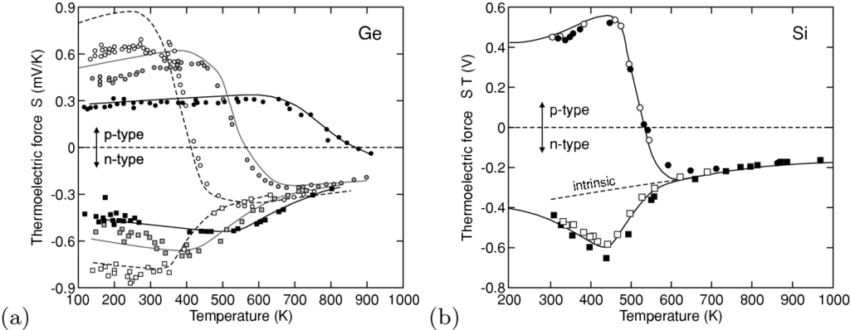

Fig. 8.29

**a** Seebeck coefficient *S* for n- and p-doped germanium. Experimental data (*symbols*) and theory (*lines*).

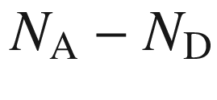

is

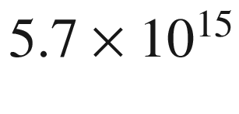

 cm



(*white circles*),

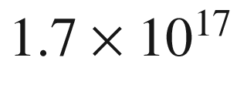

 cm



(*grey*) and

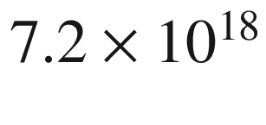

 cm



(*black*);

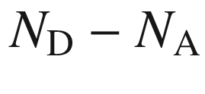

is

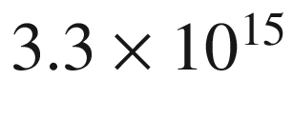

 cm



(*white squares*),

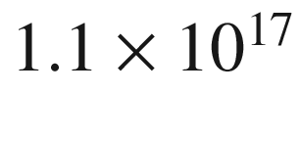

 cm



(*grey*) and

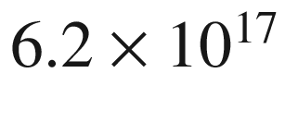

 cm



(*black*). Adapted from [821]. **b** Thermoelectric force

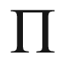

of lowly doped n- and p-silicon as a function of temperature. *Solid line* is from simple model calculation and *symbols* represent data from silicon samples with the approximate doping of *circles*:

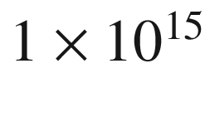

 cm



B,

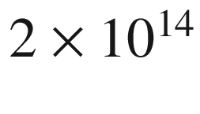

 cm

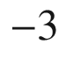

donors, *squares*:

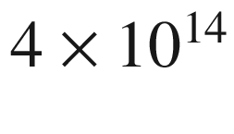

 cm



P,

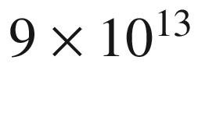

 cm



acceptors.

Adapted from [822]

However, the semiconductor should not be heated so strongly that intrinsic conduction arises. In this case the conductivity and the thermoelectric power is determined by the carrier type with the higher mobility; typically, and for the case of silicon shown in Fig. [8.29](#u116076_4_En_8_Chapter-Fig29), these are the electrons thus yielding a negative Seebeck coefficient in the intrinsic regime.

For band conduction the thermopower (J.29) is given for electrons (

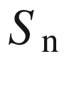

) and holes (

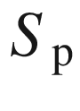

) by [823] (for a derivation see Appendix J.4)

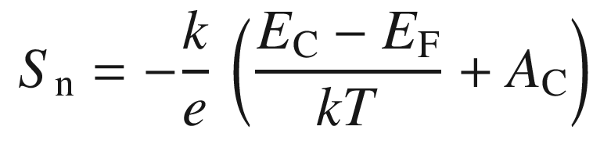

(8.76a)

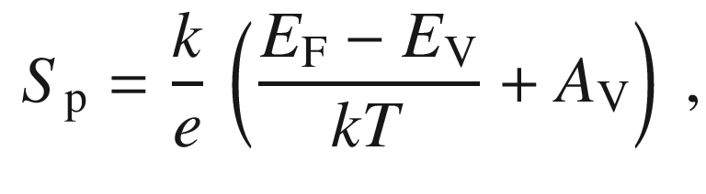

(8.76b)

where

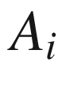

are constants (J.31a) depending on the energy dependence of the density of states and the mobility. The sign of the thermopower tells whether conduction takes place above (negative sign) or below (positive sign) the Fermi level.

If the Fermi level is fixed and both electrons and holes contribute (two-band conduction), the thermopower is (evaluating (J.32),

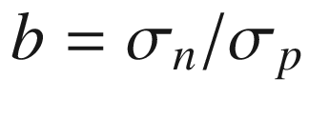

and the gap center energy

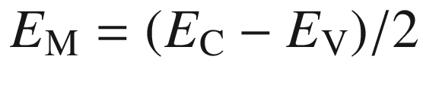

)

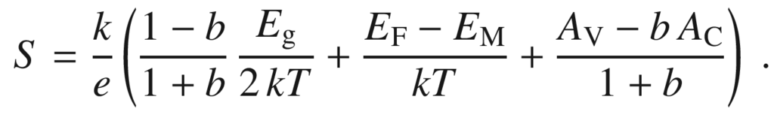

(8.77)

In the case of intrinsic conduction from ([7.​18](The_Physics_of_Semiconductors00003.docx#u116076_4_En_7_Chapter))

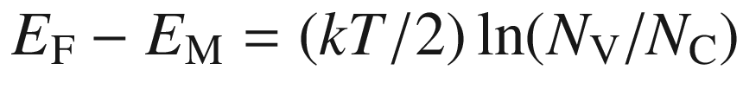

.

The thermoelectric power from some highly doped n-type silicon samples is depicted in Fig. [8.30](#u116076_4_En_8_Chapter-Fig30)a. At low temperature the (low) conductivity is due to conduction in a donor impurity band (cmp. Sect. [7.​5.​7](The_Physics_of_Semiconductors00003.docx#u116076_4_En_7_Chapter)). At high compensation of about 90% (grey data points in Fig. [8.30](#u116076_4_En_8_Chapter-Fig30)a), the band is only 10% filled and acts like a valence band with positive thermopower at sufficiently low temperature when the free carrier density is small. Without compensation, the thermopower remains negative since the almost completely filled impurity band acts conduction band like. The dependence of thermopower on doping has been simulated in [824] (Fig. [8.30](#u116076_4_En_8_Chapter-Fig30)); the decrease with increasing doping is mostly attributed to the reduced mobility due to ionized impurity scattering. The increase of thermopower at low temperatures is due to the *phonon-drag* effect which is discussed for the samples from [822] in [825].

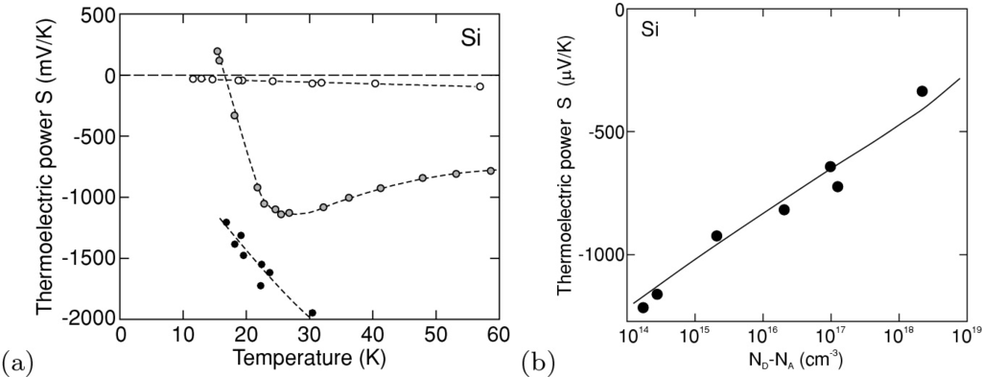

Fig. 8.30

**a** Thermoelectric power *S* of highly doped n-type silicon as a function of temperature. *Circles* are experimental data and *dashed lines* guides to the eye. The approximate doping of the samples is *white*:

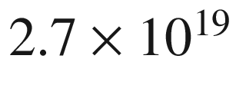

 cm



As, *grey*:

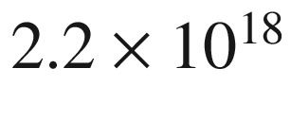

 cm



As, *black*:

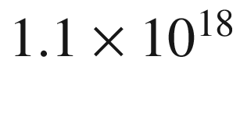

 cm



As and

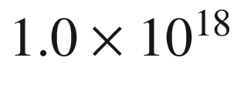

 cm



B with

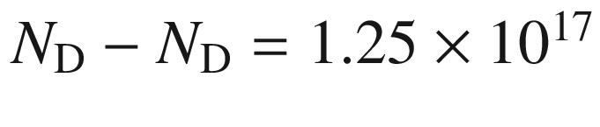

 cm



at room temperature. Adapted from [822]. **b** Thermopower of doped n-type silicon at room temperature as a function of doping concentration. Experimental data (*symbols*) from [822] and theory (*solid line*) from [824]

As a figure of merit for the production of thermoelectric power the *ZT*-value is used,

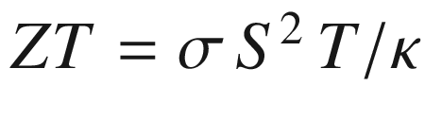

.

#### 8.14.2 Peltier Effect

In a semiconductor with a temperature difference at its ends a current flow will be allowed now (short circuit). The current leads via the charge transport also to a heat (or energy) transport. This effect is called the Peltier effect. The Peltier coefficient is negative (positive) for electrons (holes). The total amount of energy *P* that is transported consists of the generation term and the loss due to transport:

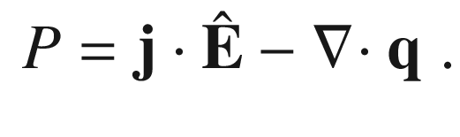

(8.78)

With ([8.72](#u116076_4_En_8_Chapter-Equ84)) and ([8.73](#u116076_4_En_8_Chapter-Equ85)) we find

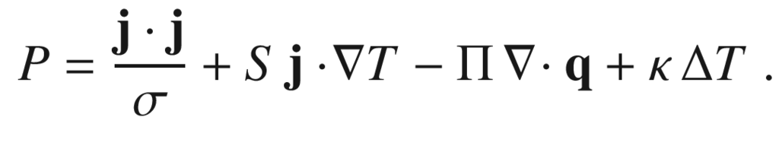

(8.79)

The first term is Joule heating, the second term is Thomson heating. The third exists only when carriers are generated or when they recombine. The fourth term is the heat conduction. In the Thomson term

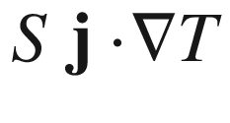

heat is generated in an n-type semiconductor if

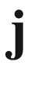

and

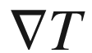

are in the same direction. This means that electrons that move from the hotter to the colder part transfer energy to the lattice. The effect can be used to construct a thermoelectric cooler, as shown in Fig. [8.31](#u116076_4_En_8_Chapter-Fig31), that generates a temperature difference due to a current flow. For optimal performance

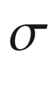

should be large to prevent excess Joule heating and

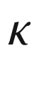

should be small such that the generated temperature difference is not rapidly equalized.

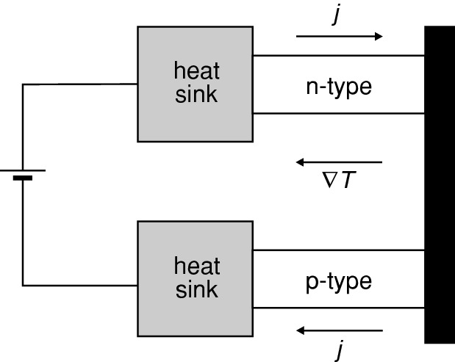

Fig. 8.31

Schematic Peltier cooler. The heat sinks (*grey*) and the cold junction (*black*) on the left are metals that make ohmic contacts with the semiconductors. The current flow is such that electrons move through the n-type semiconductor from right to left

Footnotes

[1](#u116076_4_En_8_Chapter-Fn1_source)

Going beyond the relaxation time approximation is discussed in Appendix J.

[2](#u116076_4_En_8_Chapter-Fn2_source)

The following arguments may only be followed once the concept of depletion layers and band bending is understood, see Sect. [21.​2.​1](The_Physics_of_Semiconductors00007.docx#u116076_4_En_21_Chapter).

[3](#u116076_4_En_8_Chapter-Fn3_source)

Assuming

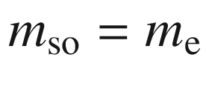

,

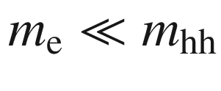

and

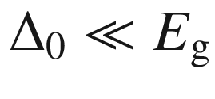

,

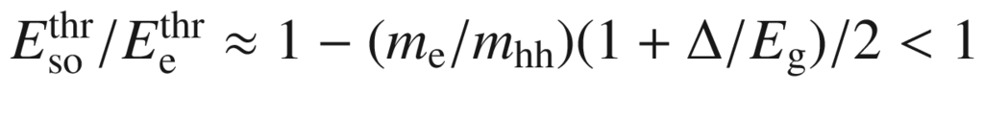

.

[4](#u116076_4_En_8_Chapter-Fn4_source)

For the calculation, many-particle theory and techniques are needed; the best solution is still given by Feynman’s path integral calculation [786–788].

[5](#u116076_4_En_8_Chapter-Fn5_source)

This constant is part of the matrix element in the Hamiltonian of the electron–phonon interaction and is related to the electric field created by LO phonons, as given in ([9.​29](#u116076_4_En_9_Chapter)).

[6](#u116076_4_En_8_Chapter-Fn6_source)

One can think about it in the way that the electron strongly polarizes the lattice and digs itself a potential hole out of which it can no longer move.

[7](#u116076_4_En_8_Chapter-Fn7_source)

This paragraph has been taken from the concise tutorial by S.J.F. Byrnes [794].

© Springer Nature Switzerland AG 2021

M. Grundmann

The Physics of Semiconductors

Graduate Texts in Physics

<https://doi.org/10.1007/978-3-030-51569-0_9>

## 9. Optical Properties

Marius Grundmann[1](#u116076_4_En_9_Chapter-Aff11)

(1)

Felix Bloch Institute for Solid State Physics, Universität Leipzig, Leipzig, Germany

Marius Grundmann

Email:

[grundmann@physik.uni-leipzig.de](mailto:grundmann@physik.uni-leipzig.de)

*Do not Bodies and Light act mutually upon one another.*

*Sir I. Newton, 1704* [826]

## Abstract

After introduction of the complex dielectric function, reflection, diffraction are briefly discussed. The focus lies on absorption mechanisms; several transition types (direct and indirect band-band transitions, impurity-related transitions, lattice absorption) are discussed including the effects of excitons, polaritons and high carrier density. Also the various effects of the presence of free carriers are given.

### 9.1 Spectral Regions and Overview

The interaction of semiconductors with light is of decisive importance for photonic and optoelectronic devices  as well as for the characterization of semiconductor properties. When light hits a semiconductor, reflection, transmission and absorption are considered, as for any dielectric material. The response of the semiconductor largely depends on the photon energy (or wavelength) of the light and various processes contribute to the dielectric function.

An overview of the electromagnetic spectrum in the optical range is given in Table [9.1](#u116076_4_En_9_Chapter-Tab1). The energy and wavelength of a photon are related by[1](The_Physics_of_Semiconductors00005.docx#u116076_4_En_9_Chapter-Fn1)

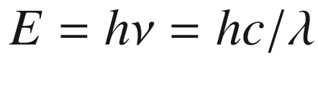

, i.e.

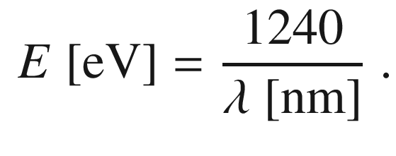

(9.1)

In the infrared regime, energy is often measured in wave numbers (cm

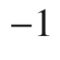

) for which the conversion 1 meV

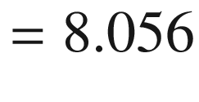

 cm

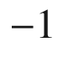

holds.Table 9.1

Spectral ranges with relevance to semiconductor optical properties

| Range |  | Wavelengths | Energies |
| --- | --- | --- | --- |
| Deep ultraviolet | DUV | $${&lt;}250$$   nm | $${&gt;}5$$   eV |
| Ultraviolet | UV | 250–400 nm | 3–5 eV |
| Visible | VIS | 400–800 nm | 1.6–3 eV |
| Near infrared | NIR | 800 nm–2  $$\upmu $$  m | 0.6–1.6 eV |
| Mid-infrared | MIR | 2–20  $$\upmu $$  m | 60 meV–0.6 eV |
| Far infrared | FIR | 20–80  $$\upmu $$  m | 1.6–60 meV |
| THz region | THz | $${&gt;}80$$    $$\upmu $$  m | $${&lt;}1.6$$   meV |

### 9.2 Complex Dielectric Function

The dielectric function (DF)

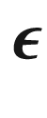

fulfills the relation between the displacement field

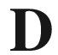

, the polarization

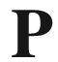

and the electric field

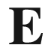

,

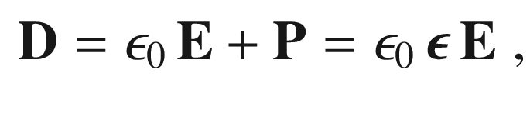

(9.2)

and is generally a tensor of rank 2 since

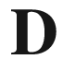

and

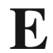

must not be collinear. For cubic materials, the DF is isotropic and can be described with a (complex) scalar

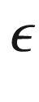

. Less symmetric crystals are optically anisotropic and the DF must be used in tensor form. Also, external fields can induce optical anisotropy in an otherwise isotropic material as discussed in Sect. [15.​2.​2](The_Physics_of_Semiconductors00006.docx#u116076_4_En_15_Chapter) for magnetic fields or has been observed for mechanical strain fields. The general form of the dielectric function tensor for various crystal symmetries is compiled in Table [9.2](#u116076_4_En_9_Chapter-Tab2).Table 9.2

General form of the tensor form of the dielectric function for the seven crystallographic systems

| Crystal system | Optical symmetry | $$\varvec{\epsilon }$$ | Examples |
| --- | --- | --- | --- |
| Cubic | Isotropic | $$\left( \begin{array}{ccc} a &amp;{} 0 &amp;{} 0 \\ 0 &amp;{} a &amp;{} 0 \\ 0 &amp;{} 0 &amp;{} a \end{array} \right) $$ | Si, GaAs, MgO, ZnSe, CuI |
| $$\begin{array}{l} \mathrm {tetragonal} \\ \mathrm {hexagonal} \\ \mathrm {trigonal} \end{array}$$ | uniaxial | $$\left( \begin{array}{ccc} a &amp;{} 0 &amp;{} 0 \\ 0 &amp;{} a &amp;{} 0 \\ 0 &amp;{} 0 &amp;{} c \end{array}\right) $$ | CuGaSe  $$_2$$  , GaN, ZnO, Bi  $$_2$$  Se  $$_3$$ |
| orthorhombic | biaxial | $$\left( \begin{array}{ccc} a &amp;{} 0 &amp;{} 0 \\ 0 &amp;{} b &amp;{} 0 \\ 0 &amp;{} 0 &amp;{} c \end{array}\right) $$ | $$\kappa $$  -Ga  $$_2$$  O  $$_3$$  , Sb  $$_2$$  Se  $$_3$$ |
| monoclinic | biaxial | $$\left( \begin{array}{ccc} a &amp;{} 0 &amp;{} d \\ 0 &amp;{} b &amp;{} 0 \\ d &amp;{} 0 &amp;{} c \end{array}\right) $$ | $$\beta $$  -Ga  $$_2$$  O  $$_3$$  , anthracene |
| triclinic | biaxial | $$\left( \begin{array}{ccc} a &amp;{} d &amp;{} e \\ d &amp;{} b &amp;{} f \\ e &amp;{} f &amp;{} c \end{array}\right) $$ | K  $$_2$$  Cr  $$_2$$  O  $$_7$$  , tetracene |

In most cases in the following,

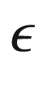

will be used as scalar (isotropic case). The dielectric function is frequency dependent

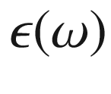

due to the various oscillators playing a role and decreases (non-monotonically) from its static value (for

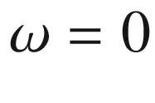

) to 1 for

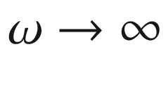

. Major influence on the DF stems from (optical) lattice vibrations (Sect. [9.5](#u116076_4_En_9_Chapter-Sec5)) and transitions within the electronic band structure (Sect. [9.6](#u116076_4_En_9_Chapter-Sec6)). In some cases also its

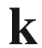

-dependence is important, known as ’spatial dispersion’ (cmp. Sect. [9.7.8](#u116076_4_En_9_Chapter-Sec15)).

An optic axis in the transparency regime (all tensor elements of

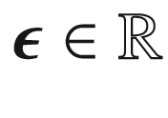

) is the direction in which the speed of light or the index of refraction is independent of polarization. Uniaxial (biaxial) materials have one (two) of such axes. The anisotropy of the index of refraction and its polarization dependence must be taken into account when light propagation is considered in birefringent semiconductors, e.g. for Raman spectroscopy [827], unless the propagation is along an optic axis.

The dielectric function is generally complex and written as (scalar)

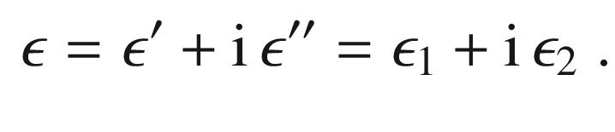

(9.3)

The real (

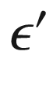

or

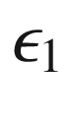

) and imaginary (

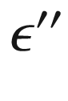

or

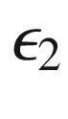

) part of the dielectric function are related to each other via the Kramers-Kronig relations (Appendix C).

The complex index of refraction

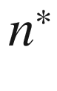

is

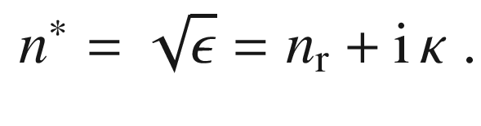

(9.4)

From

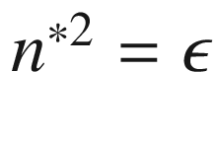

follows

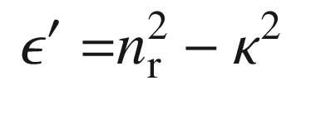

(9.5)

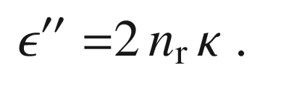

(9.6)

From

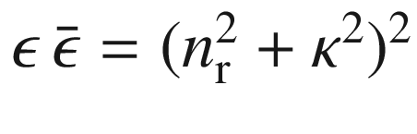

and ([9.5](#u116076_4_En_9_Chapter-Equ5)) follows

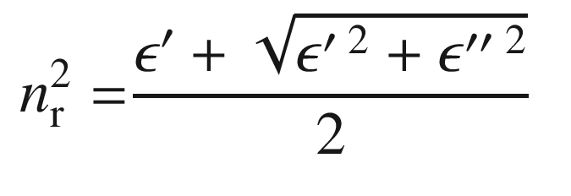

(9.7)

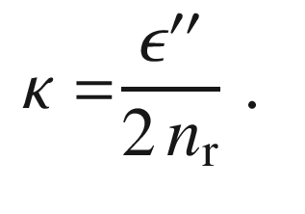

(9.8)

The real part of the complex index of refraction

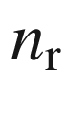

is responsible for the dispersion, the imaginary part

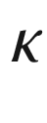

is named extinction coefficient and is related to the absorption coefficient for a plane wave (damping of the intensity

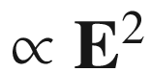

) by

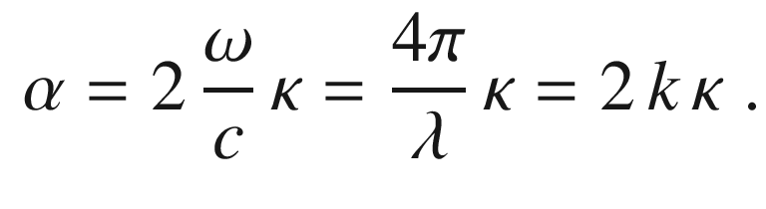

(9.9)

Here, *k* and

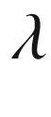

denote the respective values in vacuum. Through the Kramers-Kronig relations (Appendix C), *birefringence*, i.e. the orientational dependence of the index of refraction, is thus automatically related to *dichroism*, i.e. the orientational dependence of the absorption coefficient.

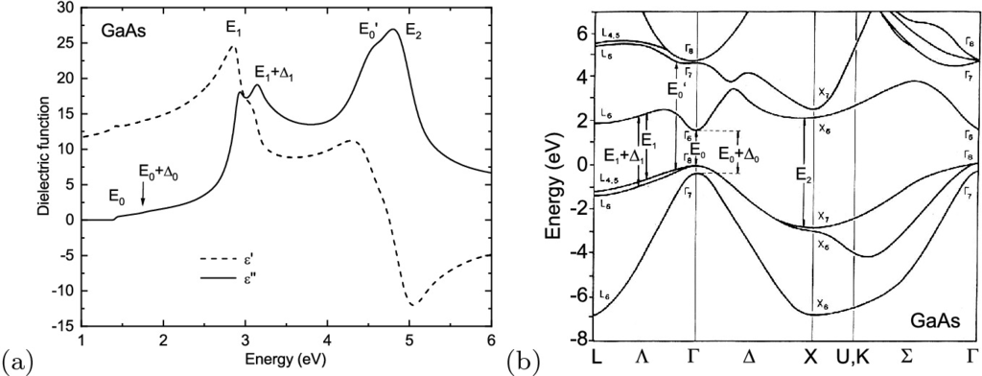

Fig. 9.1

**a** Complex dielectric function of GaAs at room temperature *dashed* (*solid*) *line*: real (imaginary) part of dielectric constant. Peak labels relate to transitions shown in part **b**. **b** Band structure of GaAs with fundamental band gap transition (

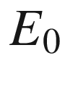

) and higher transitions (

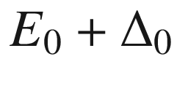

,

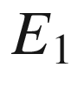

,

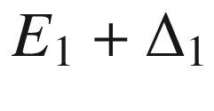

,

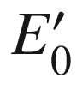

, and

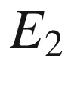

) as indicated

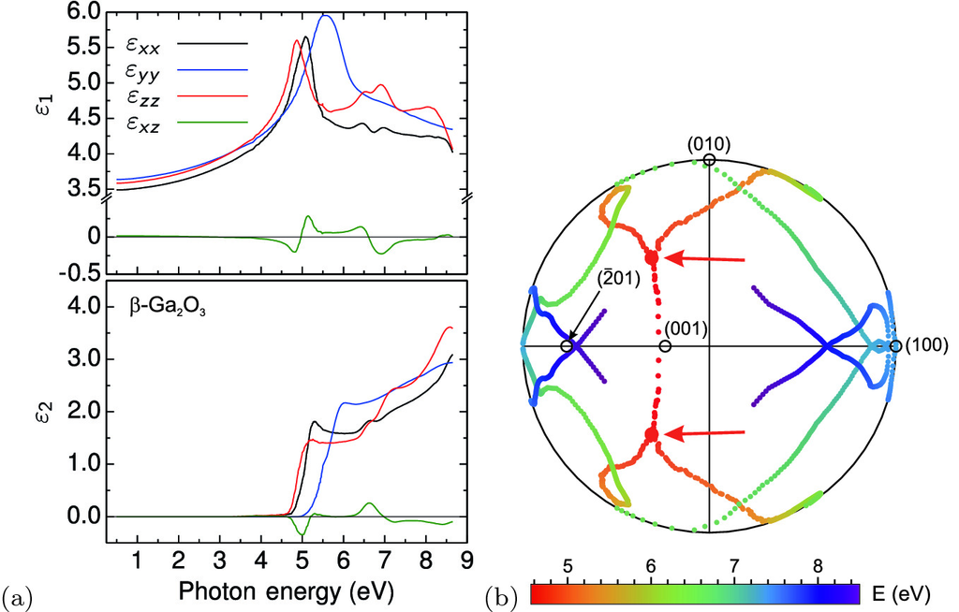

Fig. 9.2

**a** Experimental (generalized spectroscopic ellipsometry) tensor elements of the complex dielectric function of

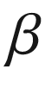

-Ga

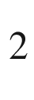

O

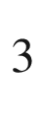

at room temperature. Adapted from [828]. **b** Stereographic projection of the angular orientation of the optic and singular optic axes of

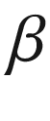

-Ga



O

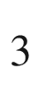

. Some crystallographic orientations are indicated. The *color* refers to the photon energy. The splitting of the two optic axes into four singular optic axes at the onset of absorption is denoted by two *red arrows*.

Adapted from [831]

As an example, in Fig. [9.1](#u116076_4_En_9_Chapter-Fig1) the dielectric function of GaAs is shown in the vicinity of the band edge and above. Since GaAs is cubic, the dielectric function at each photon energy can represented by a single complex number. The tensor character of the dielectric function is demonstrated in Fig. [9.2](#u116076_4_En_9_Chapter-Fig2)a where the four independent tensor elements for (monoclinic)

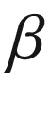

-Ga

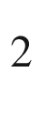

O

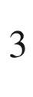

are depicted [828]. The contributions of various dipole oscillators (strength and orientation) to the dielectric function can be analyzed from these data [829].

In the absorption regime, for biaxial crystals the two optic axes split into four singular optic axes [830] as visualized for

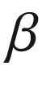

-Ga

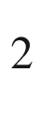

O



in Fig. [9.2](#u116076_4_En_9_Chapter-Fig2)b [831]. It should be noted that optical activity [832] is not considered in the following.

### 9.3 Reflection and Diffraction

From Maxwell’s equations and the boundary conditions at a planar interface between two media with different index of refraction for the components of the electric and magnetic fields the laws for reflection and diffraction are derived. We denote the index of refraction as *n* and also

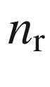

in the following. The interface between two media with refractive indices

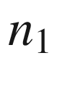

and

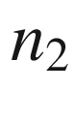

is depicted in Fig. [9.3](#u116076_4_En_9_Chapter-Fig3). In the following we assume first that no absorption occurs.

Snell’s law [833] for the angle of diffraction is

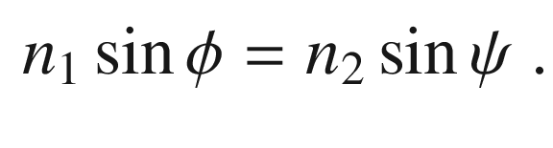

(9.10)

When the wave enters the denser medium, it is diffracted towards the normal. If the wave propagates into the less-dense medium (reversely to the situation shown in Fig. [9.3](#u116076_4_En_9_Chapter-Fig3)), a diffracted wave occurs only up to a critical angle of incidence

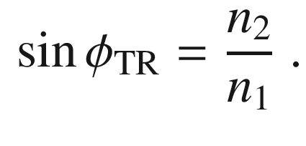

(9.11)

For larger angles of incidence, total internal reflection occurs and the wave remains in the denser medium. Thus, the angle in ([9.11](#u116076_4_En_9_Chapter-Equ11)) is called the critical angle for total reflection. For GaAs and air the critical angle is rather small,

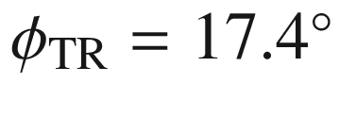

.

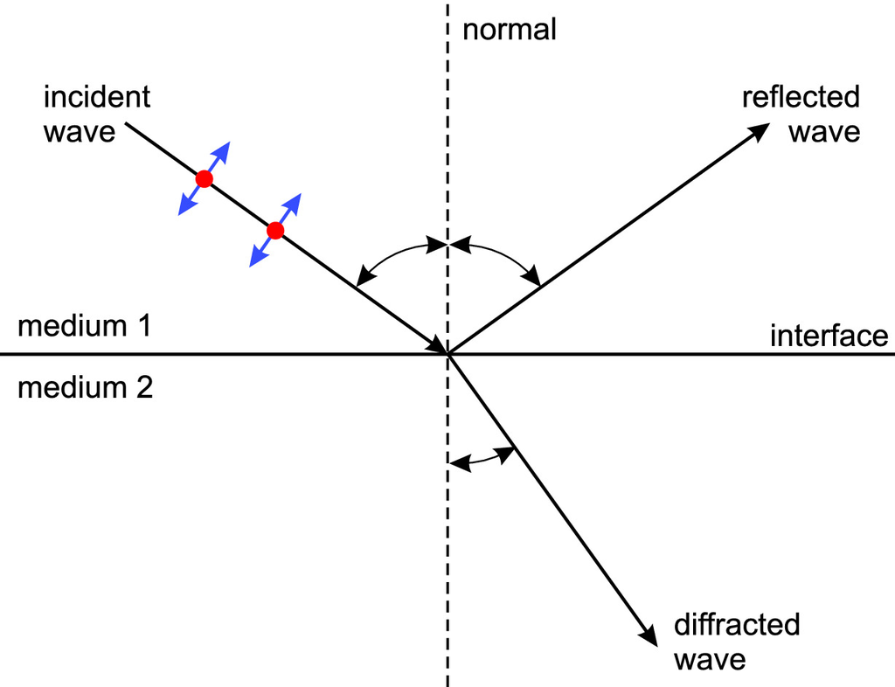

Fig. 9.3

Reflection and diffraction of an electromagnetic wave at the transition between medium ‘1’ and ‘2’,

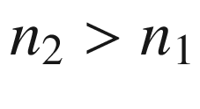

. The polarization  plane is defined by the surface normal and the *k*-vector of the light (plane of incidence). The parallel (‘p’) polarized wave (TM-wave, electric field vector oscillates in the plane) is shown as ‘

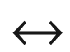

’; perpendicular (‘s’) polarization (TE-wave, electric field vector is perpendicular to plane) is depicted as ‘

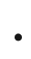

’

The reflectance depends on the polarization (Fresnel formulas [834]). The index ‘p’ (‘s’) denotes parallel polarized/TM (perpendicular polarized/TE) waves.

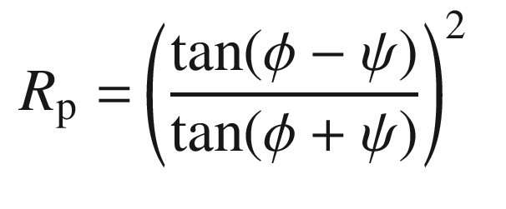

(9.12)

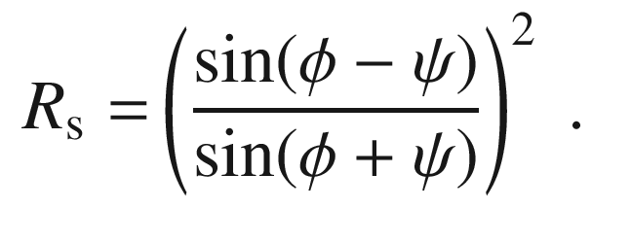

(9.13)

The situation for GaAs and air is shown for both polarization directions and unpolarized radiation in Fig. [9.4](#u116076_4_En_9_Chapter-Fig4) for a wave going into and out of the GaAs.

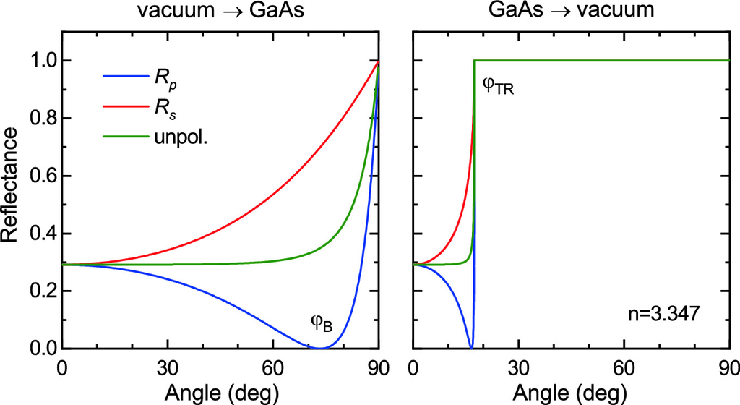

Fig. 9.4

Reflectance of the GaAs/vacuum interface (close to the band gap,

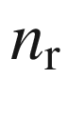

= 3.347) for radiation from vacuum/air (*left panel*) and from the GaAs (*right panel*), respectively, as a function of incidence angle and polarization

When the reflected and the diffracted wave are perpendicular to each other, the reflectance of the p-polarized wave is zero. This angle is the Brewster angle

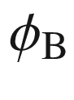

,

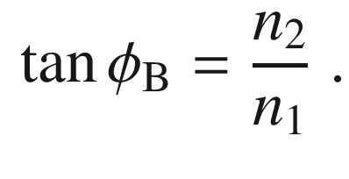

(9.14)

If a wave has vertical incidence from vacuum on a medium with index of refraction



, the reflectance is given (both polarizations are degenerate) as

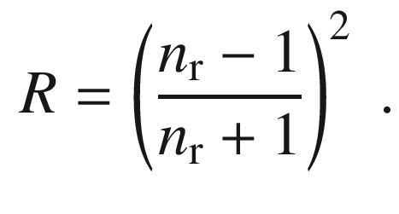

(9.15)

For GaAs, the reflectance for vertical incidence is 29.2%.

### 9.4 Absorption

In the absorption process, energy is transferred from the electromagnetic field to the semiconductor. In the case of a linear absorption process, when the probability of light absorption is proportional to the incoming intensity, the decrease of intensity in the absorbing medium is exponential (Lambert–Beer’s law [835, 836]),[2](The_Physics_of_Semiconductors00005.docx#u116076_4_En_9_Chapter-Fn2)

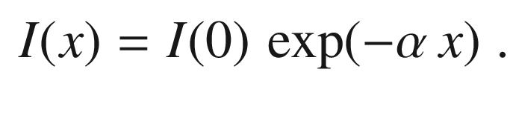

(9.16)

The quantity

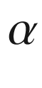

is the *absorption coefficient*, its reverse the absorption depth.

The spectral dependence

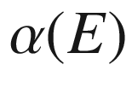

, the absorption spectrum, contains the information of the possible absorption processes, their energy, momentum and angular momentum selection rules, and their oscillator strength.

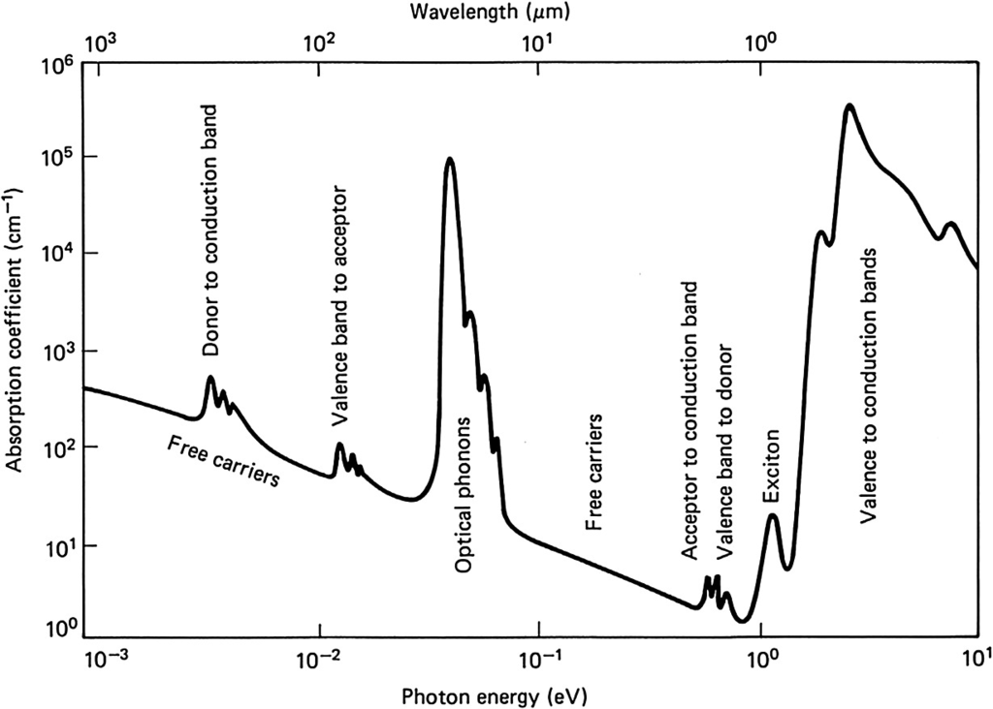

Fig. 9.5

Schematic absorption spectrum of a typical semiconductor. From [837]

In Fig. [9.5](#u116076_4_En_9_Chapter-Fig5) a schematic absorption spectrum of a semiconductor is depicted. The transition of electrons from the valence to the conduction band begins at the band gap energy. The band gaps of Si, Ge, GaAs, InP, InAs, InSb are in the IR, those of AlAs, GaP, AlP, InN in the VIS, those of GaN and ZnO in the UV, MgO and AlN are in the deep UV. The Coulomb correlation of electrons and holes leads to the formation of excitons that leads to absorption below the band gap. The typical exction binding energy is in the range of 1–100 meV (see Fig. [9.19](#u116076_4_En_9_Chapter-Fig19)). Optical transitions from valence-band electrons into donors and from electrons on acceptors into the conduction band lead to band–impurity absorption. In the region from 10–100 meV the interaction with lattice vibrations (phonons) leads to absorption if the phonons are infrared active. Further in the FIR lie transitions from impurities to the closest band edge (donor to conduction and acceptor to valence band). A continuous background is due to free-carrier absorption.

If absorption is considered, the reflectance ([9.15](#u116076_4_En_9_Chapter-Equ15)) needs to be modified. Using the complex index of refraction

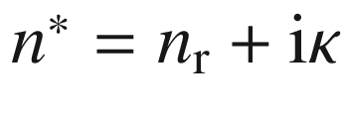

, it is given as

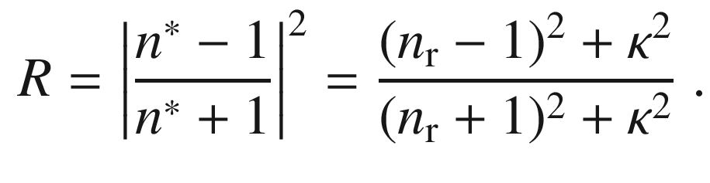

(9.17)

### 9.5 Dielectric Function due to Optical Phonons

In this section, the dielectric function around the resonance energy of optical phonons is developed. Adjacent atoms oscillate with opposite phase in an optical phonon. If the bond has (partial) ionic character, this leads to a time-dependent polarization and subsequently to a macroscopic electric field. This additional field will influence the phonon frequencies obtained from a purely mechanical approach. We consider in the following the case

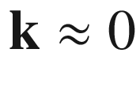

. The phonon frequency for TO and LO vibrations is given by

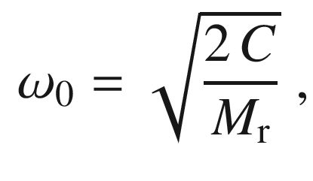

(9.18)

where

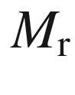

is the reduced mass of the two different atoms (cf. Sect. [5.​2.​2](The_Physics_of_Semiconductors00002.docx#u116076_4_En_5_Chapter)).

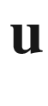

is the relative displacement

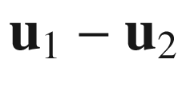

of the two atoms in a diatomic base. When the interaction with the electric field

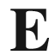

(which will be calculated self-consistently in the following) is considered, the Hamiltonian for the long-wavelength limit is given by [838]:

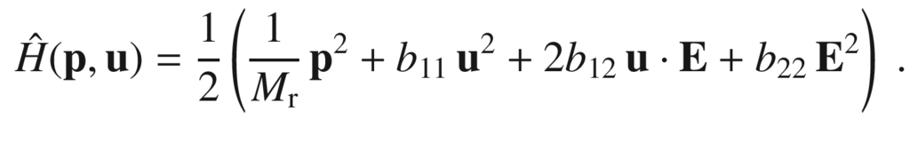

(9.19)

The first term is the kinetic energy (

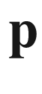

stands for the momentum of the relative motion of the atoms 1 and 2 in the base,

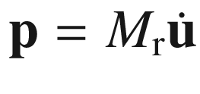

), the second the potential energy, the third the dipole interaction and the fourth the electric-field energy. The equation of motion for a plane wave

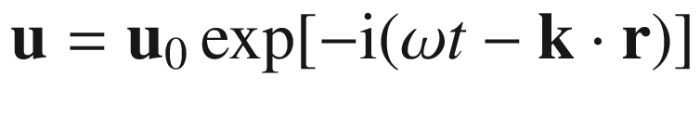

(

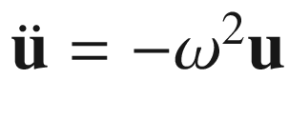

) yields

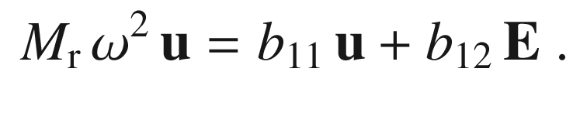

(9.20)

Thus, the electric field is

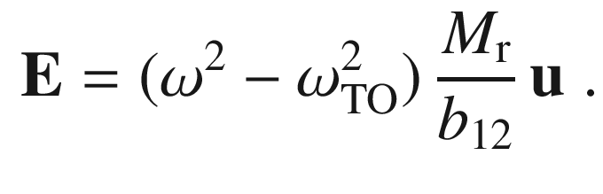

(9.21)

Here, the substitution

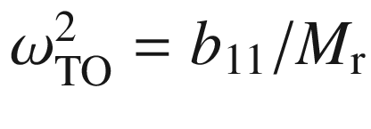

was introduced that is consistent with ([9.18](#u116076_4_En_9_Chapter-Equ18)) and

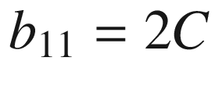

.

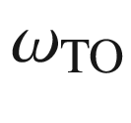

represents the mechanical oscillation frequency of the atoms undisturbed by any electromagnetic effects. Already now the important point is visible. If

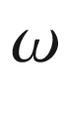

approaches

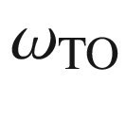

, the system plus electric field oscillates with the frequency it has without an electric field. Therefore the electric field must be zero. Since the polarization

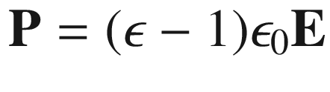

is finite, the dielectric constant

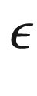

thus diverges.

The polarization is

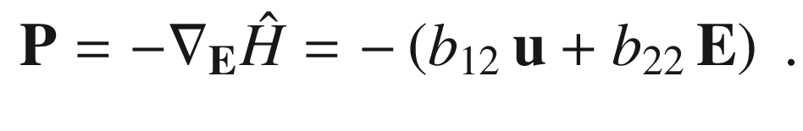

(9.22)

The displacement field is

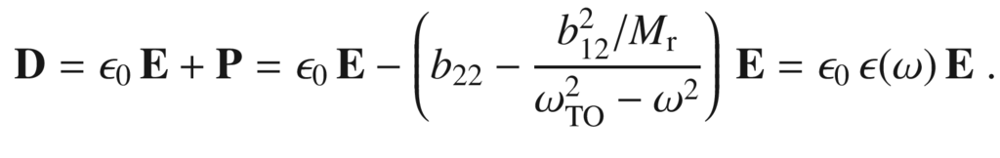

(9.23)

Therefore, the dielectric function is

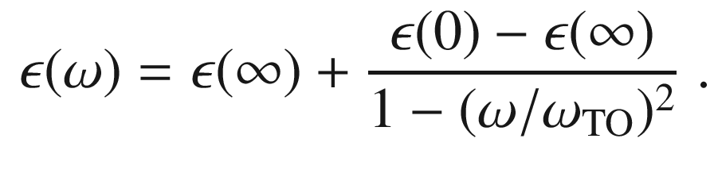

(9.24)

Here,

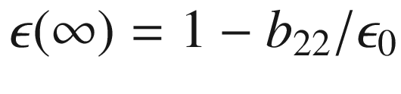

is the high-frequency dielectric constant and

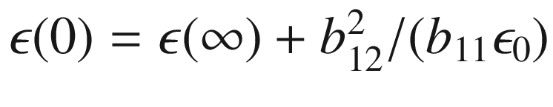

the static dielectric constant. The relation ([9.24](#u116076_4_En_9_Chapter-Equ24)) is shown in Fig. [9.6](#u116076_4_En_9_Chapter-Fig6).

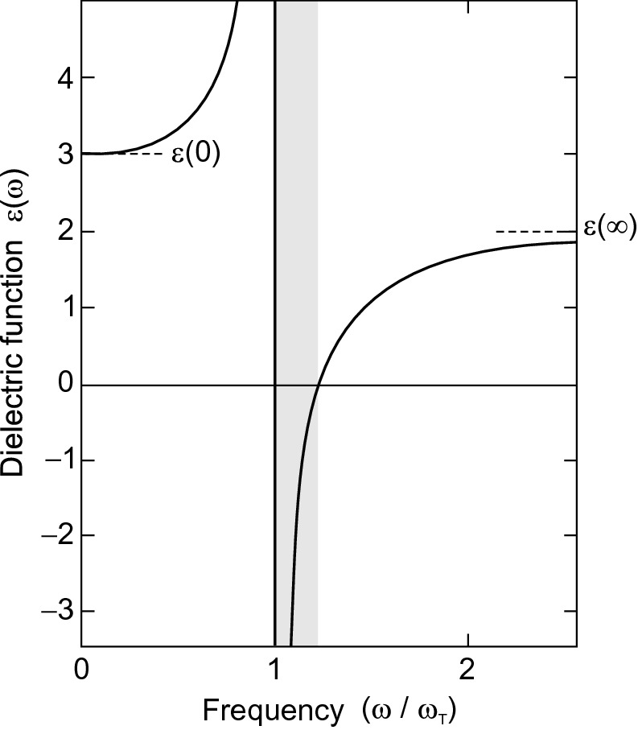

Fig. 9.6

Dielectric function according to ([9.24](#u116076_4_En_9_Chapter-Equ24)) with

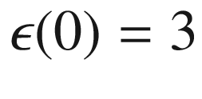

and

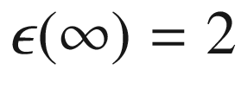

(without damping). *Grey area* denotes the region of negative

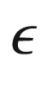

From the Maxwell equation

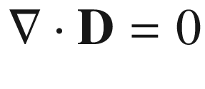

for zero free charge we obtain the relation

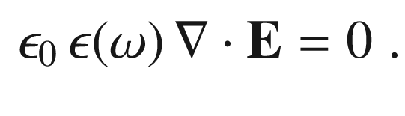

(9.25)

Thus, either

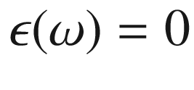

or

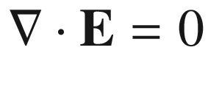

, i.e.

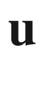

is perpendicular to



. In the latter case we have a TO phonon and, neglecting retardation effects, using

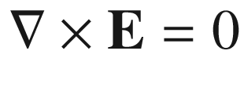

we find

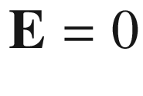

and therefore

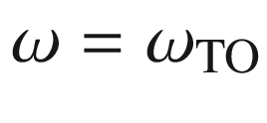

, justifying our notation. In the case of

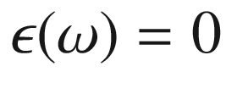

, we call the related frequency

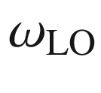

and find the so-called Lyddane–Sachs–Teller (LST) relation [839]

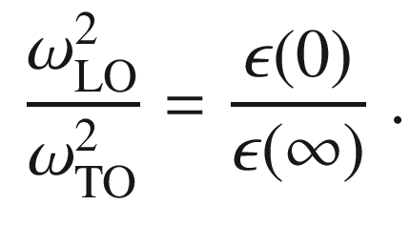

(9.26)

This relation holds reasonably well for optically isotropic, heteropolar materials with two atoms in the basis, such as NaI and also GaAs. Since at high frequencies, i.e.

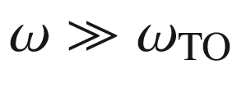

, only the individual atoms can be polarized, while for low frequencies the atoms can also be polarized against each other,

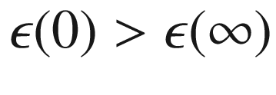

and therefore also

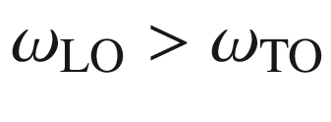

. For GaAs, the quotient of the two phonon energies is 1.07. Using the LST relation ([9.26](#u116076_4_En_9_Chapter-Equ26)), we can write for the dielectric function

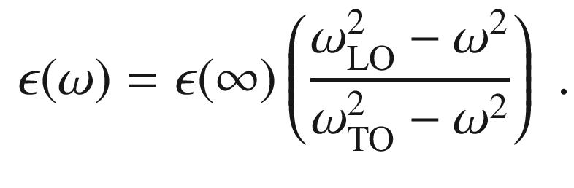

(9.27)

The (long-wavelength) TO-phonon  does not create a long-range electric field. Using



and ([9.23](#u116076_4_En_9_Chapter-Equ23)) and looking at the longitudinal fields, we have

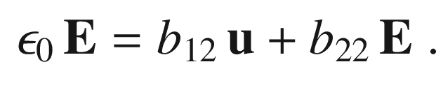

(9.28)

This can be rewritten as

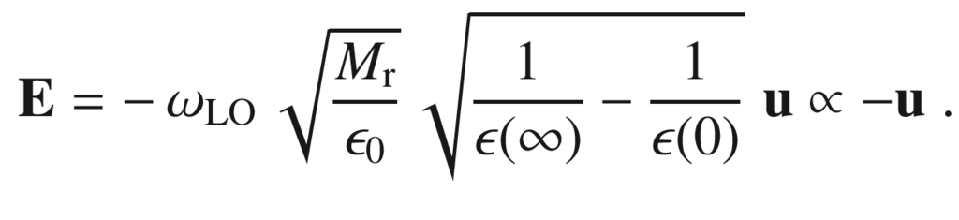

(9.29)

The (long-wavelength) LO-phonon thus creates a long-range electric field acting *against* the ion displacement and represents an additional restoring force; this is consistent with the fact that

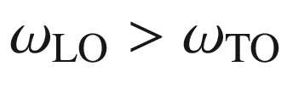

.

### 9.6 Electron–Photon Interaction

The absorption process within the band structure is quantum mechanically described by the coupling of electrons and photons. The process is described with time-dependent perturbation theory. If

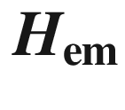

is the perturbation operator (electromagnetic field), the transition probability per time

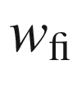

for electrons from (unperturbed) state ‘i’ (initial) to state ‘f’ (final) is given (with certain approximations) by Fermi’s golden rule

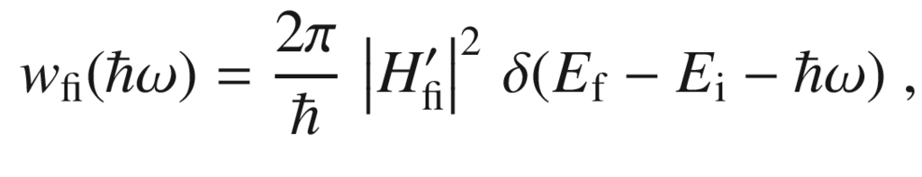

(9.30)

where

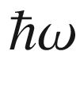

is the photon energy,

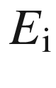

(

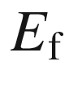

) is the energy of the initial (final) state.

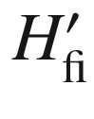

is the matrix element

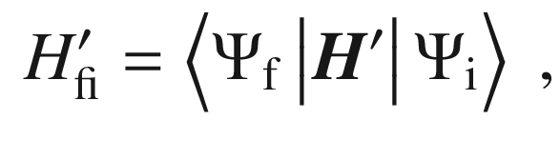

(9.31)

where

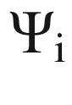

(

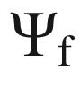

) are the wavefunctions of the unperturbed initial (final) state.

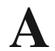

is the vector potential for the electromagnetic field, i.e.

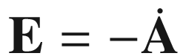

,

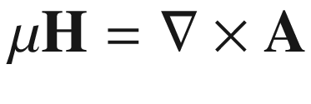

,

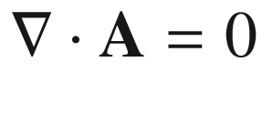

(Coulomb gauge). The Hamiltonian of an electron in the electromagnetic field is

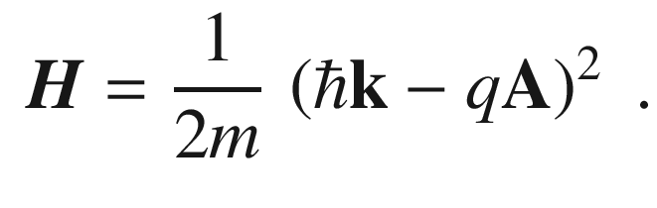

(9.32)

When terms in

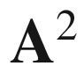

are neglected (i.e. two-photon processes), the perturbation Hamiltonian is thus

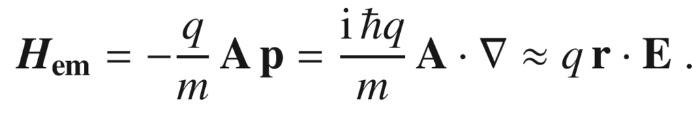

(9.33)

The latter approximation is valid for small wavevectors of the electromagnetic wave and is termed the *electric dipole approximation*.

In order to calculate the dielectric function of the semiconductor from its band structure we assume that

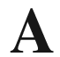

is weak and we can apply ([9.30](#u116076_4_En_9_Chapter-Equ30)). The transition probability *R* for the photon absorption rate at photon energy



is then given by[3](The_Physics_of_Semiconductors00005.docx#u116076_4_En_9_Chapter-Fn3)

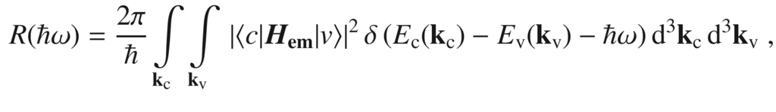

(9.34)

with the Bloch functions

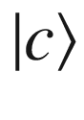

and

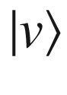

of the conduction and valence band, respectively, as given in ([6.​40b](The_Physics_of_Semiconductors00003.docx#u116076_4_En_6_Chapter)).

The vector potential is written as

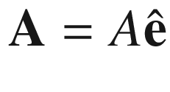

with a unit vector

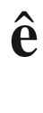

parallel to

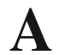

. The amplitude is connected to the electric-field amplitude *E* via

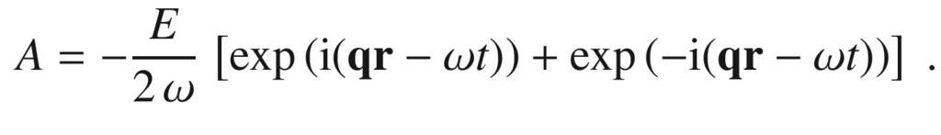

(9.35)

In the electric-dipole approximation the momentum conservation

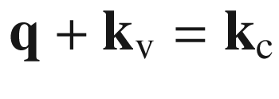

,

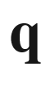

being the momentum of the light wave is approximated by

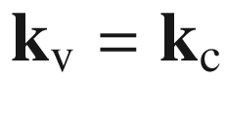

. The matrix element is then given by

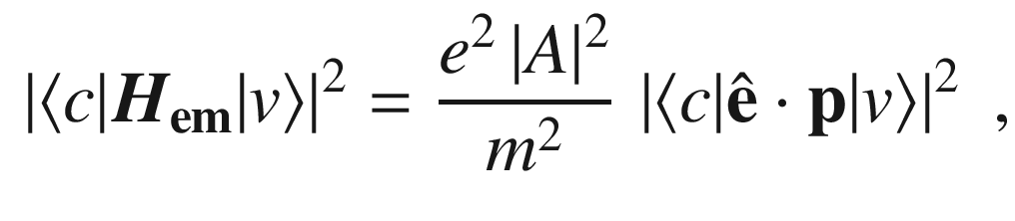

(9.36)

with

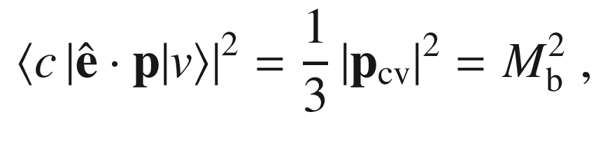

(9.37)

and the momentum matrix element

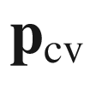

given in ([6.​39](The_Physics_of_Semiconductors00003.docx#u116076_4_En_6_Chapter)). A

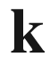

-independent matrix element

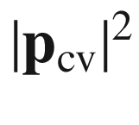

is often used as an approximation. In Fig. [9.7](#u116076_4_En_9_Chapter-Fig7) the matrix elements for valence to conduction band transitions in GaN are shown as a function of

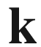

.

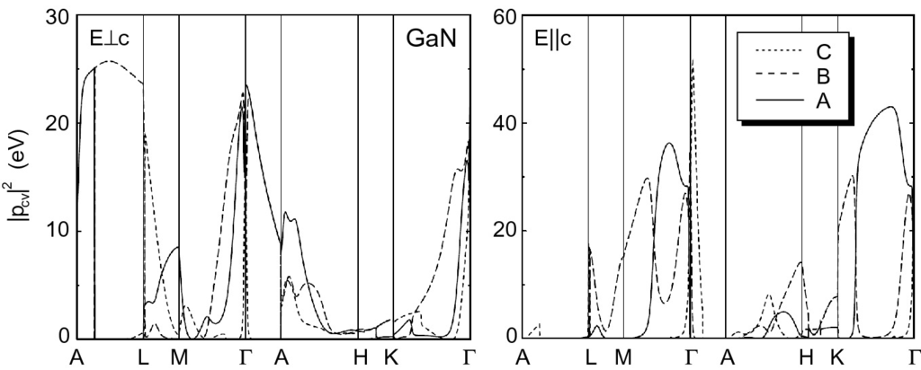

Fig. 9.7

Theoretical momentum matrix elements

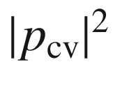

along high-symmetry directions in the Brillouin zone (see Fig. [3.​38](The_Physics_of_Semiconductors00002.docx#u116076_4_En_3_Chapter-Fig38)d) for transitions between valence and conduction bands in GaN and light polarized perpendicular (*left panel*) and parallel (*right panel*) to the *c*-axis. The transitions are A:

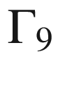

(A)

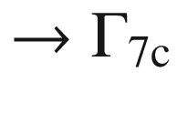

, B:

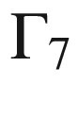

(B)



, C:

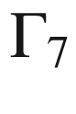

(C)

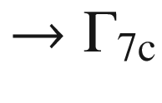

(see Fig. [6.​44](The_Physics_of_Semiconductors00003.docx#u116076_4_En_6_Chapter-Fig44)).

Adapted from [840]

In terms of the electric-field amplitude

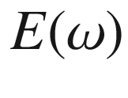

the transition probability is

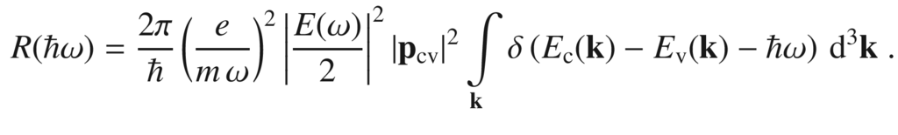

(9.38)

If the integration over

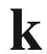

is restricted to those values allowed in unit volume, the power that is lost from the field in unit volume is given by

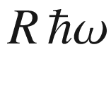

, leaving a 1/*E* factor. The dielectric function

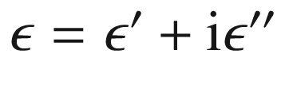

is given by

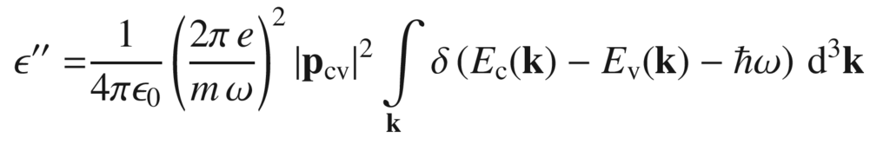

(9.39a)

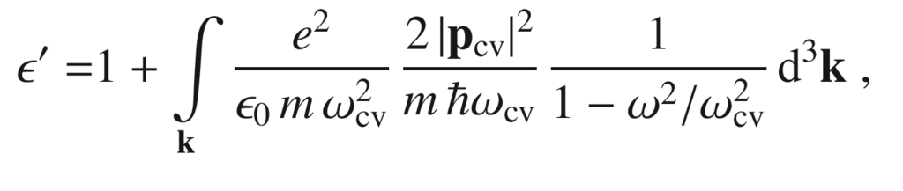

(9.39b)

with

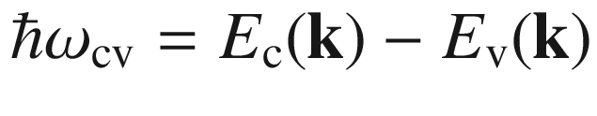

. Equation ([9.39b](#u116076_4_En_9_Chapter-Equ40)) has been obtained via the Kramers–Kronig relations[4](The_Physics_of_Semiconductors00005.docx#u116076_4_En_9_Chapter-Fn4)  (see Appendix C).

Comparison with (D.7) yields that the oscillator strength of the band–band absorption is given by

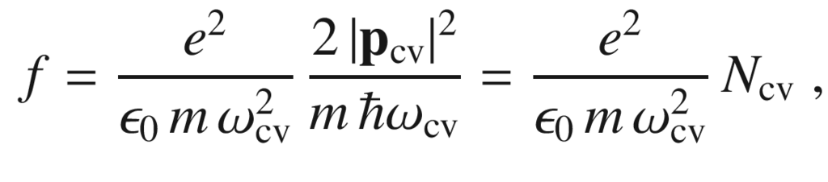

(9.40)

with the classical ’number’ of oscillators with the frequency

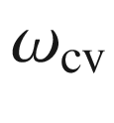

,

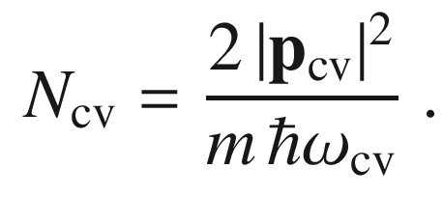

(9.41)

### 9.7 Band–Band Transitions

#### 9.7.1 Joint Density of States

The strength of an allowed optical transitions between valence and conduction bands is proportional to the joint density of states (JDOS)

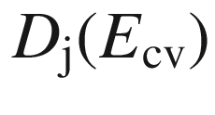

(cf. ([6.​63](The_Physics_of_Semiconductors00003.docx#u116076_4_En_6_Chapter)), ([6.​64](The_Physics_of_Semiconductors00003.docx#u116076_4_En_6_Chapter)) and ([9.39a](#u116076_4_En_9_Chapter-Equ39)))

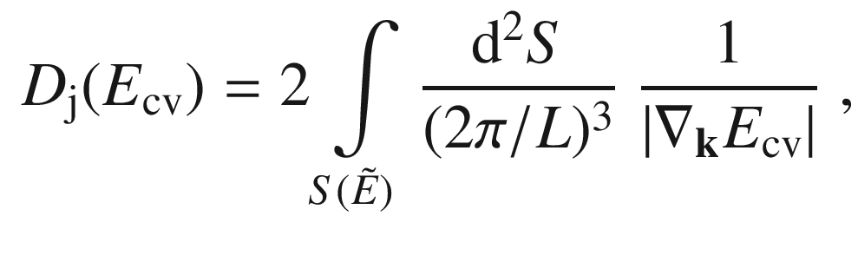

(9.42)

where

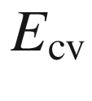

is an abbreviation for

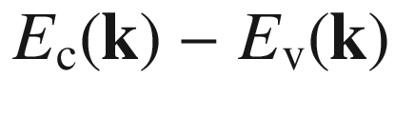

and

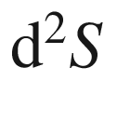

is a surface element of the constant energy surface with

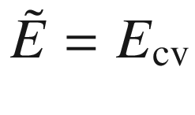

. The spin is assumed to generate doubly degenerate bands and accounts for the pre-factor 2. Singularities of the JDOS (*van-Hove singularities* or *critical points*) appear where

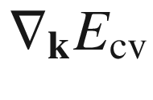

vanishes. This occurs when the gradient for both bands is zero or when both bands are parallel. The latter generates particularly large JDOS because the condition is valid at many points in

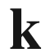

-space.

Generally, the (three-dimensional) energy dispersion

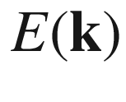

around a three-dimensional critical point (here developed at

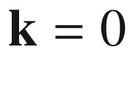

) can be written as

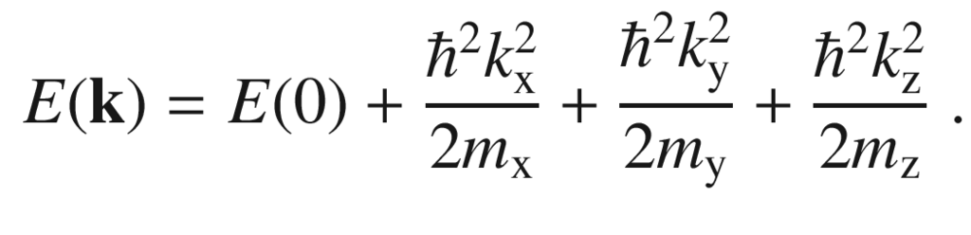

(9.43)

The singularities are classified as

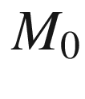

,

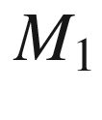

,

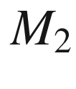

and

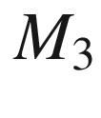

with the index being the number of masses

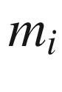

in ([9.43](#u116076_4_En_9_Chapter-Equ44)) that are negative.

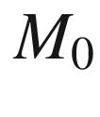

(

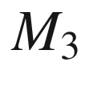

) describes a minimum (maximum) of the band separation.

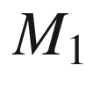

and

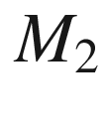

are saddle points. For a two-dimensional



-space there exist

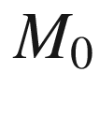

,

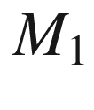

and

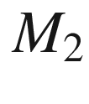

points (minimum, saddle point and maximum, respectively). For a one-dimensional

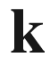

-space, there exist

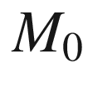

and



points (minimum and maximum, respectively). The functional dependence of the JDOS at the critical points is summarized in Table [9.3](#u116076_4_En_9_Chapter-Tab3). The resulting shape of the dielectric function is visualized in Fig. [9.8](#u116076_4_En_9_Chapter-Fig8).Table 9.3

Functional dependence of the joint density of states for critical points in 3, 2 and 1 dimensions.

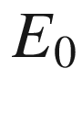

denotes the energy (band separation) at the critical point, *C* stands for a constant value. The type of critical point is given (min.: minimum, saddle: saddle point, max.: maximum)

| Dim. | Label | Type | $$D_{\mathrm {j}}$$  for  $$E&lt;E_0$$ | $$D_{\mathrm {j}}$$  for  $$E&gt;E_0$$ |
| --- | --- | --- | --- | --- |
| 3D | $$\begin{array}{l} M_0 \\ M_1 \\ M_2 \\ M_3 \end{array}$$ | $$\begin{array}{l} \mathrm {min.} \\ \mathrm {saddle} \\ \mathrm {saddle} \\ \mathrm {max.} \end{array}$$ | $$\begin{array}{l} 0 \\ C-\sqrt{E_0-E} \\ C \\ \sqrt{E_0-E} \end{array}$$ | $$\begin{array}{l} \sqrt{E-E_0} \\ C \\ C-\sqrt{E-E_0} \\ 0 \end{array}$$ |
| 2D | $$\begin{array}{l} M_0 \\ M_1 \\ M_2 \end{array}$$ | $$\begin{array}{l} \mathrm {min.} \\ \mathrm {saddle} \\ \mathrm {max.} \end{array}$$ | $$\begin{array}{l} 0 \\ -\ln (E_0-E) \\ C \end{array}$$ | $$\begin{array}{l} C \\ -\ln (E-E_0) \\ 0 \end{array}$$ |
| 1D | $$\begin{array}{l} M_0 \\ M_1 \end{array}$$ | $$\begin{array}{l} \mathrm {min.} \\ \mathrm {max.} \end{array}$$ | $$\begin{array}{l} 0 \\ \sqrt{E_0-E} \end{array}$$ | $$\begin{array}{l} \sqrt{E-E_0} \\ 0 \end{array}$$ |

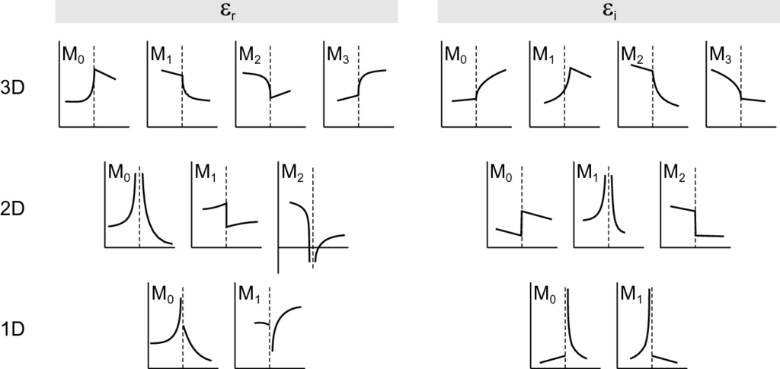

Fig. 9.8

Shape of the real (*left panel*) and imaginary (*right panel*) parts of the dielectric function in the vicinity of critical points in 3, 2 and 1 dimensions (for labels see Table [9.3](#u116076_4_En_9_Chapter-Tab3)). The *dashed line* in each graph indicates the energy position of the critical point

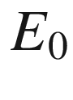

.

Adapted from [841]

#### 9.7.2 Direct Transitions

Transitions between states at the band edges at the

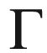

point are possible (Fig. [9.9](#u116076_4_En_9_Chapter-Fig9)). The

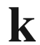

conservation requires (almost) vertical transitions in the

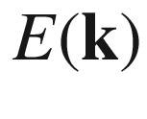

diagram because the length of the light

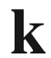

vector,

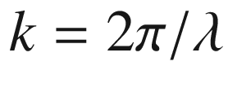

, is much smaller than the size of the Brillouin zone

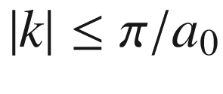

. The ratio of the lengths of the



vectors is of the order

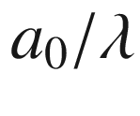

and typically about 10

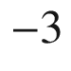

for NIR wavelengths.

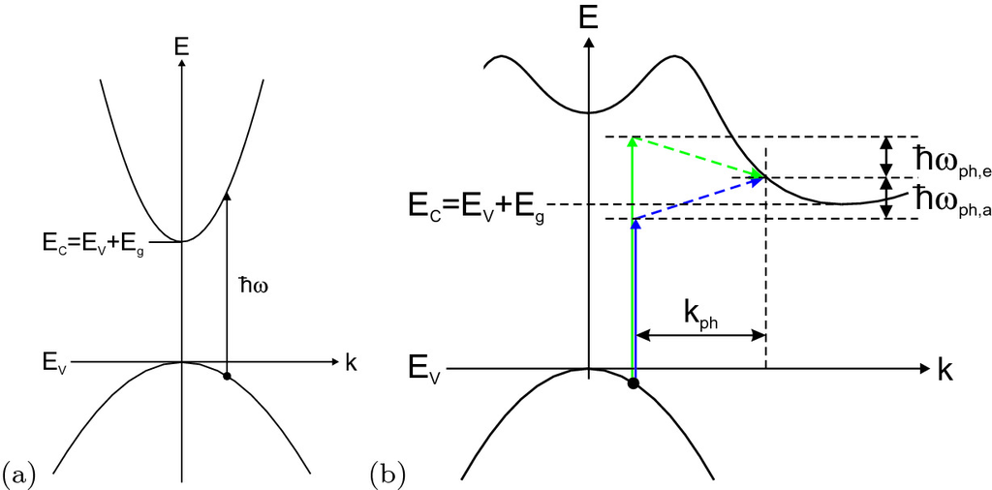

Fig. 9.9

**a** Direct optical transition and **b** indirect optical transitions between valence and conduction bands. The indirect transition involves a phonon with energy

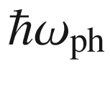

(index *a*: phonon absorption, *e*: phonon emission) and wavevector

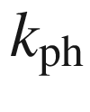

For isotropic parabolic bands the band-band transition energy versus wavevector relation is

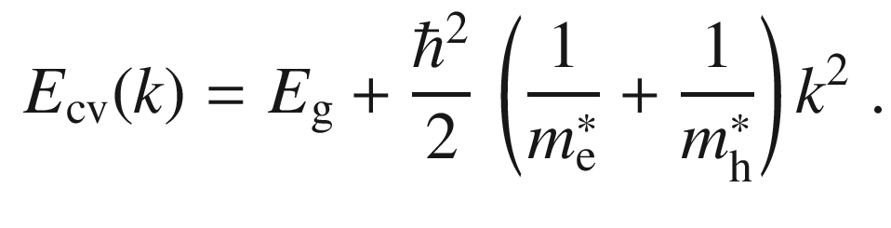

(9.44)

When the energy dependence of the matrix element is neglected, the absorption coefficient is determined by the corresponding square-root joint density of states (



critical point):

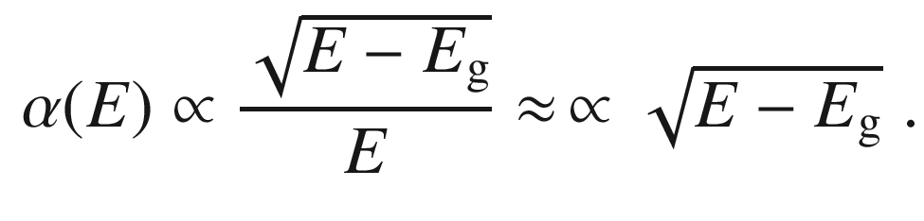

(9.45)

The approximation is valid if the considered energy interval, e.g. around a band edge, is small.

Absorption spectra of (In

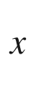

Ga

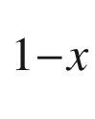

)

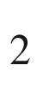

O

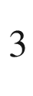

alloy thin films at room temperature are shown in Fig. [9.10](#u116076_4_En_9_Chapter-Fig10)a. The

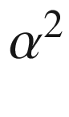

versus photon energy so-called Tauc plot shows a linear dependence with broadening and additional states at the band edge due to disorder effects. The extrapolation of the linear part yields the absorption edge (Fig. [9.10](#u116076_4_En_9_Chapter-Fig10)b).

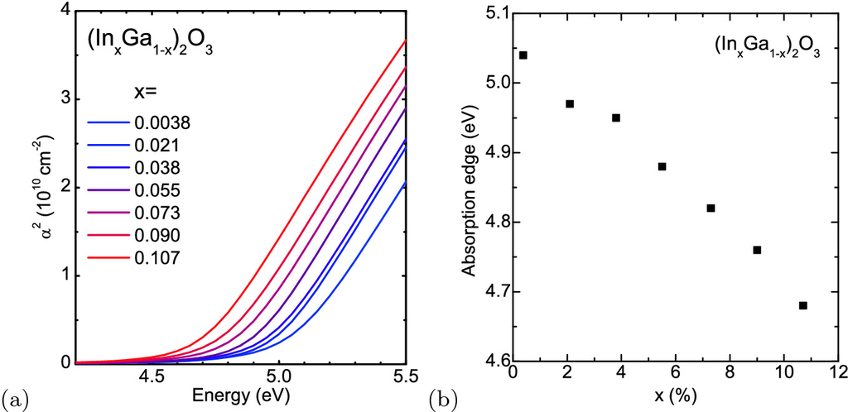

Fig. 9.10

**a** Absorption spectra of (In

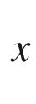

Ga

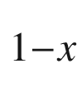

)

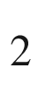

O

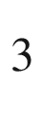

alloy thin films on Al

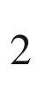

O

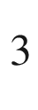

, plotted as

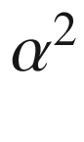

versus photon energy. **b** Band edge determined from extrapolation of linear parts

Absorption spectra of GaAs are shown in Fig. [9.11](#u116076_4_En_9_Chapter-Fig11)a for photon energies close to the band gap at various temperatures. The rapid increase, typical for direct semiconductors, is obvious. In particular at low temperatures, however, the absorption lineshape close to the band gap is dominated by an excitonic feature, discussed in Sect. [9.7.6](#u116076_4_En_9_Chapter-Sec13).

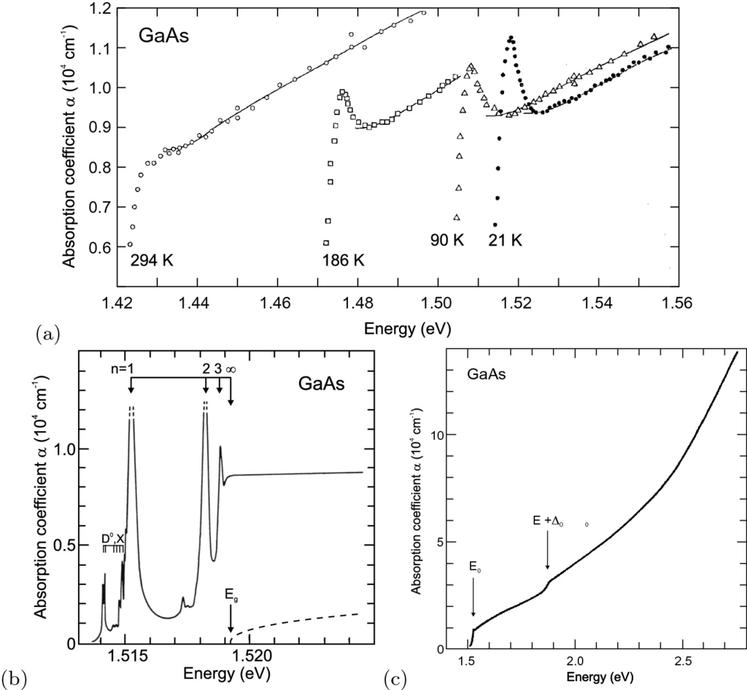

Fig. 9.11

**a** Absorption of GaAs close to the band gap at different temperatures. Adapted from [842]. **b** High-resolution absorption spectrum of highly pure GaAs at

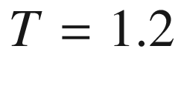

 K in the exciton region. *Dashed line* is theory without excitonic correlation. Adapted from [843]. **c** Absorption spectrum of GaAs at

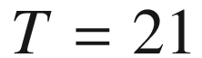

 K in the vicinity of the band gap.

Adapted from [842]

Due to the increasing density of states, the absorption increases with the photon energy (Fig. [9.11](#u116076_4_En_9_Chapter-Fig11)c). At 1.85 eV there is a step in the absorption spectrum of GaAs due to the beginning of the contribution of transitions between the s-o hole band and the conduction band (see

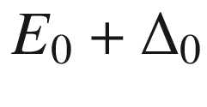

transition in Fig. [9.1](#u116076_4_En_9_Chapter-Fig1)b). When bands run in parallel, i.e. with the same separation, in the

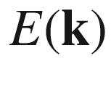

diagram, the absorption processes accumulate at the same transition energy. In this way peaks at higher energy in the complex part of the dielectric function and in the absorption spectrum due to the

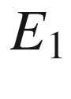

or

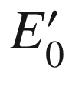

transitions originate as shown in Fig. [9.1](#u116076_4_En_9_Chapter-Fig1).

The selection rules for transitions from valence to conduction band must take into account the angular momentum and spin states of the wavefunctions. The optical transitions for circularly polarized light are shown in Fig. [9.12](#u116076_4_En_9_Chapter-Fig12)a, fulfilling the selection rule

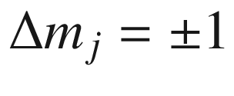

. A lifting of the energetic degeneracies of these states occurs, e.g. by magnetic fields (cmp. Fig.[15.​12](The_Physics_of_Semiconductors00006.docx#u116076_4_En_15_Chapter-Fig12)) or spatial confinement (cmp. Fig. [12.​30](The_Physics_of_Semiconductors00005.docx#u116076_4_En_12_Chapter-Fig30)). For two-photon absorption (Chap.[9.7.14](The_Physics_of_Semiconductors00005.docx#u116076_4_En_9_Chapter-Sec21)), the selection rule is

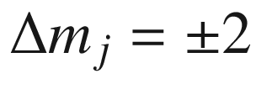

as shown in Fig. [9.12](#u116076_4_En_9_Chapter-Fig12)b [844].

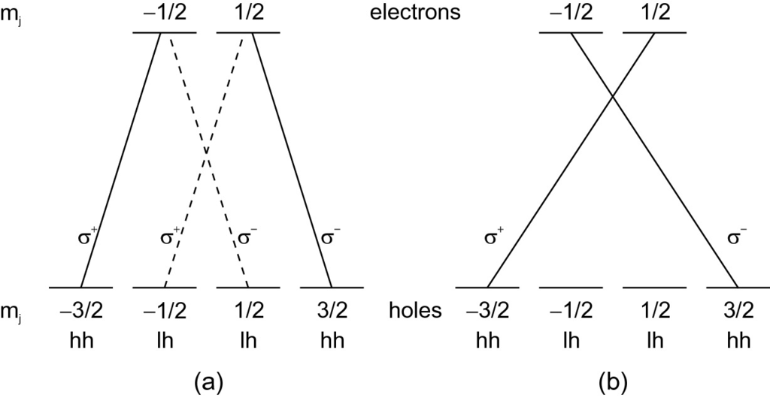

Fig. 9.12

Optical selection rules for band–band transitions in bulk material for **a** single photon transitions and **b** two-photon transitions (with photon energy equal to half the transition energy)

We note that in some materials the direct transition between certain bands is forbidden. An example is SnO

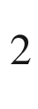

where the direct transition from the topmost valence band into the lowest conduction band (at

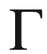

) is forbidden (cmp. Fig. [9.48](The_Physics_of_Semiconductors00005.docx#u116076_4_En_9_Chapter-Fig48)). If the matrix element increases linearly with

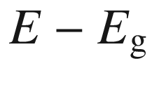

, the absorption coefficient varies like

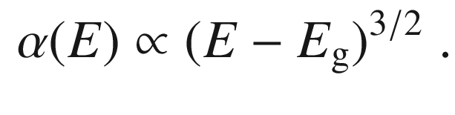

(9.46)

#### 9.7.3 Indirect Transitions

In an indirect band structure the missing

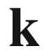

difference (across the Brillouin zone) between valence- and conduction-band state needs to be provided by a second quantum. A phonon can provide the necessary momentum and additionally contributes a small amount of energy

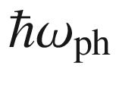

. There are several steps in the absorption spectrum due to various involved phonons (or combinations of them). At low temperature (

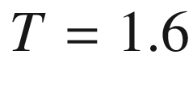

 K, Fig. [9.13](#u116076_4_En_9_Chapter-Fig13)) phonons can only be generated and the absorption starts at energies *above* the band gap. At higher temperatures (typically above 40 K [845], Fig. [9.13](#u116076_4_En_9_Chapter-Fig13)), acoustical phonons assisting the optical absorption transition can also be absorbed from the crystal; in this case due to energy conservation the absorption starts already at an energy

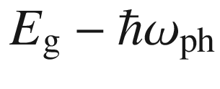

*below* the band gap. At even higher temperatures (

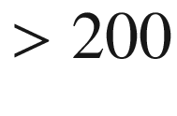

 K, Fig. [9.13](#u116076_4_En_9_Chapter-Fig13)), also optical phonons can be absorbed.

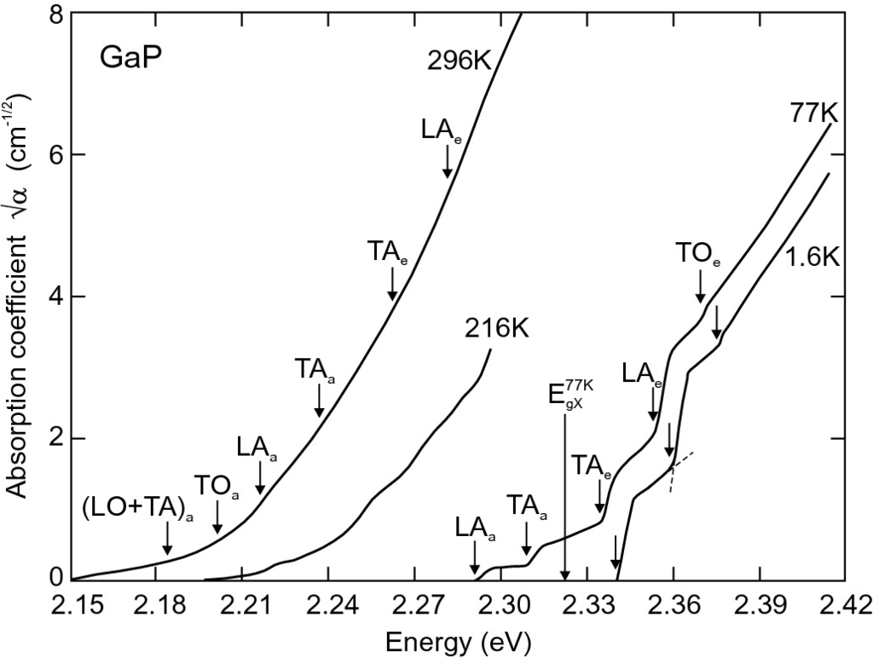

Fig. 9.13

Absorption edge of GaP (

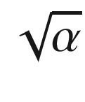

versus *E*) at various temperatures. The index ‘e’ (‘a’) indicates phonon emission (absorption) during the optical absorption process. The theoretical excitonic gap (

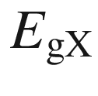

) at

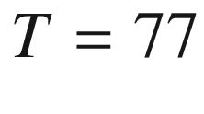

 K is indicated.

Adapted from [845]

The perturbation calculation yields an absorption coefficient with a quadratic dependence on energy ([9.47a](#u116076_4_En_9_Chapter-Equ48)) [846]. Essentially, for the absorption into a specific (empty) conduction band state (with square-root density of states) various initial (filled) valence band states (also with square-root density of states) are possible, making the probability depend on the product of the DOS and thus on the energy to the first power. Integrating over all energy states with energy separation

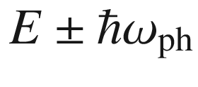

, yields an

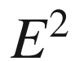

-dependence.[5](The_Physics_of_Semiconductors00005.docx#u116076_4_En_9_Chapter-Fn5) Considering the temperature dependent population of the phonon density of states (Bose statistics, (E.3)) the absorption coefficients for transitions with phonon emission (

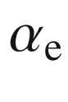

) and phonon absorption (

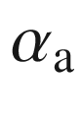

) are:

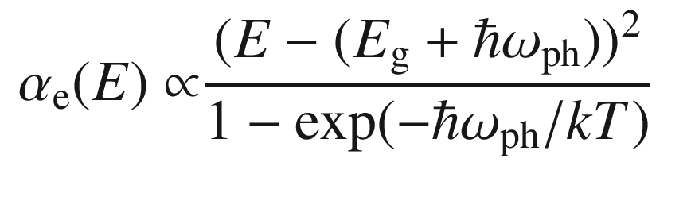

(9.47a)

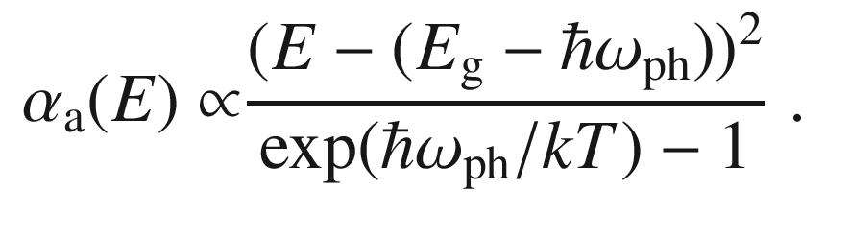

(9.47b)

The two-particle process is less probable than the direct absorption that only involves one photon. The strength of indirect absorption close to the band gap is about 10

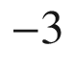

smaller than for the direct transition.

An 11-parameter formula based on terms like ([9.47a](#u116076_4_En_9_Chapter-Equ48)) can describe the room temperature absorption spectrum of silicon in the visible with a precision of a few percent [847].

The absorption spectra close to the absorption edge are shown for GaP (Fig. [9.13](#u116076_4_En_9_Chapter-Fig13)) and Si (Fig. [9.14](#u116076_4_En_9_Chapter-Fig14)a). According to ([9.47a](#u116076_4_En_9_Chapter-Equ48)), the plot of

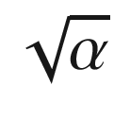

versus energy (Macfarlane–Roberts plot [848]) yields a straight line beyond the spectral region of phonon effects. The complicated form close to the (indirect) gap energy is due to the contribution of different phonons. The phonon energies found to contribute to the silicon absorption edge [849] agree with the TA and TO energy at the X minimum [850] (Fig. [9.14](#u116076_4_En_9_Chapter-Fig14)b). Also multiple phonons can contribute (Fig. [9.13](#u116076_4_En_9_Chapter-Fig13)). The momentum conservation can also be achieved by impurity scattering or electron-electron scattering [851].

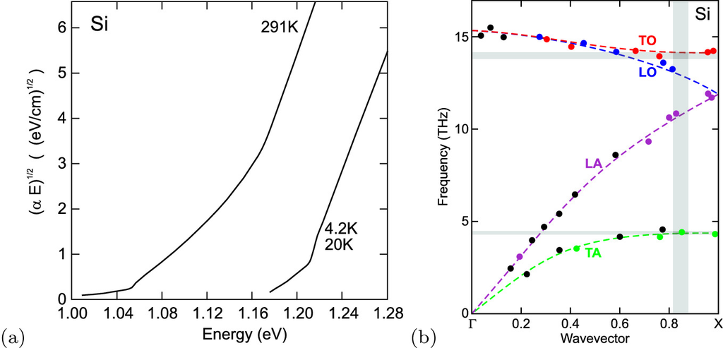

Fig. 9.14

**a** Absorption edge of Si at two different temperatures. Adapted from [849]. **b** Phonon energies in silicon along [001] obtained from neutron scattering (*black*: unidentified, *green*: TA, *purple*: LA, *blue*: LO, *red*: TO). The *vertical grey bar* indicates the position of the conduction band minimum, the *horizontal grey bars* the energies of the phonons observed at the indirect optical absorption edge. The *dark grey* overlap areas indicate that TO and TA phonons contribute.

Adapted from [850]

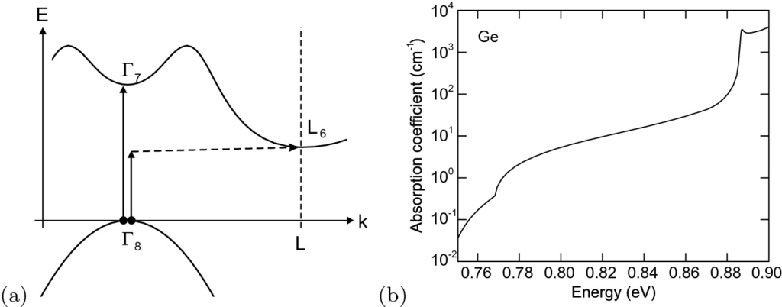

Fig. 9.15

**a** Scheme of indirect and direct optical transitions starting at the top of the valence band in Ge. Vertical *solid lines* represent the involved photon, the horizontal *dashed line* the involved phonon. **b** Experimental absorption spectrum of Ge (

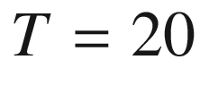

 K).

Adapted from [849]

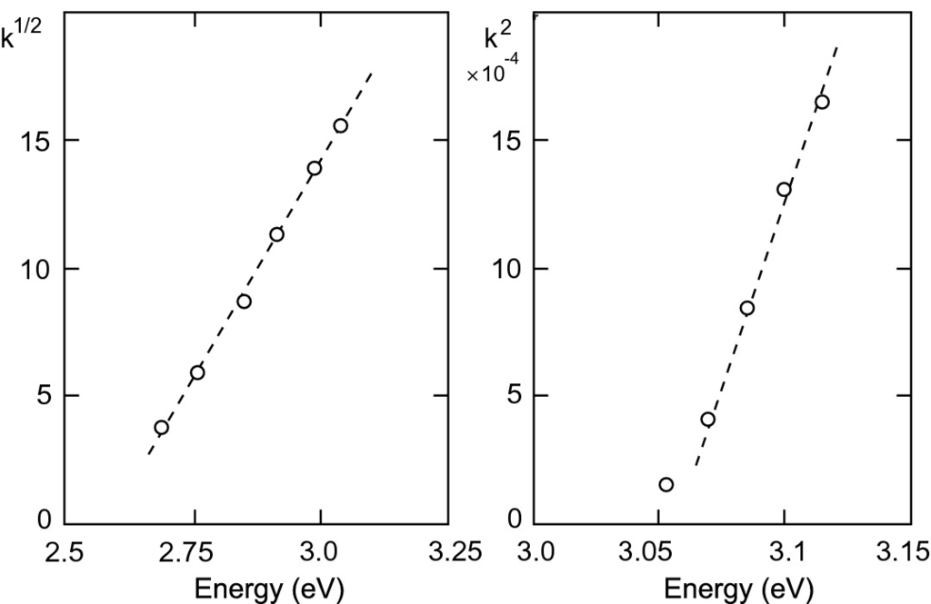

Fig. 9.16

Absorption of BaTiO

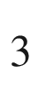

at room temperature. Experimental data (*circles*) from [852] with fits (*dashed lines*)

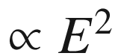

and

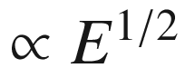

, respectively

We note also that the indirect semiconductors have an optical transition between

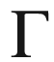

 valence- and conduction-band states. However, this transition is at higher energies than the fundamental band gap, e.g. for Si (

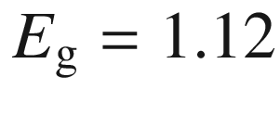

 eV) at 3.4 eV (see Fig. [6.​9](The_Physics_of_Semiconductors00003.docx#u116076_4_En_6_Chapter-Fig9)a). In Fig. [9.15](#u116076_4_En_9_Chapter-Fig15), the absorption scheme for indirect and direct absorption processes starting with an electron at the top of the valence band is shown together with an experimental absorption spectrum for Ge with the direct transition (

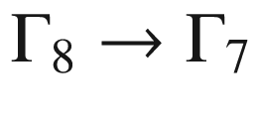

) at 0.89 eV, 0.136 eV above the fundamental band gap.

In Fig. [9.16](#u116076_4_En_9_Chapter-Fig16), the absorption edge of BaTiO



is shown. An indirect transition with an increase of (weak) absorption

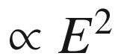

and an indirect gap of

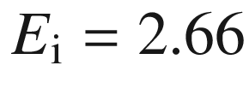

 eV and a direct transition with an increase of (strong) absorption

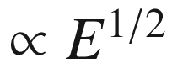

and a direct gap of

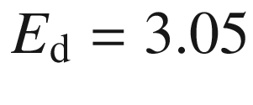

 eV are observed. These transitions could be due to holes at the M (indirect gap) and

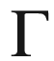

(direct gap) points (cf. Sect. [6.​3.​11](The_Physics_of_Semiconductors00003.docx#u116076_4_En_6_Chapter)), respectively.

#### 9.7.4 Urbach Tail

Instead of the ideal

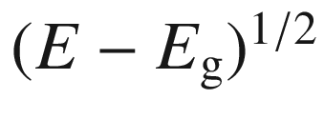

dependence of the direct band-edge absorption, often an exponential tail is observed (see Fig. [9.17](#u116076_4_En_9_Chapter-Fig17)). This tail is called the Urbach tail [853] and follows the functional dependence (for

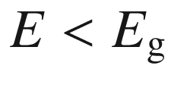

)

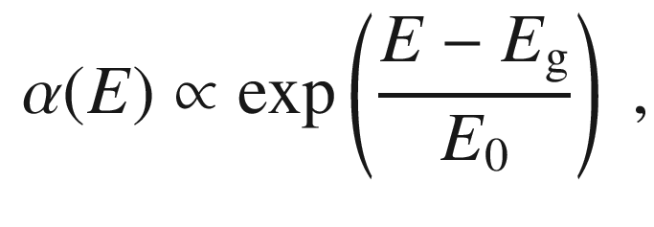

(9.48)

where

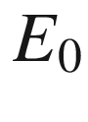

is the characteristic width of the absorption edge, the so-called Urbach parameter.

The Urbach tail is attributed to transitions between band tails below the band edges. Such tails can originate from disorder of the perfect crystal, e.g. from defects or doping, and the fluctuation of electronic energy bands due to lattice vibrations. The temperature dependence of the Urbach parameter

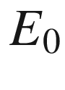

is thus related to that of the band gap as discussed in [854, 855].

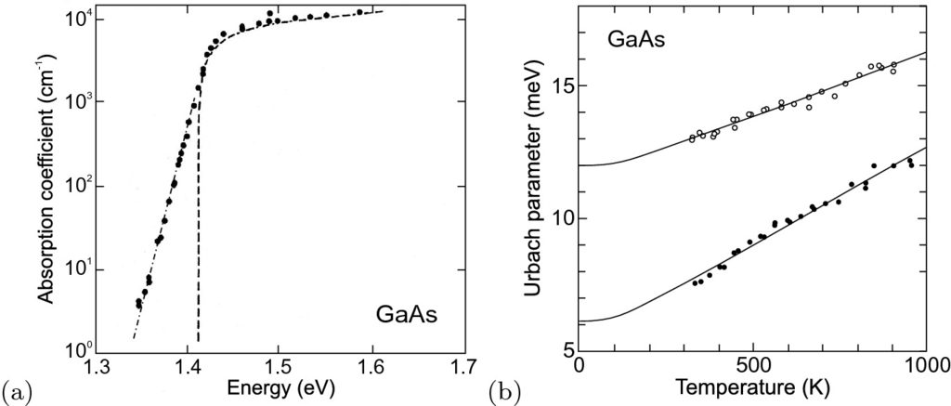

Fig. 9.17

**a** Experimental absorption spectrum (*circles*) of GaAs at room temperature on a semilogarithmic plot. The exponential tail below the band gap is called the Urbach tail (the *dash-dotted* line corresponds to

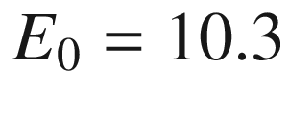

 meV in ([9.48](#u116076_4_En_9_Chapter-Equ50))). The *dashed line* is the theoretical dependence from ([9.45](#u116076_4_En_9_Chapter-Equ46)). Adapted from [856]. **b** Temperature dependence of Urbach parameter

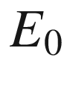

for two GaAs samples. Experimental data for undoped (*solid circles*) and Si-doped (

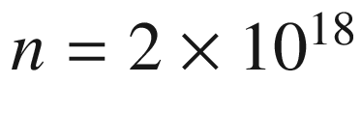

 cm

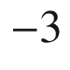

, *empty circles*) GaAs and theoretical fits (*solid lines*) with one-phonon model.

Adapted from [854]

#### 9.7.5 Amorphous Semiconductors

The sharp features in the dielectric function due to critical points in the band structure of crystalline semiconductors are washed out in amorphous material. As an example the spectra of the imaginary part of the dielectric function for crystalline (trigonal) and amorphous selenium are shown in Fig. [9.18](#u116076_4_En_9_Chapter-Fig18).

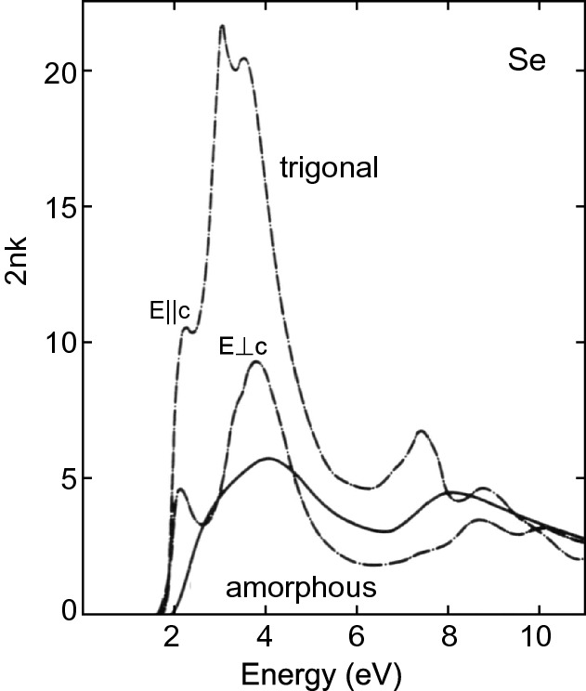

Fig. 9.18

Imaginary part of the dielectric function of amorphous (*solid line*) and crystalline (trigonal) selenium (*dash-dotted lines* for two different polarization directions). From [857]

#### 9.7.6 Excitons

An electron in the conduction band and a hole in the valence band form a hydrogen-like state due to the mutual Coulomb interaction. Such a state is called an exciton. The center-of-mass motion is separated and has a dispersion

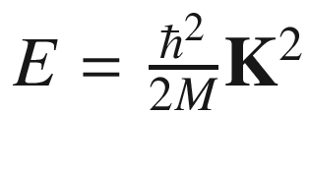

, where

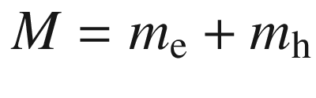

is the total mass and

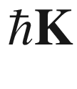

is the center-of-mass momentum

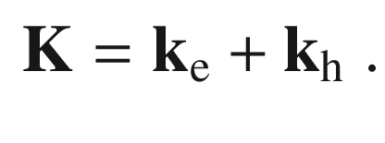

(9.49)

The relative motion yields hydrogen-like quantized states

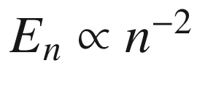

(

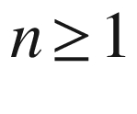

):

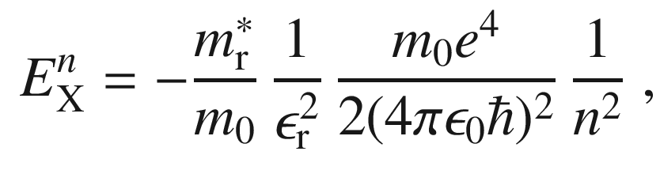

(9.50)

where

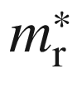

denotes the reduced effective mass

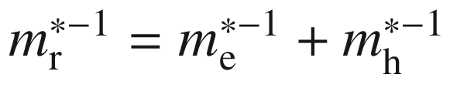

. The third factor is the atomic Rydberg energy (13.6 eV). The exciton binding energy

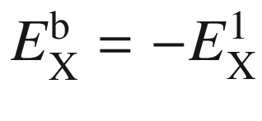

is scaled by

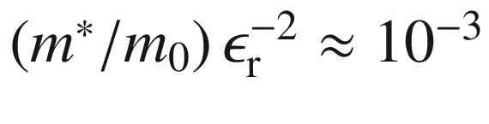

. A more detailed theory of excitons beyond the simple hydrogen model presented here, taking into account the valence-band structure, can be found in [858] for direct and [859] for indirect cubic and in [860] for wurtzite semiconductors. The exciton binding energies for various semiconductors are listed in Table [9.4](#u116076_4_En_9_Chapter-Tab4) and shown in Fig. [9.19](#u116076_4_En_9_Chapter-Fig19)a versus the band gap.Table 9.4

Exciton (

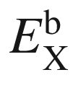

) and biexciton (

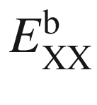

, see Sect. [9.7.10](#u116076_4_En_9_Chapter-Sec17)) binding energies in various bulk semiconductors. Values for 10 nm GaAs/15 nm Al

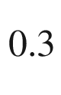

Ga

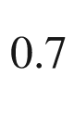

As quantum well (QW) are taken from [861]

| Material | $$E_{\mathrm {X}}^{\mathrm {b}}$$  (meV) | $$E_{\mathrm {XX}}^{\mathrm {b}}$$  (meV) | $$E_{\mathrm {XX}}^{\mathrm {b}}/E_{\mathrm {X}}^{\mathrm {b}}$$ |
| --- | --- | --- | --- |
| GaAs | 4.2 |  |  |
| GaAs QW | 9.2 | 2.0 | 0.22 |
| ZnSe | 17 | 3.5 | 0.21 |
| GaN | 25 | 5.6 | 0.22 |
| CdS | 27 | 5.4 | 0.20 |
| ZnS | 37 | 8.0 | 0.22 |
| ZnO | 59 | 15 | 0.25 |

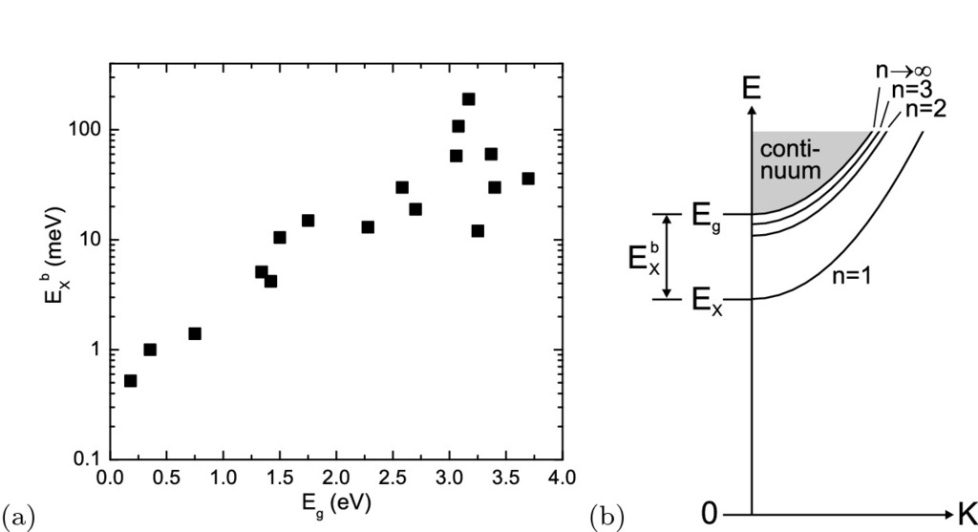

Fig. 9.19

**a** Exciton binding energy versus band gap for various semiconductors. **b** Schematic dispersion of excitonic levels. The *K*-vector refers to the center-of-mass motion

The radius of the exciton is

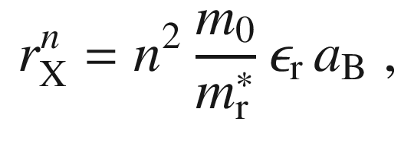

(9.51)

where

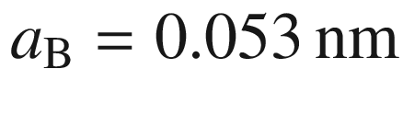

denotes the hydrogen Bohr radius.[6](The_Physics_of_Semiconductors00005.docx#u116076_4_En_9_Chapter-Fn6) The Bohr radius of the exciton is

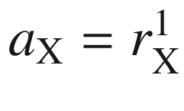

(14.6 nm for GaAs,

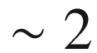

 nm for ZnO). The exciton moves with the center-of-mass

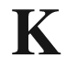

-vector through the crystal. The complete dispersion is (see Fig. [9.19](#u116076_4_En_9_Chapter-Fig19)b)

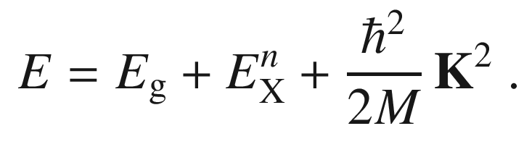

(9.52)

The oscillator strength of the exciton states decays

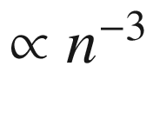

. The absorption due to excitons is visible in Fig. [9.11](#u116076_4_En_9_Chapter-Fig11)a for GaAs at low temperatures. If inhomogeneities are present, typically only the

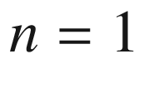

transition is seen. However, under special conditions also higher transitions of the exciton Rydberg series are seen (e.g.

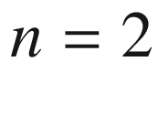

and 3 in Fig. [9.11](#u116076_4_En_9_Chapter-Fig11)b).

The exciton concept was introduced first for absorption in Cu

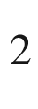

O [862]. The

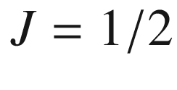

absorption spectrum (‘yellow series’) is shown in Fig. [9.20](#u116076_4_En_9_Chapter-Fig20). In this particular material both the valence and conduction bands have s character, thus the 1s transition of the exciton is forbidden and the *n*p transitions are observed in normal (one-photon) absorption. With two-photon absorption also the s (and d) transitions can be excited. On a piece of natural Cu

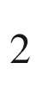

O, the Rydberg series has been measured up to

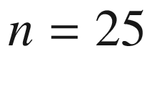

[863] (Fig. [9.21](#u116076_4_En_9_Chapter-Fig21)a). The peak energy and the oscillator strength follow the

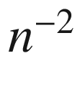

(

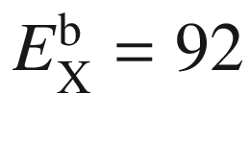

 meV,

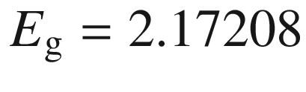

 eV) and

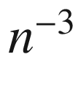

laws, respectively, expected from a hydrogen model (Fig. [9.21](#u116076_4_En_9_Chapter-Fig21)b). The deviation from the

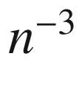

-dependence for the oscillator strength at large *n* is due to interaction effects of excitons with large radius at finite exciton density.

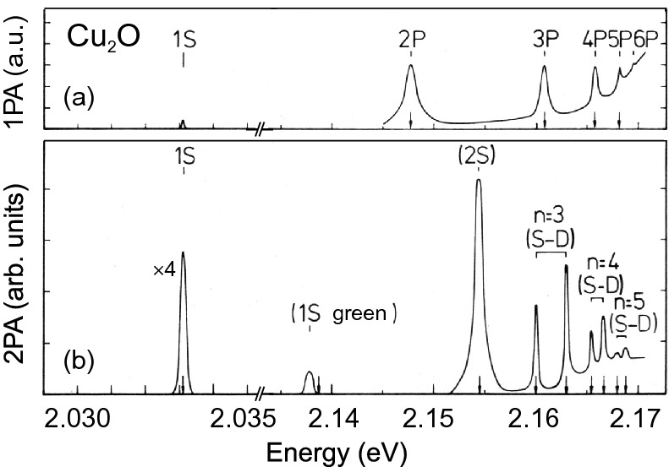

Fig. 9.20

One-photon (*top*) and two-photon (*bottom*) absorption spectra of Cu



O at

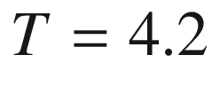

 K. *Arrows* denote theoretical peak positions.

Adapted from [864]

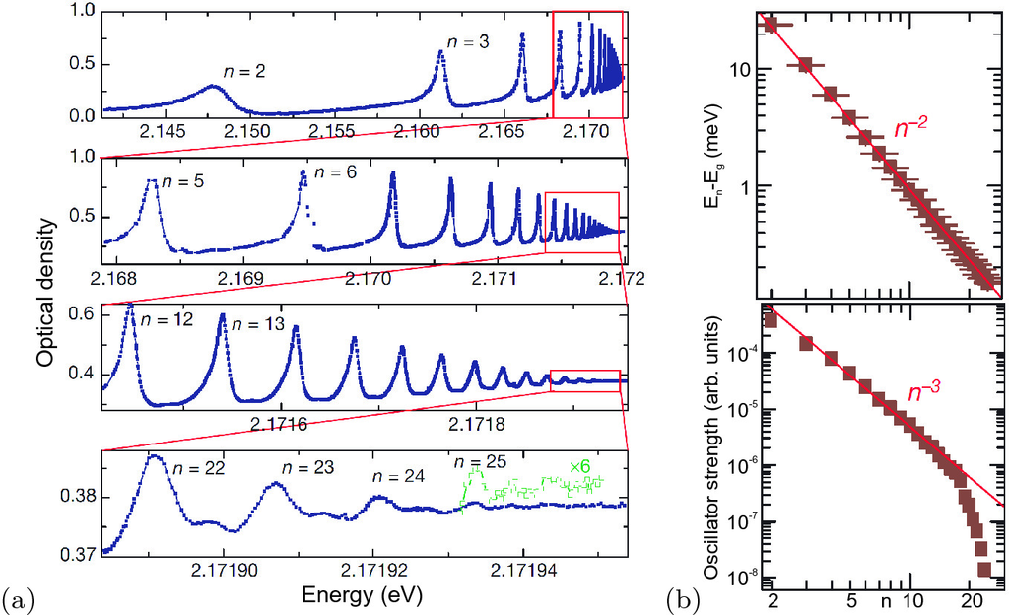

Fig. 9.21

(One photon) Absorption spectrum of Cu



O (thickness 34

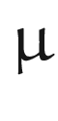

m) at



 K with transitions labelled

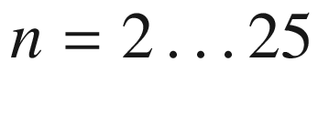

.

Adapted from [863]

The scattering (unbound) states of the exciton [865] for

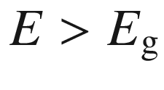

contribute to absorption above the band gap. The factor by which the absorption spectrum is changed is called the Sommerfeld factor. For bulk material it is

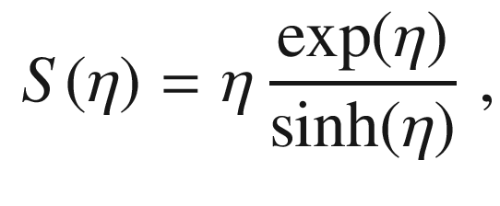

(9.53)

with

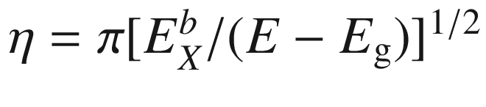

. The change of the absorption spectrum due to the Coulomb correlation is shown in Fig. [9.22](#u116076_4_En_9_Chapter-Fig22). There is a continuous absorption between the bound and unbound states. At the band gap there is a finite absorption (

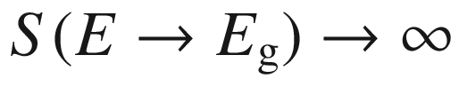

). The detail to which exciton peaks can be resolved depends on the spectral broadening.

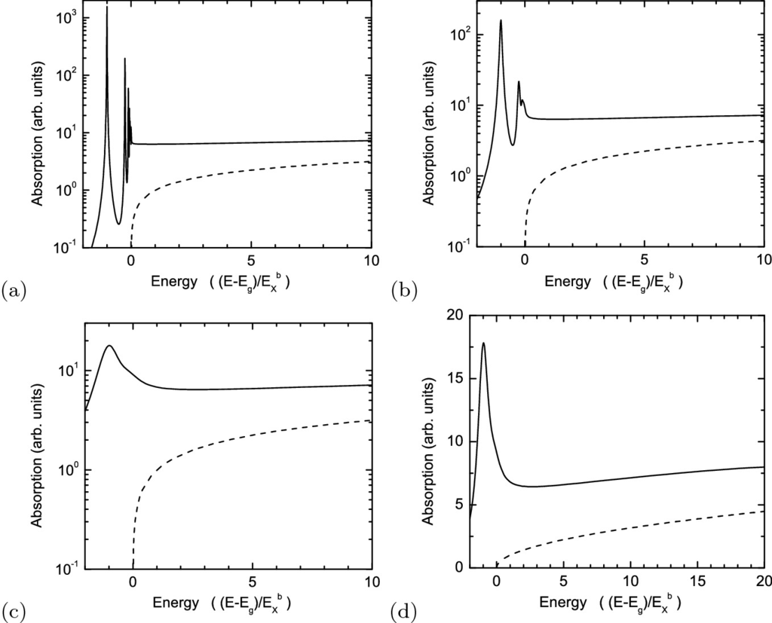

Fig. 9.22

Modification of the absorption edge of a direct transition by excitonic effects for different spectral (Lorentzian) broadening (

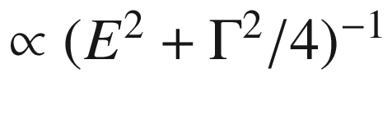

), **a**

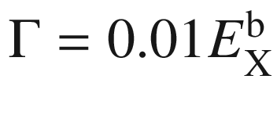

, **b**

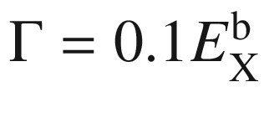

, **c**

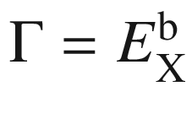

. **d** is **c** in linear scale. *Dashed lines* are electron–hole plasma absorption according to ([9.45](#u116076_4_En_9_Chapter-Equ46))

In Fig. [9.23](#u116076_4_En_9_Chapter-Fig23) the energy separations of the A-, B-, and C-excitons in GaN are shown [540]. Thus, the ordering of the valence bands depends on the strain state of the semiconductor.

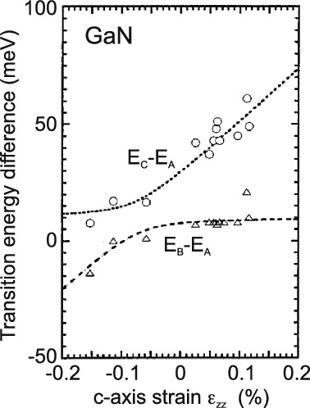

Fig. 9.23

Theoretical dependency (*lines*) for the the differences of the C-line and A-line as well as B-line and A-line exciton transition energies in GaN as a function of the *c*-axis strain. *Symbols* are experimental data from [866]. Adapted from [540]

#### 9.7.7 Phonon Broadening

The  scattering with phonons and the related dephasing leads to homogeneous broadening

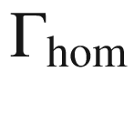

of absorption (and recombination) lines. Acoustic and optical phonons contribute to the broadening according to the dependence [867]

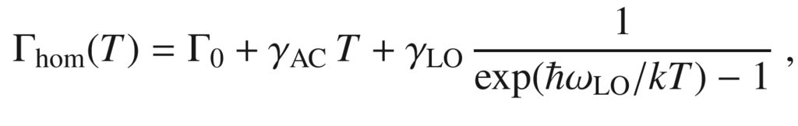

(9.54)

where

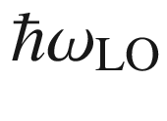

is the optical phonon energy and the last factor is the Bose function (E.24).

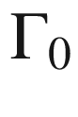

is a temperature-independent contribution,

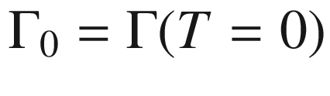

. The increasing broadening with increasing temperature is obvious, e.g., in absorption spectra (Fig. [9.24](#u116076_4_En_9_Chapter-Fig24)a). In Fig. [9.24](#u116076_4_En_9_Chapter-Fig24)b experimental data for GaAs, ZnSe and GaN are assembled. The data have been fitted with ([9.54](#u116076_4_En_9_Chapter-Equ56)); the resulting phonon broadening parameters are listed in Table [9.5](#u116076_4_En_9_Chapter-Tab5).[7](The_Physics_of_Semiconductors00005.docx#u116076_4_En_9_Chapter-Fn7) The optical transitions in polar semiconductors exhibit stronger coupling to optical phonons. The phonon coupling parameters from different measurements on GaN are discussed and compared in [870].

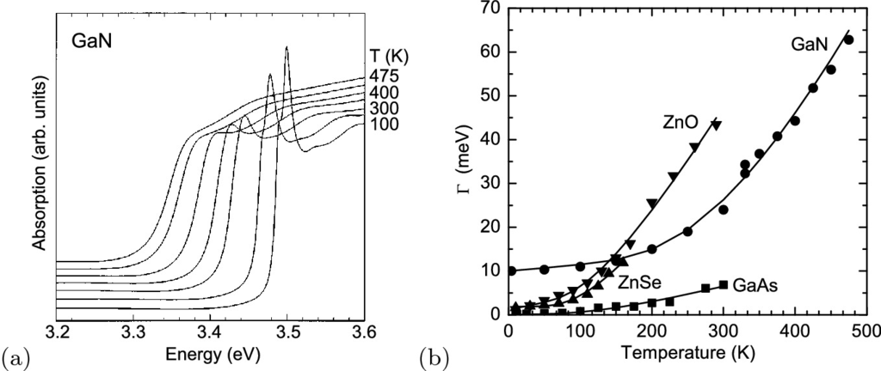

Fig. 9.24

**a** Absorption spectra of GaN bulk (0.38

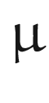

m thick epilayer on sapphire) for various temperatures

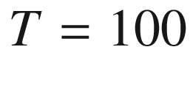

, 200, 300, 350, 400, 450, and 475 K. Adapted from [868] **b** Homogeneous broadening as a function of temperature, *symbols* are experimental data, *solid lines* are fits, rf. Table [9.5](#u116076_4_En_9_Chapter-Tab5)

Table 9.5

Phonon broadening parameters (FWHM) of various bulk semiconductors. Values from fits with ([9.54](#u116076_4_En_9_Chapter-Equ56)) to experimental data for GaAs [871], ZnSe [869], GaN [868], ZnO [872] (phonon energy fitted) as shown in Fig. [9.25](#u116076_4_En_9_Chapter-Fig25)b

| Material | $$\hbar \omega _{\mathrm {LO}}$$  (meV) | $$\Gamma _0$$  (meV) | $$\gamma _{\mathrm {AC}}$$  (  $$\upmu $$  eV/K) | $$\gamma _{\mathrm {LO}}$$  (meV) |
| --- | --- | --- | --- | --- |
| GaAs | 36.8 | 0 | $$4 \pm 2$$ | $$16.8 \pm 2$$ |
| ZnSe | 30.5 | 1.9 | $$0 \pm 7$$ | $$84 \pm 8$$ |
| GaN | 92 | 10 | $$15 \pm 4$$ | $$408 \pm 30$$ |
| ZnO | 33 | 1.2 | $$32 \pm 26$$ | $$96 \pm 24$$ |

#### 9.7.8 Exciton Polariton

Electrons and holes are particles with spin 1/2. Thus, the exciton can form states with total spin

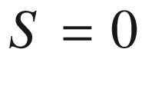

(para-exciton, singlet) and

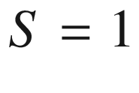

(ortho-exciton, triplet). The exchange interaction leads to a splitting of these states, the singlet being the energetically higher. The singlet state splits into the longitudinal and transverse exciton  with respect to the orientation of the polarization carried by the Bloch functions and the center-of-mass motion

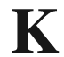

of the exciton. Dipole transitions are only possible for singlet excitons (bright excitons). The triplet excitons couple only weakly to the electromagnetic field and are thus also called dark excitons.

The coupling of these states to the electromagnetic field creates new quasi-particles, the exciton polaritons [873, 874]. The dielectric function of the exciton (with background dielectric constant

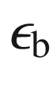

) is

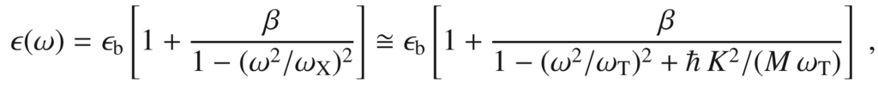

(9.55)

where

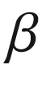

is the oscillator strength and the energy is

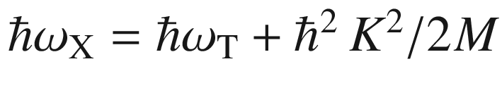

.

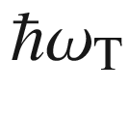

is the energy of the transverse exciton at

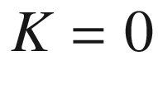

. With this dispersion the wave dispersion must be fulfilled, i.e.

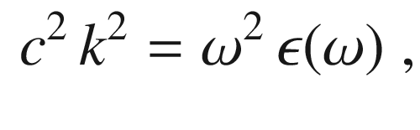

(9.56)

where *k* is the *k*-vector of the light that needs to be

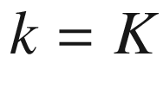

due to momentum conservation. The dependence of the dielectric function on *k* is called *spatial dispersion* [875]. Generally, up to terms in

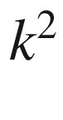

it is written as

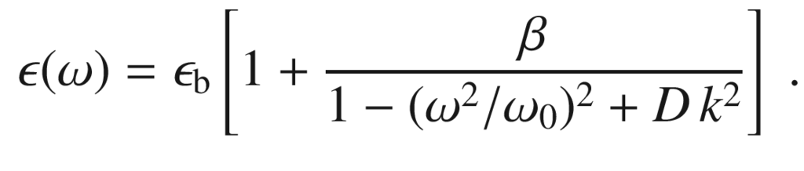

(9.57)

The term

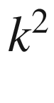

with curvature *D* (for the exciton polariton

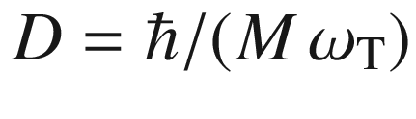

) plays a role in particular when

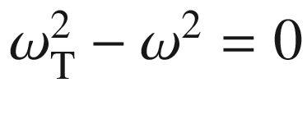

. For

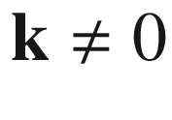

even a cubic material is anisotropic. The dimensionless curvature

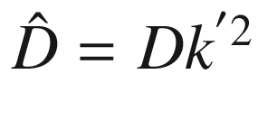

should fulfill

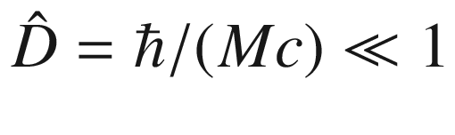

in order to make

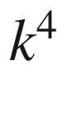

terms unimportant. For exciton polaritons[8](The_Physics_of_Semiconductors00005.docx#u116076_4_En_9_Chapter-Fn8) typically

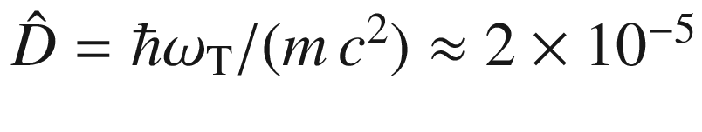

for

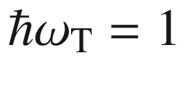

 eV and

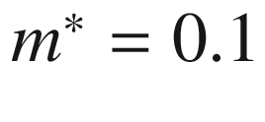

.

From ([9.56](#u116076_4_En_9_Chapter-Equ58)) together with ([9.57](#u116076_4_En_9_Chapter-Equ59)) two solutions result:

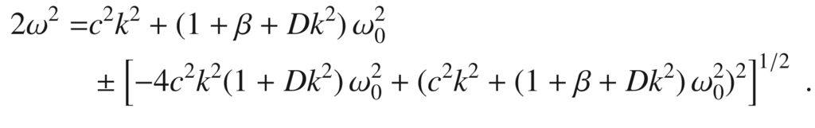

(9.58)

The two branches are shown schematically in Fig. [9.25](#u116076_4_En_9_Chapter-Fig25)a. Depending on the *k* value they have a photonic (linear dispersion) or excitonic (quadratic dispersion) character. The anticrossing behavior at

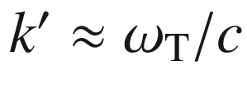

(for

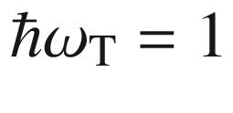

 eV,

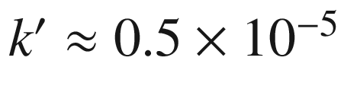

 cm

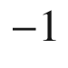

) creates a bottleneck region in the lower polariton branch. This name stems from the small emission rate of acoustic phonons (i.e. cooling) in that region, as predicted in [876] and experimentally found, e.g. in CdS [877]. The polaritons decay into a photon when they hit the surface. The effect of the oscillator strength of the dispersion is shown in Fig. [9.26](#u116076_4_En_9_Chapter-Fig26) for two-exciton resonance. In the case of several excitons ([9.57](#u116076_4_En_9_Chapter-Equ59)) reads

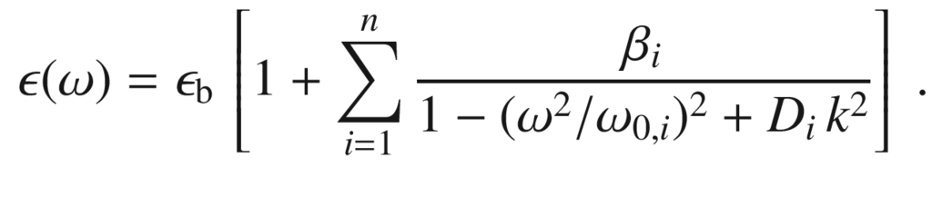

(9.59)

For

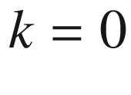

either

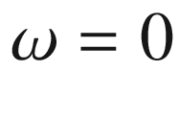

(lower polariton branch) or

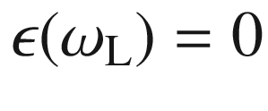

. For the latter we find from ([9.57](#u116076_4_En_9_Chapter-Equ59))

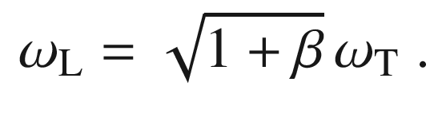

(9.60)

Therefore, the energy splitting

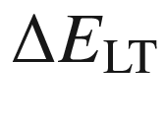

, mostly denoted as

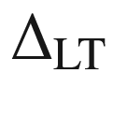

, between the L- and T-exciton energy given by

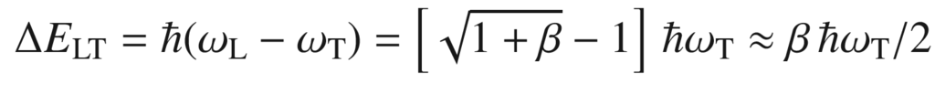

(9.61)

is proportional to the exciton oscillator strength (for experimental values see Table [9.6](#u116076_4_En_9_Chapter-Tab6)). We note that if (D.9) is used for the dielectric function,



in ([9.61](#u116076_4_En_9_Chapter-Equ63)) needs to be replaced by

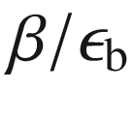

.

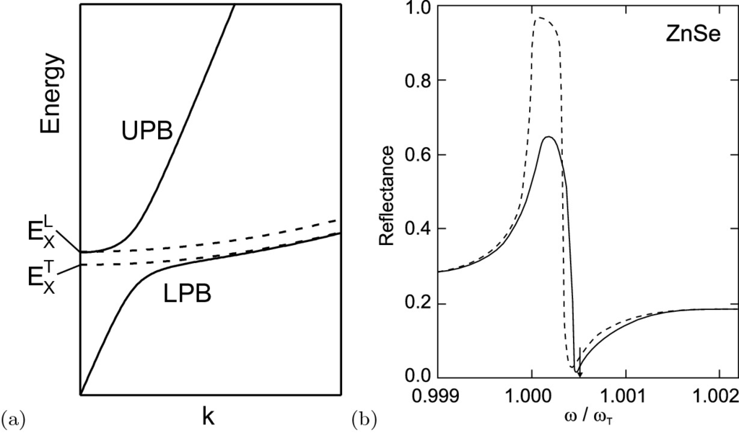

Fig. 9.25

**a** Schematic dispersion of exciton polaritons. The lower polariton branch (‘LPB’) is at small *k* photon-like, at large *k* exciton-like. The upper branch (‘UPB’) is exciton-like at small *k* and photon-like at larger *k*. The limit of the UPB for

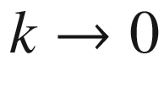

is the energy of the longitudinal exciton. The *dashed lines* represent the pure exciton dispersions. **b** Theoretical effect of spatial dispersion on the reflectance at the fundamental exciton resonance at normal incidence for ZnSe material parameters (

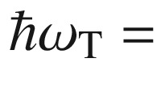

2.8 eV,

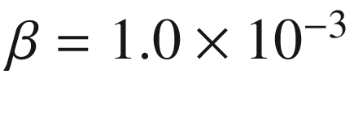

and a background dielectric constant of

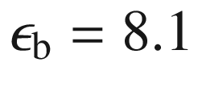

, damping was set to

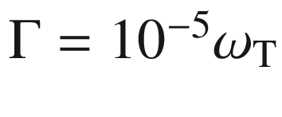

). The arrow denotes the position of

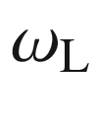

. The *solid* (*dashed*) *line* is with (without) spatial dispersion for

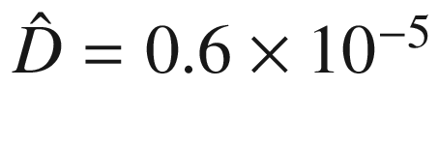

(

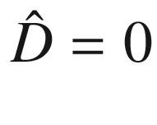

). Data from [875]

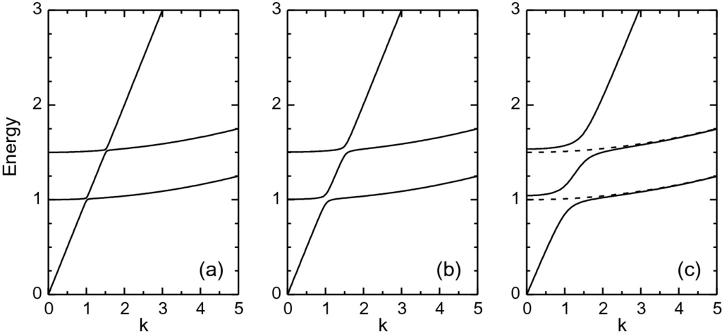

Fig. 9.26

Schematic polariton dispersion for a two-exciton resonance (curvature of exciton dispersion greatly exaggerated,

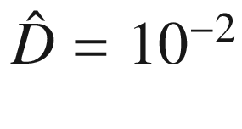

) at

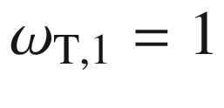

and

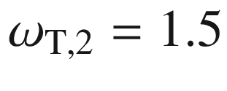

for three different oscillator strengths **a**

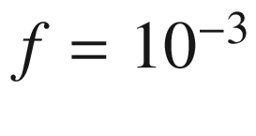

, **b**

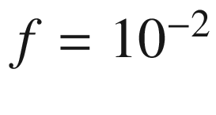

, **c**

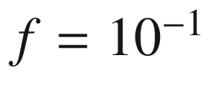

. The *dashed lines* in **c** represent the pure exciton dispersions

Table 9.6

Exciton energy (low temperature), LT splitting and exciton polariton oscillator strength for various semiconductors. Values for ZnO from [878], values for GaAs from [879], all other values from [880]

|  |  | CdS A | CdS B | ZnO A | ZnO B | ZnSe | GaN A | GaN B | GaAs |
| --- | --- | --- | --- | --- | --- | --- | --- | --- | --- |
| $$\hbar \omega _{\mathrm {T}}$$ | (eV) | 2.5528 | 2.5681 | 3.3776 | 3.3856 | 2.8019 | 3.4771 | 3.4816 | 1.5153 |
| $$\Delta _{\mathrm {LT}}$$ | (meV) | 2.2 | 1.4 | 1.45 | 5 | 1.45 | 1.06 | 0.94 | 0.08 |
| $$\beta $$ | (  $$10^{-3}$$  ) | 1.7 | 1.1 | 0.9 | 3.0 | 1.0 | 0.6 | 0.5 | 0.11 |

The effect of spatial dispersion on the reflection at the fundamental exciton resonance is depicted in Fig. [9.25](#u116076_4_En_9_Chapter-Fig25)b. For non-normal incidence an additional feature due to the longitudinal wave is observed for p-polarization [875]. For a detailed discussion additional effects due to anisotropy in wurtzite crystals, an exciton free layer at the semiconductor surface, additional boundary conditions  and damping need to be considered [881, 882]. The polariton dispersions of ZnO and GaN are shown in Fig. [9.27](#u116076_4_En_9_Chapter-Fig27).

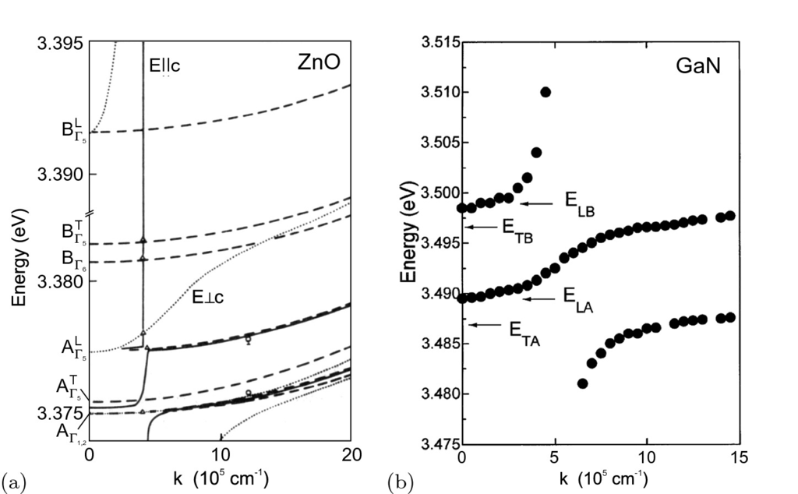

Fig. 9.27

**a** Exciton polariton dispersion (

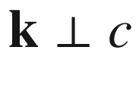

) of ZnO with experimental data (

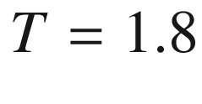

 K). *Solid* (*dotted*) *lines* are for polaritons with

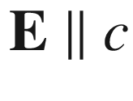

(

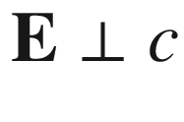

). The *dashed lines* refer to excitons. Adapted from [883]. **b** Exciton polariton dispersion (

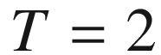

 K) in GaN (on sapphire) for



.

Adapted from [884]

#### 9.7.9 Bound-Exciton Absorption

Excitons can localize at impurities or inhomogeneities. Such excitons are called *bound excitons*. Here, the absorption due to such complexes is discussed. The recombination is discussed in Sect. [10.​3.​2](The_Physics_of_Semiconductors00005.docx#u116076_4_En_10_Chapter). In GaP:N excitons are bound to isoelectronic N impurities (substituting P), resulting in the ‘A’ line at 2.3171 eV (at



 K).[9](The_Physics_of_Semiconductors00005.docx#u116076_4_En_9_Chapter-Fn9) The absorption due to A excitons is well resolved in the spectrum of Fig. [9.28](#u116076_4_En_9_Chapter-Fig28)b. At sufficiently high nitrogen doping, there exist nitrogen pairs, i.e. a complex where a nitrogen impurity has a second nitrogen impurity in the vicinity. The pairs are labeled NN

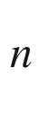

. It was believed that the second nitrogen atom is in the *n*th shell around the first one. However, the proper level asignment is probably different in the view of modern theory [544]. Also clusters with more than two nitrogen atoms may exist. NN

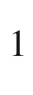

is a prominent level and relates to a N–Ga–N complex having 12 equivalent sites for the second N atom on the next neighbor anion site. The transitions due to excitons bound to NN

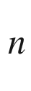

, as shown in Fig. [9.28](#u116076_4_En_9_Chapter-Fig28)a, give a series of lines (see Table [9.7](#u116076_4_En_9_Chapter-Tab7)) that fulfill

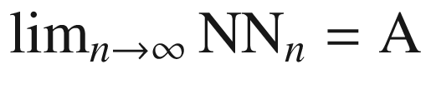

. Although GaP has an indirect band structure, the absorption coefficient of N-related transitions is large, about

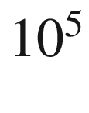

 cm



for a nitrogen doping level of

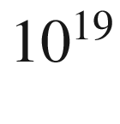

 cm



.[10](The_Physics_of_Semiconductors00005.docx#u116076_4_En_9_Chapter-Fn10) This is due to the fact that the electron spatially localized at the nitrogen isoelectronic trap (Sect. [7.​7.​9](The_Physics_of_Semiconductors00003.docx#u116076_4_En_7_Chapter)) has a sizeable

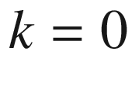

-component of its wave-function (Fig. [7.​40](#u116076_4_En_7_Chapter-Fig40)), leading to a large transition probability for

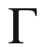

-point holes with an oscillator strength of 0.09 [885].

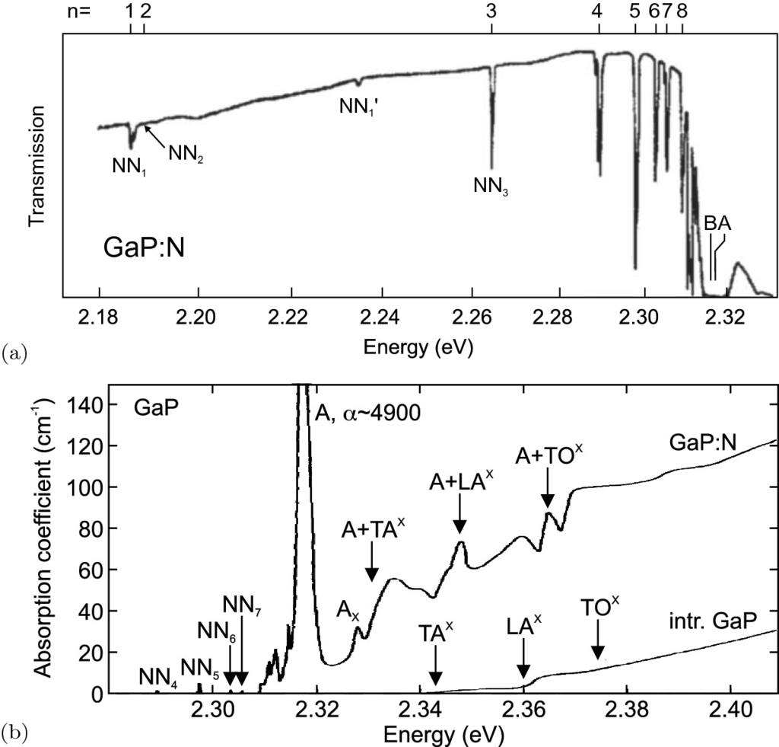

Fig. 9.28

**a** Transmission spectrum of GaP:N with a nitrogen concentration of about 10

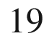

 cm

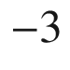

at 1.6 K (thickness: 1.1 mm). *n* is indicated for the first eight transitions due to excitons bound to nitrogen pairs. NN

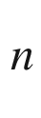

’ indicate phonon replica. The ‘A’ line denotes the position of the transition due to excitons bound to a single nitrogen atom (observable for samples with low N doping). The ‘B’ line is forbidden and due to the

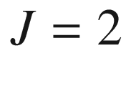

exciton. Adapted from [694]. **b** Absorption spectra of N-doped (

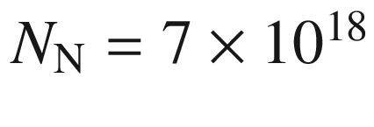

 cm

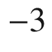

) and intrinsic GaP (

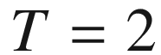

 K).

Adapted from [690]

Table 9.7

Index of nitrogen pairs NN

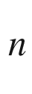

and energy separation

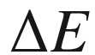

of bound-exciton transitions from the free-exciton line for

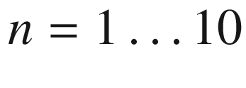

and the ‘A’ line

| *n* | 1 | 2 | 3 | 4 | 5 | 6 | 7 | 8 | 9 | 10 | $$\infty $$  (A) |
| --- | --- | --- | --- | --- | --- | --- | --- | --- | --- | --- | --- |
| $$\Delta E$$  (meV) | 143 | 138 | 64 | 39 | 31 | 25 | 22 | 20 | 18 | 17 | 11 |

#### 9.7.10 Biexcitons

Similar to two hydrogen atoms forming a hydrogen molecule, two excitons can also form a bound complex, the biexciton involving two electrons and two holes. The biexciton binding energy is defined as

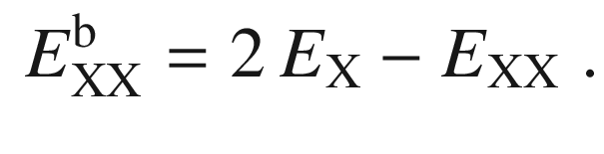

(9.62)

Biexcitons are binding in bulk material. Accordingly, the biexciton recombination or absorption occurs at lower energy than that of the exciton. Values of the biexciton binding energy are listed in Table [9.4](#u116076_4_En_9_Chapter-Tab4) for various semiconductors. The ratio of biexciton and exciton binding energies is fairly constant about 0.2. In semiconductors with small exciton binding energy, such as GaAs, biexcitons are hard to observe in bulk material but show up in heterostructures that provide additional carrier confinement (see also Sect. [14.​4.​4](The_Physics_of_Semiconductors00006.docx#u116076_4_En_14_Chapter)). While the exciton density increases linearly with external excitation, the density of biexcitons increases quadratically.

#### 9.7.11 Trions

The complexes ‘eeh’ and ‘ehh’ are called trions. Also, the notation X

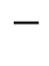

and X

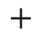

is common. X

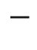

is typically stable in bulk material but hard to observe. In quantum wells or dots, trions are easier to observe. In quantum dots excitons with higher charge, e.g. X

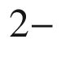

, have also been observed (see Fig. [14.​45](The_Physics_of_Semiconductors00006.docx#u116076_4_En_14_Chapter-Fig45)).